Heritage Impact Assessment: Hotel Virginia, Torquay
HELAA2021 Ref: | 24T010
Site Address: | Hotel Virginia, Falkland Road, Torquay
Site Area (ha): | 0.08
Site Yield: | 14
HIA Assessment

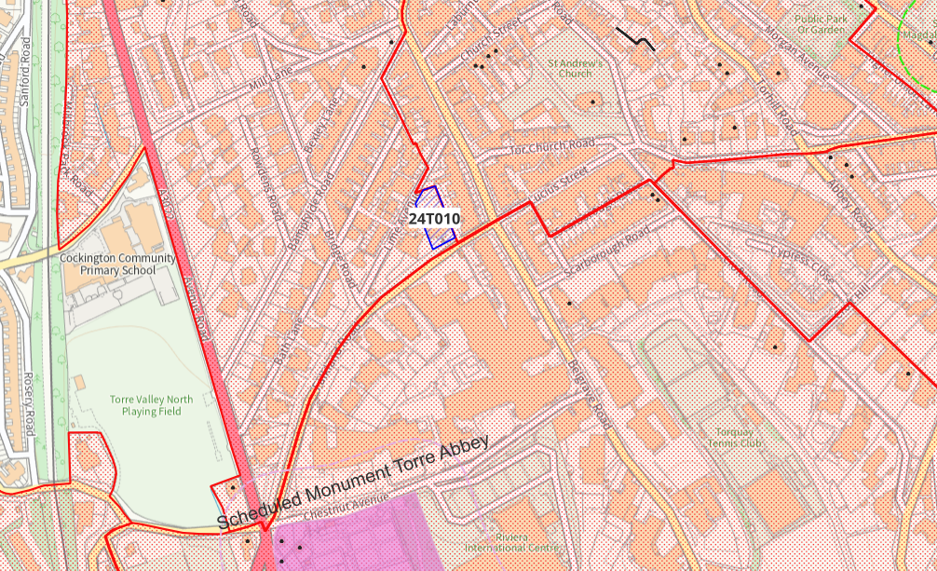
Site overview and heritage context:
The site is a vacant, semi-derelict building located on Falkland Road which was in use as a 25-bed hotel until 2022. The building was historically a C19 pair of semi-detached villas which have been joined to form the hotel. The building has undergone various alterations and extensions to facilitate its use as a hotel.
The form, style, detailing and positioning of the building suggest that it was a later infill development of a lesser status than the nearby Italianate terraces of Belgrave Road, and the landscaping and boundary treatment to the front of the site, along with the building itself, mark a clear change in the townscape in this area which denotes the historical development of the land west of Belgrave Road.
The site is within the Torre Conservation Area and is on the border of the Tormohun and Belgravia Conservation Areas.

Planning History:
P/2023/0868 – Redevelopment to form 14 apartments. Refused March 2024 in part due to proposed demolition of existing building.

Heritage Asset Affected by Allocation | Designation | Contributing Elements to Significance | Impact of Development on Significance | Mitigation Measures for any Identified Harm /Opportunities to Enhance Significance | Impact on Significance with Mitigation in place
Torre Conservation Area  Tormohun Conservation Area (immediately W of site)  Belgravia Conservation Area (immediately S of site)  Virginia Hotel | Conservation Area  Conservation Area  Conservation Area  Non-designated heritage asset | The Conservation Area is characterised by spaciously laid out C19 villas, many of which are now used as hotels and guest houses. The form, style, detailing and positioning of the site suggest that it was a later infill development than the nearby Italianate terraces of Belgrave Road, denoting the historical development of the area.  The site has been vacant since the hotel closed in 2022, and as such as fallen into disrepair, with windows on the lower level boarded. The building has undergone some unsympathetic alterations associated with its use as a hotel, including single storey flat roof extensions to the rear and replacement of original windows.  However, the design and character of the site remains of historic interest and there is significant surviving historic fabric, in particular the bracketed eaves, slate hung façade, slate roof and chimneys.  Overall, the site is identified as making a positive contribution to the character and appearance of the Conservation Area.  The site is part of the setting of the Tormohun Conservation Area, the border of which runs immediately to the east of the site. The building can be seen in context with the Italianate terraces of Belgrave Road when looking west along Falkland Road. The landscaping and boundary treatment to the front of the site, along with the building itself, mark a clear change in the townscape in this area and denotes the historical development of the land west of Belgrave Road.  The application site therefore makes a minor contribution to the setting and therefore the significance of the Tormohun Conservation Area.  The site forms part of the setting of the Belgravia Conservation Area, the boundary of which can be found on the southern side of Falkland Road.  The building can be seen in context with the southern section of Italianate terraces of Belgrave Road when looking west along Falkland Road. The landscaping and boundary treatment to the front of the site, along with the building itself, mark a clear change in the townscape in this area and denotes the historical development of the land west of Belgrave Road.  The application site therefore makes a minor contribution to the setting and therefore the significance of the Belgravia Conservation Area.  Due to the historic and architectural features that have remained within the villa, its prominent location within the street scene and its demonstrable group value with neighbouring villas, it is considered that the Virginia Hotel is a non-designated heritage asset, albeit one which has clear opportunity for enhancement. | The proposed yield of 14 could be achieved through the sensitive conversion of the site which would result in a positive impact to the significance of this asset.  The sensitive conversion of the site which would result in a positive impact to the significance of this asset.  The sensitive conversion of the site which would result in a positive impact to the significance of this asset.  The proposed yield of 14 could be achieved through the sensitive conversion of the site which would result in a positive impact to the significance of this asset. | Opportunity to enhance significance through sensitive conversion of the site and removal of detrimental elements no longer necessary for hotel use.  Opportunity to enhance significance through sensitive conversion of the site and removal of detrimental elements no longer necessary for hotel use.  Opportunity to enhance significance through sensitive conversion of the site and removal of detrimental elements no longer necessary for hotel use.  Opportunity to enhance significance through sensitive conversion of the site and removal of detrimental elements no longer necessary for hotel use. | Positive  Positive  Positive  Positive

