Heritage Impact Assessment: 48-50 The Terrace
HELAA2021 Ref: | 24T008
Site Address: | 48-50 The Terrace, Torquay
Site Area (ha): | 0.07
Site Yield: | 12
HIA Assessment

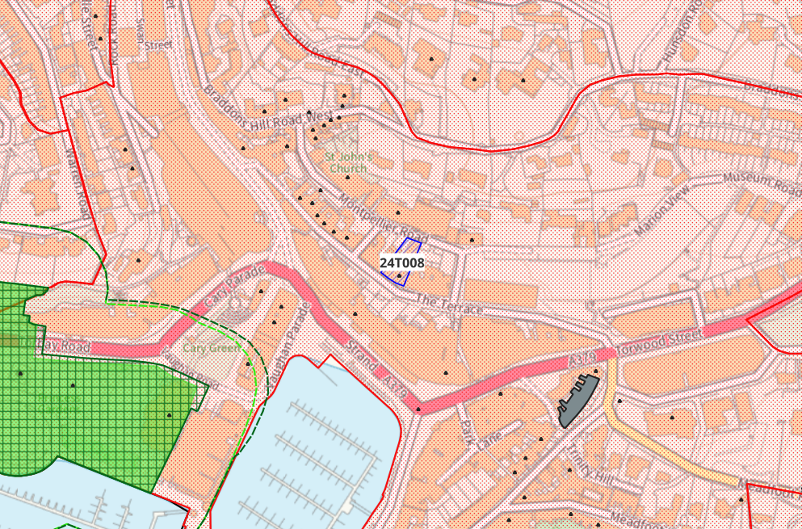
Site overview and heritage context:
The site is a mid-terrace building, previously in use as offices. The Terrace is in a prominent location in the centre of Torquay above the harbour, and is visible in several views across Torquay. The site is a designated as a GII Listed Building (NHLE ref. 1280014) and there are several other GII Listed Buildings in the vicinity as well as one GI Listed Building. The site is also located in the Torquay Harbour Conservation Area.
The Terrace is the earliest part of Sir Lawrence Palk’s developments and comprises 9 houses built in 1811 to the design of Jacob Harvey. The Terrace is therefore of great local importance and indeed national importance as Torquay was proclaimed as the nation’s pre-eminent resort in the mid C19. The Terrace is identified in the Torquay Harbour Conservation Area Appraisal of as being part of an important building group with largely unspoilt frontage retaining significant period details.
Within The Terrace, No.50 occupies the principle location, and its prominence is defined by having 5 bays rather than 3, and stands proud of the terrace by a shallow projection.

Planning History:
P/2022/0895 – Change of use from office to residential, internal alterations, extension, demolition of 5 Montpelier Road and construction of apartment block to create a total of 13 apartments – approved 09/07/2024

Heritage Asset Affected by Allocation | Designation | Contributing Elements to Significance | Impact of Development on Significance | Mitigation Measures for any Identified Harm /Opportunities to Enhance Significance | Impact on Significance with Mitigation in place
Torquay Harbour Conservation Area Appraisal  Parish Church of St John the Evangelist (NW of site)  Higher Terrace and Attached Front Railings (site)  Royal Bank of Scotland (S of site)  Unity Church (NE of site)  St John’s House (N of site)  38, The Terrace (NW of site)  The Clarence Hotel (NW of site)  34, The Terrace (NW of site)  32, The Terrace (NW of site)  30, The Terrace (NW of site)  28, The Terrace (NW of site)  Wall and Railings to South of the Church of St John the Evangelist (NW of site) | Conservation Area  GI Listed Building  GII Listed Building  GII Listed Building  GII Listed Building  GII Listed Building  GII Listed Building  GII Listed Building  GII Listed Building  GII Listed Building  GII Listed Building  GII Listed Building  GII Listed Building | The Terrace is highly visible from several parts of the Conservation Area, and is identified in the Conservation Area Appraisal as a key building that contributes to the significance of the heritage asset.  1861-73 parish church to the designs of GE Street. Significance derived from the survival of high-quality historic features with little modern intervention.  Each building has a 3-bay front except for the 5-bay No.50 styled in accordance with traditional Fibonacci Principles. Continuous cast iron balcony with interlace balustrade divided by vertical panels of roundels. Round-headed doorway with moulded architrave. Gibbs surrounds with vermiculated rustication and keyblocks with carved or cast heads; panelled reveals. Original doors 6-panel, mostly with plain fanlights and segmental-headed windows: ground floor originally 12-pane but reglazed as 2-pane sashes. No.50 and No.58 have square-headed doorways on the front with moulded architraves with keyblocks. Elevations are rendered brickwork and stone walls, painted white, with slate roofs, stacks with rendered shafts.  Within The Terrace, No.50 occupies the principle location, and its prominence is defined by having 5 bays rather than 3, and stands proud of the terrace by a shallow projection.  1893 bank to the designs of C R Grittle, chief architect at National Provincial Bank. C17 Artisan Manerist style.  1912 Unitarian Church to the designs of Bridgman and Bridgman in the Free Gothic style.  1820s house, formerly part of terrace on the site of St John’s church.  1830s terraced houses in use as offices.  1830s terraced houses in use as offices  1830s terraced houses in use as offices  1830s terraced houses in use as offices  1830s terraced houses in use as offices  1830s terraced houses in use as offices  Retaining wall dated 1820s and railings dated 1861-73 designed by GE Street, contemporary with the Church of St. John the Evangelist. | The proposed yield of 12 could be achieved through the sensitive conversion of the site which would result in a neutral impact to the significance of this asset.  The proposed yield of 12 could be achieved through the sensitive conversion of the site which would result in a neutral impact to the significance of this asset.  The proposed yield of 12 could be achieved through the sensitive conversion of the site which would result in a neutral impact to the significance of this asset.  The proposed yield of 12 could be achieved through the sensitive conversion of the site which would result in a neutral impact to the significance of this asset.  The proposed yield of 12 could be achieved through the sensitive conversion of the site which would result in a neutral impact to the significance of this asset.  The proposed yield of 12 could be achieved through the sensitive conversion of the site which would result in a neutral impact to the significance of this asset.  The proposed yield of 12 could be achieved through the sensitive conversion of the site which would result in a neutral impact to the significance of this asset.  The proposed yield of 12 could be achieved through the sensitive conversion of the site which would result in a neutral impact to the significance of this asset.  The proposed yield of 12 could be achieved through the sensitive conversion of the site which would result in a neutral impact to the significance of this asset.  The proposed yield of 12 could be achieved through the sensitive conversion of the site which would result in a neutral impact to the significance of this asset.  The proposed yield of 12 could be achieved through the sensitive conversion of the site which would result in a neutral impact to the significance of this asset.  The proposed yield of 12 could be achieved through the sensitive conversion of the site which would result in a neutral impact to the significance of this asset.  The proposed yield of 12 could be achieved through the sensitive conversion of the site which would result in a neutral impact to the significance of this asset. | N/A  N/A  N/A  N/A  N/A  N/A  N/A  N/A  N/A  N/A  N/A  N/A  N/A | Neutral  Neutral  Neutral  Neutral  Neutral  Neutral  Neutral  Neutral  Neutral  Neutral  Neutral  Neutral  Neutral

