Heritage Impact Assessment: Chelston Telephone Exchange
HELAA2021 Ref: | 24T005
Site Address: | Chelston Telephone Exchange, Torquay
Site Area (ha): | 0.3
Site Yield: | 10
HIA Assessment

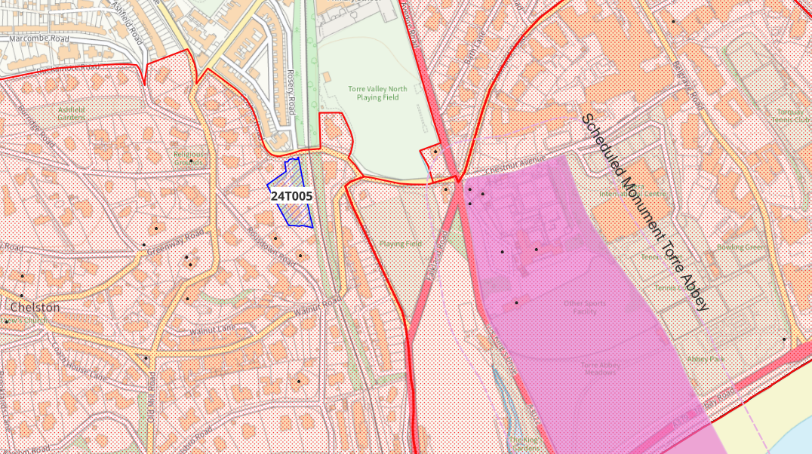
Site overview and heritage context:
The site is building formerly in use at the BT Telephone Exchange, sited to the south of where Goshen and Rosery Road’s meet. The railway line runs to the immediate east of the site, but it is almost completely obscured from the railway line and road by mature trees.
The site is within the Chelston Conservation Area, which is characterised by its late C19 development of modest villas in the garden suburb style. The Conservation Area is very green in character, with avenues of plane trees along roads. The Chelston Telephone Exchange site is a later development, likely late 20s/30s in origin – early OS maps confirm it is in situ by 1933.
Although it doesn’t conform to the Victorian suburb character of the Conservation Area, the building is of architectural interest as an example of early C19 industrial design, and of historical interest as an example of an early purpose-built telephone exchange.

Planning History:

Heritage Asset Affected by Allocation | Designation | Contributing Elements to Significance | Impact of Development on Significance | Mitigation Measures for any Identified Harm /Opportunities to Enhance Significance | Impact on Significance with Mitigation in place
Chelston Conservation Area  Belgravia Conservation Area (E of site)  Tor View Holiday flats (S of site)  Ambrook Little, Ambrook Lower, Ambrook (S of site)  Methodist Church (NW of site)  Chelston Cottage and Attached Wall (SW of site)  Ice House West of Chelston Cottage (SW of site)  Chelston Telephone Exchange | Conservation Area  Conservation Area  GII Listed Building  GII Listed Building  GII Listed Building  GII Listed Building  GII Listed Building  Non-Designated Heritage Asset | Chelston Conservation Area is identified as one of the best preserved Victorian suburbs of Torquay, with development from the late C19 that incorporates elements of the garden suburb style. The style of buildings suggest an area of middle status, with villas being somewhat smaller than those found in the Lincombes or Warberries Conservation Areas.  The site does not conform to Victorian villa style of the Conservation Area, but makes a positive contribution to the significance of the Conservation Area as it speaks to the ongoing development of the area.  The view towards to site from the western edge of Belgravia Conservation Area is almost entirely obscured by mature trees that line the railway line on both sides. As such, the site has a neutral impact on the Conservation Area.  1870s Villa, now divided into holiday flats. A good example of a conventional later C19 Torquay villa, with minimal modern alteration. The site is directly behind the building and is likely visible from upper windows, although trees may provide screening. While the site is in the setting of this heritage asset, it cannot be viewed in the same aspect due to screening from vegetation, so impact is minimal.  1870s Villa, now divided into three dwellings. A good example of a conventional later C19 Torquay villa, with minimal modern alteration. The site is directly behind this building and is likely visible from upper windows, although trees may provide screening. While the site is in the setting of this heritage asset, it cannot be viewed in the same aspect due to screening from vegetation, so impact is minimal.  Church dated to 1908 designed in the Gothic style and constructed of local red sandstone. The stone slated spire to the front is of particular note. The site forms part of the wider setting of this heritage asset.  C18 building, constructed of local red sandstone with some grey limestone.  Probably C18 ice house, constructed of local red sandstone.  Due to the historic and architectural features that have remained unaltered on the building, and its demonstrable historic value as an example of an early purpose-built telephone exchange, it is considered that the Chelston Telephone Exchange is a non-designated heritage asset.  Bringing the site into use through sensitive conversion would help ensure the survival of historic fabric. | The proposed yield of 10 could be achieved through the sensitive conversion of the site which would result in a neutral impact to the significance of this asset.  The proposed yield of 10 could be achieved through the sensitive conversion of the site which would result in a neutral impact to the significance of this asset.  Conversion to residential use to accommodate 10 units would have a negligible neutral impact on the significance of the asset.  Conversion to residential use to accommodate 10 units would have a negligible neutral impact on the significance of the asset.  Conversion to residential use to accommodate 10 units would have a negligible neutral impact on the significance of the asset.  Conversion to residential use to accommodate 10 units would have a negligible neutral impact on the significance of the asset.  Conversion to residential use to accommodate 10 units would have a negligible neutral impact on the significance of the asset.  The proposed yield of 10 could be achieved through the sensitive conversion of the site which would result in a neutral impact to the significance of this asset. | N/A  N/A  N/A  N/A  N/A  N/A  N/A  N/A | Neutral  Neutral  Neutral  Neutral  Neutral  Neutral  Neutral  Neutral

