Heritage Impact Assessment: Maycliffe Hotel
HELAA2021 Ref: | 24T002
Site Address: | Maycliffe Hotel, St Lukes Road, Torquay
Site Area (ha): | 0.09
Site Yield: | 10
HIA Assessment

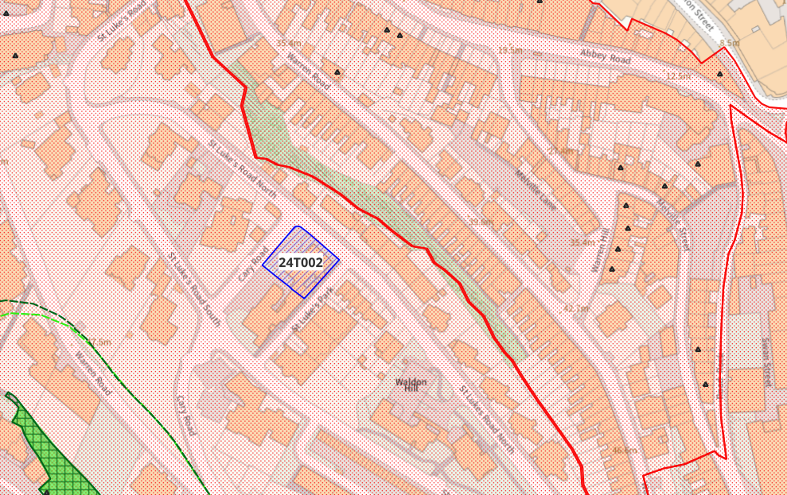
Site overview and heritage context:

Area on a plot that is bounded by Cary Road along the northwestern boundary, and by St Luke’s Road North along the northern boundary. This part of the Conservation Area sits high on Waldon Hill, and the area has been heavily terraced to allow for development. Its location makes this area a prominent feature on the horizon from many areas in Torquay, but the Maycliffe Hotel site is hidden amongst other development. It has previously been in use as a hotel, and more recently as a student residence.
Unsympathetic alterations and extensions approved in 1989 have altered the character of the building. The original form of the building is tricky to decipher, but happily the 1989 planning documents do preserve the earlier floorplan. Clues towards the original form may be taken from neighbouring Brampton Court which, while somewhat altered, still retains its original roof and chimney structures, and some ornamental detailing.
This part of the Conservation Area contains several original villas that have been restored to residential use following previous use as hotels and guest houses. The Belgravia Conservation Area Appraisal highlights the nieghbouring Abbey Hall as a particularly good example of this restoration.

Planning History:
P/2018/0493 – Change of use from hotel to student residence - Approved 16/08/2018
P/2015/0715 – Change of use of hotel to form 10 flats – Approved 21/10/2015

Heritage Asset Affected by Allocation | Designation | Contributing Elements to Significance | Impact of Development on Significance | Mitigation Measures for any Identified Harm /Opportunities to Enhance Significance | Impact on Significance with Mitigation in place
Belgravia Conservation Area  Abbey Road Conservation Area (NE of site) | Conservation Area  Conservation Area | The site occupies a part of the Conservation Area that was developed by the Cary family in the mid-1800s as part of the expansion of Torquay. The area is predominantly occupied with large Victorian villas sitting in large garden plots, however widescale 20th century development somewhat compromises the significance of the Conservation Area.  The Maycliffe Hotel site is an example of a classic Victorian villa which has undergone significant unsympathetic extension and alteration to facilitate its use as a hotel in the 1980s. In its current form, the site negatively impacts the Conservation Area.  The conservation area is characterised by its preserved 19th century street layout and surviving elements of the historic built environment. The site sites outside of the conservation area and currently makes a neutral contribution to its urban setting and thereby its significance. | The noted yield of 10 units could be adequately achieved through the conversion of the existing building which would have a positive impact on the asset’s significance.  The noted yield of 10 units could be adequately achieved through the conversion of the existing building which would have a positive impact on the asset’s significance. | Opportunity to enhance significance through sensitive conversion of the site and removal of detrimental elements no longer necessary for hotel use.  Opportunity to enhance significance through sensitive conversion of the site and removal of detrimental elements no longer necessary for hotel use. | Positive  Positive

