**Heritage Impact Assessment:** Car Park Between Meadfoot Sea Rd & Daddyhole Rd, Torquay

|  |  |
| --- | --- |
| **HELAA2021 Ref:** | 24T001 |
| **Site Address:** | Car Park Between Meadfoot Sea Rd & Daddyhole Rd, Torquay |
| **Site Area (ha):** | 0.08 |
| **Site Yield:** | 10 |
| **HIA Assessment** |  |

**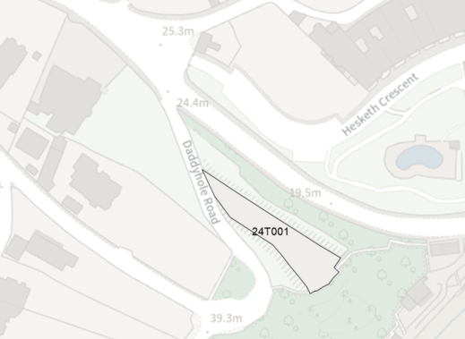  
Site overview and heritage context:**

The site is a narrow, triangular shaped piece of land off Daddyhole Road that is currently in use as a car park. It has views across the sea from the south-eastern side and overlooks GII* Hesketh Crescent (Osbourne Hotel) on the north-eastern side, although mature tree growth provides screening on all sides. The site is relatively level, although slopes slightly down towards Daddyhole Road on the western side, and it meets the cliff edge of Meadfoot Beach on the south-eastern side.

The site is within the Lincombes Conservation Area, and has the potential to impact on the setting of GII* Listed Building Hesketh Crescent and GII Listed Building Lodge at West Entrance to Hesketh Crescent.

**Planning History:**

|  |  |  |  |  |  |
| --- | --- | --- | --- | --- | --- |
| **Heritage Asset Affected by Allocation** | **Designation** | **Contributing Elements to Significance** | **Impact of Development on Significance** | **Mitigation Measures for any Identified Harm /Opportunities to Enhance Significance** | **Impact on Significance with Mitigation in place** |
| Lincombes Conservation Area  Hesketh Crescent and Attached Railings (Osbourne Hotel)  Lodge at West Entrance to Hesketh Crescent | Conservation Area  GII* Listed Building  GII Listed Building | The Conservation Area is characterised by villas set in large garden plots, interspersed with areas of green space. The site is located on the southern edge of the Conservation Area which is an extended length of cliffside along the coastline which remains undeveloped with mature growth framing views across the sea. The nearby villas are arranged with long gardens leading towards the cliffside, adding to the sense of green space separating the development from the cliffside.  The lack of development at the site in its existing form makes a positive contribution to the character of the Conservation Area as it adds to the verdant, undeveloped nature of the area.  This listed building is a crescent of 15 houses constructed in 1846-48 by the younger Harveys for Sir Laurence Palk. The building is a fine example of a crescent terrace, with very good survival of original features. Its position and landscaping optimize views across the sea from the front elevation, and conceal any other development from view.  The site overlooks Hesketh Crescent by virtue of its elevated position. The site is highly visible from the Crescent, and the existing lack of development contributes to its setting.  This lodge was likely constructed at the same time and by the same architects as Hesketh Crescent. It retains many of its original features.  The site is visible from some parts of the building, and the existing lack of development contributes to its setting. | Development of the site to the stated quantum would have a negative impact on the verdant, open character of this part of the Conservation Area. This would amount to a degree of less than substantial harm to its significance.  Development of the site to the any quantum would create a built up area that would be highly visible from many views from Hesketh Crescent. Part of the significance of the listed building is derived from its intentional positioning which creates the illusion of being surrounded by no other development. Development of the identified site would therefore cause a degree of less than substantial harm to its significance.  Development of the site to the stated quantum would have a negative impact on the verdant, open character of this part of the Conservation Area. This would amount to a degree of less than substantial harm to its significance. | A significant reduction in the quantum of development to one or two with significant landscaping and planting may reduce the level of harm to neutral.  N/A  A significant reduction in the quantum of development to one or two with significant landscaping and planting would reduce the level of harm to neutral. | Harm / Neutral  Harm  Neutral |