Heritage Impact Assessment: Former Halifax
HELAA2021 Ref: | 24P010
Site Address: | Former Halifax, 30 Torquay Road, Paignton
Site Area (ha): | 0.03
Site Yield: | 10
HIA Assessment

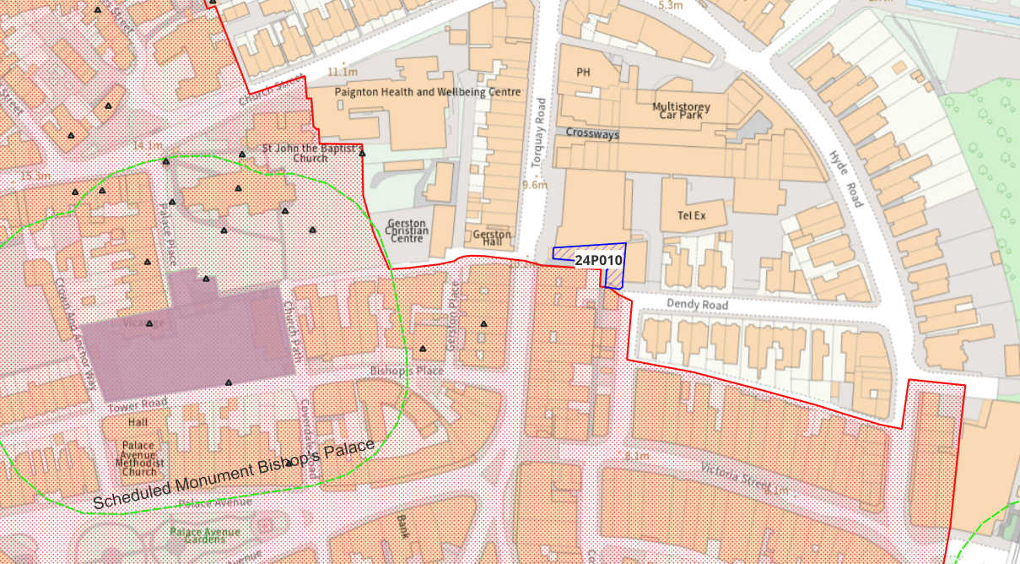
Site overview and heritage context:
The site is a small, vacant building on Torquay Road high street, formerly in use as a Halifax bank, which is offset from the road by a wide pavement area. The existing building is of a concrete construction, and its design is constrained by its use as a commercial unit, and its location ‘wedged’ into a small space between the large post office building, and the historic high street of the conservation area. It is situated within a commercial context, with the high street extending to the north and south along Torquay Road.
Old Paignton Conservation Area is immediately south of the site, and there are several Listed Buildings in the vicinity.

Planning History:
P/2024/0873 – Change of use from commercial, business and service to mixed use. Internal alterations to create 2 residential apartments – awaiting decision

Heritage Asset Affected by Allocation | Designation | Contributing Elements to Significance | Impact of Development on Significance | Mitigation Measures for any Identified Harm /Opportunities to Enhance Significance | Impact on Significance with Mitigation in place
Old Paignton Conservation Area (immediately S of site)  The Old Well Public House (SW of site)  Paignton  Community College (SW of site)  Churchyard Cross to the South East of Parish Church of St John The Baptist (W of site)  Churchyard Wall to Church of St John The Baptist (W of site) | Conservation Area  GII Listed Building  GII Listed Building  GII Listed Building  GII Listed Building | The Conservation Area is characterised by the mid-Victorian rush of development associated with the extension of the railway line that popularised Paignton as a fashionable resort town. The Conservation Area covers a wide range of development types, with the area nearest the site being defined by the start of the commercial high street area.  The high street to the immediate south of the site is Victorian, containing several mid C19 commercial buildings some of which retain original features. Although greatly compromised by the trappings of modern commercial units. The row of commercial buildings to the immediate south of the site is identified as a key building group with some buildings dating from 1830.  The site in its current form has a low negative impact on the significance of the Conservation Area.  Late 1860s public house with C20 alterations. Occupies a prominent corner position on the high street, and the main elevations retain most of its historic features.  The site in its current form makes a limited contribution to the setting and significance of this heritage asset  1908 building, formerly the Paignton School of Art and Science. Local red breccia construction, designed in a C17 style. Of particular note are the series of sgraffito panels extending the full length of the building that illustrate the disciplines of Applied Design, Sculpture, Painting and Architecture.  The site in its current form makes a limited contribution to the setting and significance of this heritage asset.  C18-C19 churchyard wall constructed of local red breccia rubble with toothed capping.  The site in its current form makes a limited contribution to the setting and significance of this heritage asset  Churchyard cross with Medieval shaft and base, and crosspiece restored in C19 or C20. Granite on red breccia plinth.  The site in its current form makes a limited contribution to the setting and significance of this heritage asset | Development of the site to the stated quantum would require significant ‘building up’ of the site. This would cause less than substantial harm to the significance of the Conservation Area.  Development of the site to the stated quantum would require significant ‘building up’ of the site. This would cause less than substantial harm to the significance of the heritage asset.  Development of the site to the stated quantum would require significant ‘building up’ of the site. This would cause less than substantial harm to the significance of the heritage asset.  Development of the site to the stated quantum would require significant ‘building up’ of the site. This would cause less than substantial harm to the significance of the heritage asset.  Development of the site to the stated quantum would require significant ‘building up’ of the site. This would cause less than substantial harm to the significance of the heritage asset. | The existing site already has a negative impact on the heritage setting. A reduction in the quantum of development, with high quality and well thought out design could reduce the level of harm to result in a neutral impact.  A reduction in the quantum of development, with high quality and well thought out design could reduce the level of harm to result in a neutral impact.  A reduction in the quantum of development, with high quality and well thought out design could reduce the level of harm to result in a neutral impact.  A reduction in the quantum of development, with high quality and well thought out design could reduce the level of harm to result in a neutral impact.  A reduction in the quantum of development, with high quality and well thought out design could reduce the level of harm to result in a neutral impact. | Neutral  Neutral  Neutral  Neutral  Neutral

