Heritage Impact Assessment: Barton Pines
HELAA2021 Ref: | 24P006
Site Address: | Barton Pines, Blagdon Road
Site Area (ha): | 7.49
Site Yield: | 50
HIA Assessment

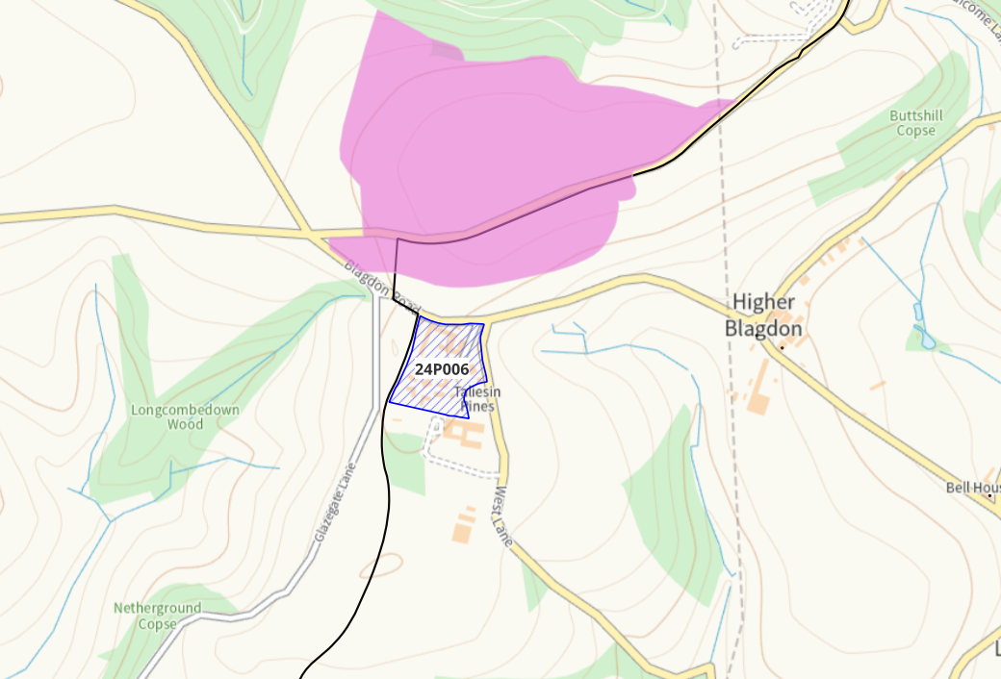
Site overview and heritage context:
The site is in an isolated position on the eastern edge of the local authority boundary and is surrounded on all sides by open land, mostly in agricultural use. The site itself contains several self-contained units of accommodation and was formerly in use as holiday accommodation but is now vacant. The site is flat, and views somewhat shielded by mature hedges along West Lane, and a wall that runs along Blagdon Road. To the immediate south of the site is a residential development of 19 flats. The site is situated on a hill with views across nearby Higher and Lower Blagdon and further towards Paignton to the east.
Across Blagdon Road to the north of the site is Scheduled Monument ‘Two prehistoric hilltop enclosures, a ditch system and four bowl barrows, 300m north of Barton Pines Inn’. The proximity of this prehistoric settlement gives this site high archeological potential. There are two GII listed buildings in Higher Blagdon approx. 400m to the east which may have line of sight to the site due to its prominent position on the hill.

Planning History:
P/2008/1217 – Formation of holiday village. Approved 25/11/2008. Several applications for amendments and variations follow until 2017.

Heritage Asset Affected by Allocation | Designation | Contributing Elements to Significance | Impact of Development on Significance | Mitigation Measures for any Identified Harm /Opportunities to Enhance Significance | Impact on Significance with Mitigation in place
Two prehistoric hilltop enclosures, a ditch system and four bowl barrows, 300m north of Barton Pines Inn  (N of site)  Peach Cottage (E of site)  Higher Blagdon Farmhouse (E of site) | Scheduled Monument  GII Listed Building  GII Listed Building | The Scheduled Monument includes four late Neolithic to Bronze Age bowl barrows, overlaid by a complex group of prehistoric settlement and stock enclosures. The monument survives as slight earthworks with buried features visible as cropworks. The Monument has suffered some damage due to ploughing but generally survives well. It occupies an area of approx. 15.7 ha. of combination open land and wooded areas.  Hilltop enclosures of this type are important archaeological sites which are unrecorded outside England. They contribute to our understanding of Bronze Age settlement and farming practices.  The road that bisects the monument is excluded from the scheduling, although the ground beneath it is included. Increased traffic on this road may have a negative impact on the heritage asset, and associated road works may require Scheduled Monument Consent.  The current development on the proposed site has a moderate impact on the setting of the Scheduled Monument, but further development of the site would negatively impact the setting.  Late C18 farm cottage associated with Higher Blagdon Farmhouse. Line of sight is shielded by hedgerows, but site may be visible from upper floors of the building.  Farmhouse constructed c.1840. Line of sight is shielded by hedgerows, but site may be visible from upper floors of the building. | The development of the site to the quantum proposed would have a demonstrable impact on the setting of the Scheduled Monument. This would cause ‘less than substantial’ harm to its significance.  The development of the site to the quantum proposed would have a limited impact on the direct setting and significance of the asset. The impact of the development would likely be neutral.  The development of the site to the quantum proposed would have a limited impact on the direct setting and significance of the asset. The impact of the development would likely be neutral. | A reduced quantum of development limited to the S of the site with a landscape buffer between the development and the Scheduled Monument may reduce the level of harm to its significance so as to have a neutral effect.  n/a  n/a | Neutral  Neutral  Neutral

