Heritage Impact Assessment: 12-14 Victoria Street
HELAA2021 Ref: | 24P005
Site Address: | 12-14 Victoria Street, Paignton
Site Area (ha): | 0.04
Site Yield: | 12
HIA Assessment

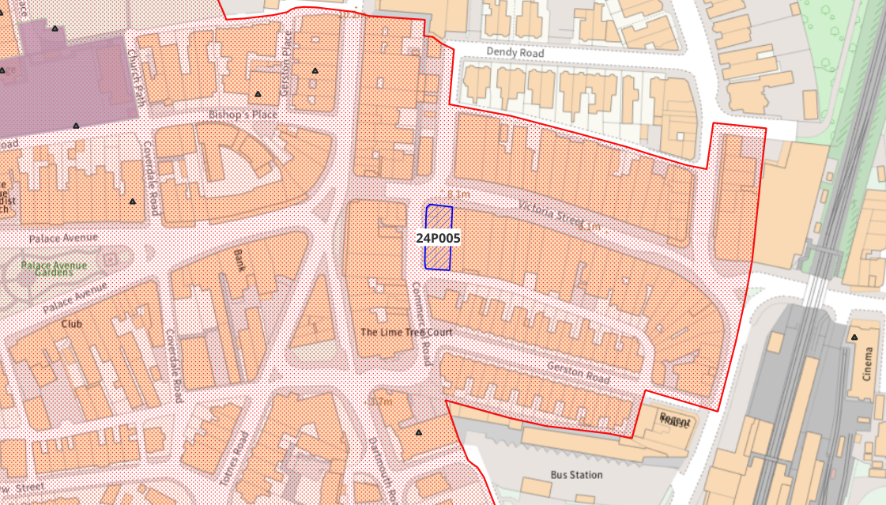
Site overview and heritage context:
The site is located in the heart of Paignton Town Centre and consists of a 3-story end-of-terrace building set on a corner plot facing Victoria Street to the front, with Commercial Road to the side. The existing building is finished in painted render, with a mix of slate pitched roofs and flat roofing which matches the roofline of others in the terrace. The lower floor of the site is in retail use, while the upper floors have previously been used as offices.
The site is within the Old Paignton Conservation Area, and there are several GII Listed Buildings nearby.

Planning History:
P/2024/0293 – Change of use from office to 12no residential flats with external alterations including two dormer windows. Permission granted 17/10/2024.

Heritage Asset Affected by Allocation | Designation | Contributing Elements to Significance | Impact of Development on Significance | Mitigation Measures for any Identified Harm /Opportunities to Enhance Significance | Impact on Significance with Mitigation in place
Old Paignton Conservation Area  United Reform Church and Adjoining School (S of site)  Paignton Community College (NW of site)  The Old Well House Public House (NW of site)  12-14 Victoria Street | Conservation Area  GII Listed Building  GII Listed Building  GII Listed Building  Non-Designated Heritage Asset | The Conservation Area is characterised by the mid-Victorian rush of development associated with the extension of the railway line that popularised Paignton as a fashionable resort town. The Conservation Area covers a wide range of development types, with the area nearest the site being defined by the start of the commercial high street area.  The site is located on Victoria Street which is identified in the Conservation Area Appraisal as the largest of the mid-century streets in the historic Town Centre, with the buildings constructed mostly in white brick with regular ornamentation. The Conservation Area Appraisal notes that this part of the Conservation Area is ‘on the whole a remarkably complete survival of late Victorian development, with only minor change’.  The Conservation Area Appraisal identifies the as a key building that makes a significant contribution to the Conservation Area.  1886 non-conformist chapel built to the designs of GS Bridgman. Constructed of local grey snecked limestone with Bathstone and red sandstone bands in a Gothic style.  The site makes a limited contribution to the setting and significance of this heritage asset.  1908 building, formerly the Paignton School of Art and Science. Local red breccia construction, designed in a C17 style. Of particular note are the series of sgraffito panels extending the full length of the building that illustrate the disciplines of Applied Design, Sculpture, Painting and Architecture.  The site makes a limited contribution to the setting and significance of this heritage asset.  Late 1860s public house with C20 alterations. Occupies a prominent corner position on the high street, and the main elevations retain most of its historic features.  The site makes a limited contribution to the setting and significance of this heritage asset.  Due to the historic and architectural features that have remained within the building, its prominent location within the street scene and its demonstrable group value with neighbouring buildings on the terrace, it is considered that 12-14 Victoria Street is a non-designation heritage asset. | The proposed yield of 12 could be achieved through the sensitive conversion of the site which would result in a neutral or minor positive impact to the significance of this asset.  The proposed yield of 12 could be achieved through the sensitive conversion of the site which would result in a neutral impact to the significance of this asset.  The proposed yield of 12 could be achieved through the sensitive conversion of the site which would result in a neutral impact to the significance of this asset.  The proposed yield of 12 could be achieved through the sensitive conversion of the site which would result in a neutral impact to the significance of this asset.  The proposed yield of 12 could be achieved through the sensitive conversion of the site which would result in a neutral or minor positive impact to the significance of this asset. | Opportunity to enhance significance through sensitive conversion of the site, preventing the building from falling into disrepair through disuse.  Opportunity to enhance significance through sensitive conversion of the site, preventing the building from falling into disrepair through disuse.  Opportunity to enhance significance through sensitive conversion of the site, preventing the building from falling into disrepair through disuse.  Opportunity to enhance significance through sensitive conversion of the site, preventing the building from falling into disrepair through disuse.  Opportunity to enhance significance through sensitive conversion of the site, preventing the building from falling into disrepair through disuse. | Neutral/Positive  Neutral  Neutral  Neutral  Neutral/Positive

