Heritage Impact Assessment: Oldway Mansion, Paignton
HELAA2021 Ref: | 24P004
Site Address: | Oldway Mansion, Paignton
Site Area (ha):
Site Yield: | 46
HIA Assessment

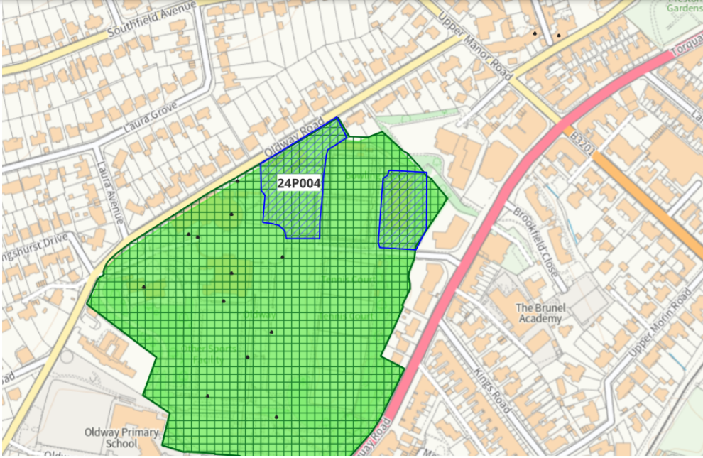
Site overview and heritage context:
Oldway Mansion sits within its own landscaped grounds with are a designated Registered Park & Garden. Throughout the grounds are various designated heritage assets associated with mansion and its history as the family home of the Singers, the inventors of the Singer sewing machine.
The site is relatively enclosed but is surrounded by development on all sides, it is predominantly accessed via Torquay Road but Oldway Road provides additional access.

Planning History:
P/2011/1020 and 21 - Use of Oldway Mansion, Rotunda and Stables as a 57 bed hotel with ancillary spa, conference and banqueting facilities, internal and external alterations, formation of entrance foyer to stables, restoration/refurbishment of existing glass conservatory. Demolition of squash courts. Improvements to car parking area - Oldway Mansion Torquay Road Paignton Devon TQ3 2TY – FINALLY DISPOSED OF 26/11/2024

Heritage Asset Affected by Allocation | Designation | Contributing Elements to Significance | Impact of Development on Significance | Mitigation Measures for any Identified Harm /Opportunities to Enhance Significance | Impact on Significance with Mitigation in place
Oldway Mansion  Oldway Mansion Garden  Former rising school and banqueting house at Oldway Mansion (N of site)  Grotto (SE of site)  Terrace walls and rustic seat at south end of south garden at Oldway Mansion (S of site)  Terrace wall, steps and statue south east of Oldway Mansion (S of site)  Terrace wall with 14 urns to terrace east and south east of Oldway Mansion (SE of site)  Walls, steps and sphinxes to garden south of Oldway Mansion (S of site)  Courtyard arch and screen walls at west end of Oldway Mansion courtyard (NW of site)  Lamp standard immediately west of courtyard archway at Oldway Mansion (NW of site)  Walls to entrance to Oldway Mansion (N of site)  Little Oldway (W of site) | Grade II* listed building  Grade II Park and Garden  Grade II listed building  Grade II listed building  Grade II listed building  Grade II listed building  Grade II listed building  Grade II listed building  Grade II listed building  Grade II listed building  Grade II listed building  Grade II listed building | The asset has clear historic, communal evidential and artistic value through its survival of interior decorative features, early use of building technologies, its link with the internationally renowned Singer family and historic uses and connection with the Palace of Versailles.  Early C20 gardens and pleasure grounds for which the design was supplied by Achille Duchene. The significance of this asset relates to the mansion, its ancillary buildings, associated garden structures (most of which are listed separately) and the garden itself.  The garden and associated structures have clear architectural, historic, communal and artistic values all of which make up its significance.  Riding school and banqueting hall, riding school now used. 1874 by GS Bridgman for Isaac Singer. The asset has a close association with the mansion and has a positive impact on its significance.  Grotto. 1907-1910, contemporary with the remodelling of Oldway Mansion and forming part of the landscaped grounds.  The asset has a close association with the mansion and has a positive impact on its significance.  Terrace walls, steps and rustic seat at the south end of the garden south of Oldway Mansion (qv). 1904-1907, contemporary with the remodelling of Oldway Mansion (qv) for Paris Singer.  The asset has a close association with the mansion and has a positive impact on its significance.  Terrace wall to terrace SE of Oldway Mansion, including flight of steps and statue of Pan and Bacchus. c1907-1907, contemporary with the remodelling of Oldway Mansion (qv) for Paris Singer.  The asset has a close association with the mansion and has a positive impact on its significance.  Terrace walls, incorporating flight of steps, surmounted by urns. c1904-1907, probably contemporary with the remodelling of Oldway Mansion for Paris Singer.  The asset has a close association with the mansion and has a positive impact on its significance.  Walls to garden S of Oldway Mansion, including flights of steps and sphinxes. c1907-1907, contemporary with the remodelling of Oldway Mansion (qv) for Paris Singer.  The asset has a close association with the mansion and has a positive impact on its significance.  Triumphal arch with screen walls at the W end of the courtyard to Oldway Mansion (qv). 1904-1907, contemporary with the remodelling of the house for Paris Singer  The asset has a close association with the mansion and has a positive impact on its significance.  Lamp standard. Probably 1904-1907, contemporary with the remodelling of Oldway for Paris Singer.  The asset has a close association with the mansion and has a positive impact on its significance.  Walls. 1870s, contemporary with the building of Oldway Manor in 1874 to the designs of GS Bridgman for Isaac Singer. Local red breccia, with some grey limestone toothed capping, some brick and some concrete balustrading. The walls bound the site of Oldway Mansion on the Oldway Road side. Have group value with Oldway Mansion and associated structures.  The asset has a close association with the mansion and has a positive impact on its significance.  Villa, in use as old people's home. c1850 with 1870s alterations for Isaac Merritt Singer (qv Oldway Mansion). Isaac Merritt Singer lived here while Oldway Mansion (qv), immediately to the E, was built for him and therefore the two sites share a close historic relationship and has a positive impact on its significance. | The proposed quantum of development would likely require significant alterations to the internal plan form of the asset and potential loss of surviving historic fabric, this would result in harm to its significance of varying degrees.  The proposed quantum of development would likely have a detrimental impact on the architectural value of the mansion and would likely result in increased pressure for car parking and associated infrastructure within the site. This is likely to result in less than substantial harm to the significance of the asset.  The proposed quantum of development would likely have a detrimental impact on the architectural value of the mansion and would likely result in increased pressure for car parking and associated infrastructure within the site. This is likely to result in less than substantial harm to the significance of the asset.  The proposed quantum of development would likely have a detrimental impact on the architectural value of the mansion and would likely result in increased pressure for car parking and associated infrastructure within the site. This is likely to result in less than substantial harm to the significance of the asset.  The proposed quantum of development would likely have a detrimental impact on the architectural value of the mansion and would likely result in increased pressure for car parking and associated infrastructure within the site. This is likely to result in less than substantial harm to the significance of the asset.  The proposed quantum of development would likely have a detrimental impact on the architectural value of the mansion and would likely result in increased pressure for car parking and associated infrastructure within the site. This is likely to result in less than substantial harm to the significance of the asset.  The proposed quantum of development would likely have a detrimental impact on the architectural value of the mansion and would likely result in increased pressure for car parking and associated infrastructure within the site. This is likely to result in less than substantial harm to the significance of the asset.  The proposed quantum of development would likely have a detrimental impact on the architectural value of the mansion and would likely result in increased pressure for car parking and associated infrastructure within the site. This is likely to result in less than substantial harm to the significance of the asset.  The proposed quantum of development would likely have a detrimental impact on the architectural value of the mansion and would likely result in increased pressure for car parking and associated infrastructure within the site. This is likely to result in less than substantial harm to the significance of the asset  The proposed quantum of development would likely have a detrimental impact on the architectural value of the mansion and would likely result in increased pressure for car parking and associated infrastructure within the site. This is likely to result in less than substantial harm to the significance of the asset  The proposed quantum of development would likely have a neutral impact on the significance of the asset.  The proposed quantum of development would likely have a neutral impact on the significance of the asset. | A significant reduction in the quantum of development to 16 apartments as advised within the associated masterplan for the asset would likely result in a neutral to positive impact on its significance.  A significant reduction in the quantum of development to 16 apartments as advised within the associated masterplan for the asset would likely result in a neutral to positive impact on its significance.  A significant reduction in the quantum of development to 16 apartments as advised within the associated masterplan for the asset would likely result in a neutral impact on its significance.  A significant reduction in the quantum of development to 16 apartments as advised within the associated masterplan for the asset would likely result in a neutral impact on its significance.  A significant reduction in the quantum of development to 16 apartments as advised within the associated masterplan for the asset would likely result in a neutral impact on its significance.  A significant reduction in the quantum of development to 16 apartments as advised within the associated masterplan for the asset would likely result in a neutral impact on its significance.  A significant reduction in the quantum of development to 16 apartments as advised within the associated masterplan for the asset would likely result in a neutral impact on its significance.  A significant reduction in the quantum of development to 16 apartments as advised within the associated masterplan for the asset would likely result in a neutral impact on its significance.  A significant reduction in the quantum of development to 16 apartments as advised within the associated masterplan for the asset would likely result in a neutral impact on its significance.  A significant reduction in the quantum of development to 16 apartments as advised within the associated masterplan for the asset would likely result in a neutral impact on its significance.  n/a  n/a | Neutral/positive  Neutral/positive  Neutral  Neutral  Neutral  Neutral  Neutral  Neutral  Neutral  Neutral  Neutral  Neutral

