**Heritage Impact Assessment:** Land at Long Road and Stoke Road, Paignton

|  |  |
| --- | --- |
| **HELAA2021 Ref:** | 24P001 |
| **Site Address:** | Land at Long Road and Stoke Road, Paignton |
| **Site Area (ha):** | 4.48 |
| **Site Yield:** | 200 |
| **HIA Assessment** |  |

**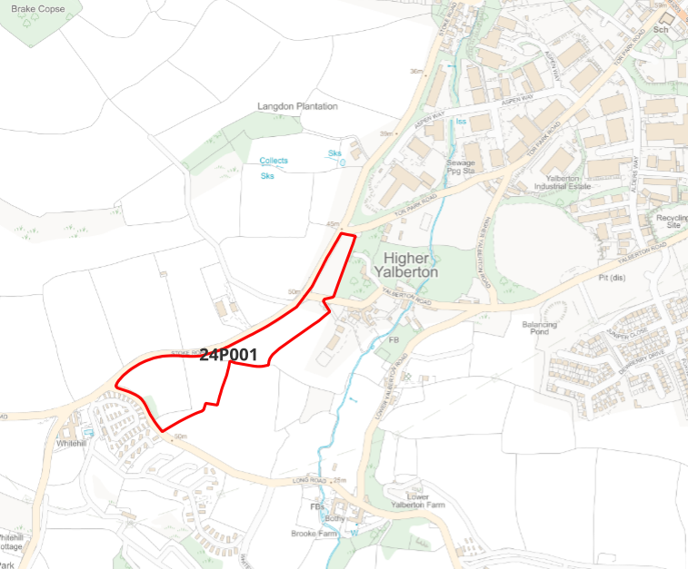  
  
Site overview and heritage context:**

The site is a series of four undeveloped fields situated in the Higher Yalberton area towards the edge of the Torbay area. The site is bounded by Stoke Road to the north and open fields to the south. Existing residential development in the area is limited, with the historic hamlet of Higher Yalberton to the north east, and modern development of a caravan park to the south and an industrial complex to the north. The character of the site is overwhelmingly rural, with open fields on two sides and uninterrupted views southwards across the countryside.

The site is within the setting of several GII Listed Buildings. The site does not sit within or near any current Conservation Areas, however the Yalberton Valley area is being considered for designation as a Conservation Area as part of the ongoing Conservation Area review process. The surrounding area has evidence of medieval field systems, and any development should include a course of archeological investigation prior to commencement.

**Planning History:**

|  |  |  |  |  |  |
| --- | --- | --- | --- | --- | --- |
| **Heritage Asset Affected by Allocation** | **Designation** | **Contributing Elements to Significance** | **Impact of Development on Significance** | **Mitigation Measures for any Identified Harm /Opportunities to Enhance Significance** | **Impact on Significance with Mitigation in place** |
| Higher Yalberton Farmhouse and Attached Outbuilding to East  Yalberton Farmhouse  Barn, Linhay and Stable South of Higher Yalberton Farmhouse  Barn Immediately to South of West Yalberton Farmhouse  Cider Barn at Higher Yalberton Farm | GII Listed Building  GII Listed Building  GII Listed Building  GII Listed Building  GII Listed Building | Mid 19th Century farmhouse constituting the largest building within the historic hamlet of Higher Yalberton. In a state of disrepair but nevertheless retains many original features of note. The site occupies a slightly elevated position in relation to the farmhouse, and its north-eastern area is only 40 meters away. Incorrectly pinned on HE mapping.  The site is directly within the setting of this listed building. Its existing undeveloped character makes a positive contribution to the significance of the listed building by enhancing its rural setting.  Mid 16th-17th century farmhouse, extended in early 19th century. Part cob with thatched roof, part stucco with slate roof. High survival of original features inside and out.  The site is directly within the setting of this listed building. Its existing undeveloped character makes a positive contribution to the significance of the listed building by enhancing its rural setting.  19th century barn ancillary to Higher Yalberton Farmhouse, now converted to residential use. Some original features of interest retained.  The site is directly within the setting of this listed building. Its existing undeveloped character makes a positive contribution to the significance of the listed building by enhancing its rural setting.  19th century barn ancillary to Higher Yalberton Farmhouse, now converted to residential use. Some original features of interest retained.  The site is directly within the setting of this listed building. Its existing undeveloped character makes a positive contribution to the significance of the listed building by enhancing its rural setting.  19th century barn ancillary to Higher Yalberton Farmhouse. Some original features of interest retained. Incorrectly pinned on HE mapping.  The site is directly within the setting of this listed building. Its existing undeveloped character makes a positive contribution to the significance of the listed building by enhancing its rural setting. | Development of the site to the stated quantum would have a significant impact on the rural character of the setting of the listed building.  This would amount to a degree of less than substantial harm.  Development of the site to the stated quantum would have a significant impact on the rural character of the setting of the listed building.  This would amount to a degree of less than substantial harm.  Development of the site to the stated quantum would have a significant impact on the rural character of the setting of the listed building.  This would amount to a degree of less than substantial harm.  Development of the site to the stated quantum would have a significant impact on the rural character of the setting of the listed building.  This would amount to a degree of less than substantial harm.  Development of the site to the stated quantum would have a significant impact on the rural character of the setting of the listed building.  This would amount to a degree of less than substantial harm. | The degree of harm could be mitigated by reducing the quantum of development and limiting it to the two eastern fields. Substantial landscaping to retain the rural character of the area would further reduce the impact.  The degree of harm could be mitigated by reducing the quantum of development and limiting it to the two eastern fields. Substantial landscaping to retain the rural character of the area would further reduce the impact.  The degree of harm could be mitigated by reducing the quantum of development and limiting it to the two eastern fields Substantial landscaping to retain the rural character of the area would further reduce the impact.  The degree of harm could be mitigated by reducing the quantum of development and limiting it to the two eastern fields. Substantial landscaping to retain the rural character of the area would further reduce the impact.  The degree of harm could be mitigated by reducing the quantum of development and limiting it to the two eastern fields. Substantial landscaping to retain the rural character of the area would further reduce the impact. | Neutral  Neutral  Neutral  Neutral  Neutral |