Heritage Impact Assessment: Former Palace Hotel, Torquay
HELAA2021 Ref: | 23T008
Site Address: | Former Palace Hotel, Babbacombe Road
Site Area (ha): | 18.5
Site Yield: | 70
HIA Assessment

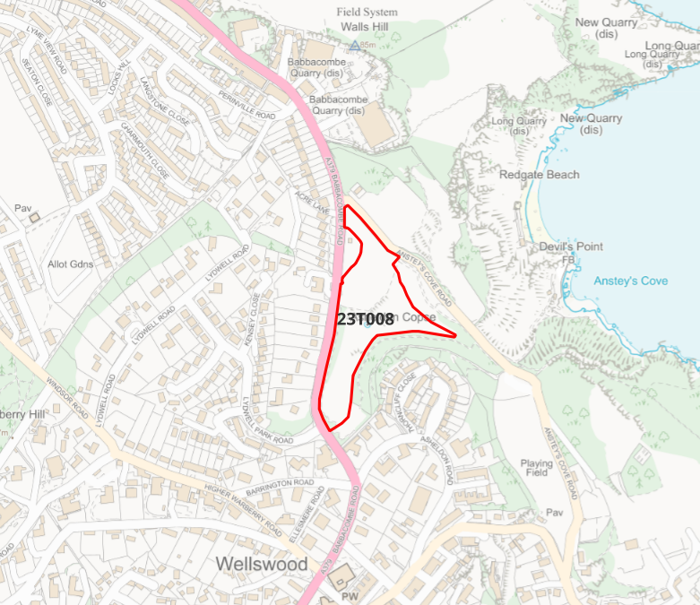
Site overview and heritage context:
The site is bounded by Anstey’s Cove Road to the east and Babbacombe Road to the west, and vhas been cleared for building. Woodland provides screening to the south and east, and mature hedges shield the site from the road to the west. To the north is a new development of 38 dwellings developed by the same landowner. Permission has already been granted for formation of a 248 bedroom hotel on this site, however the landowner has stated they are revising these plans in favour of a residential development on this site. No plans have been submitted to date.
To the south of the site is a GII* church, and there are scheduled monuments to the south-east and north-east. The Conservation Areas of Warberries and Lincombes are to the immediate south of the site.

Planning History:
P/2019/0716 – Demolition of former hotel and associated buildings. Formation of 248 bedroom hotel, 38 dwellings, associate landscaping and works – Granted Feb 2020

Heritage Asset Affected by Allocation | Designation | Contributing Elements to Significance | Impact of Development on Significance | Mitigation Measures for any Identified Harm /Opportunities to Enhance Significance | Impact on Significance with Mitigation in place
Warberries Conservation Area  Lincombes Conservation Area  Prehistoric Field System at Walls Hill  Kents Cavern  Parish Church of St Matthias | Conservation Area  Conservation Area  Scheduled Monument  Scheduled Monument  GII* Listed Building | The site sits within the wider setting of the Conservation Area and makes a limited contribution to its significance.  The site sits within the wider setting of the Conservation Area and makes a limited contribution to its significance.  The prehistoric field system here survives well as low earthworks, especially to the south. The significance of the site derives from its near complete survival which is unusual in Devon.  The verdant nature of the site makes a limited contribution to the significance of the scheduled monument.  The site sits within the wider setting of the Kents Cavern, and makes a limited contribution to its significance.  The site sits within the wider setting of the Listed Building, and makes a limited contribution to its significance. | Development of the site to the quantum stated could be achieved through sensitive design which maintains the verdant backdrop of the site. This would have a neutral impact on the significance of the asset.  Development of the site to the quantum stated could be achieved through sensitive design which maintains the verdant backdrop of the site. This would have a neutral impact on the significance of the asset.  The site is shielded from the heritage asset by the associated residential development to the north which reduces the site’s impact on the asset. Development of the site to the quantum stated could be achieved through sensitive design which maintains the verdant backdrop of the site. Development of the site would result in a neutral impact.  Development of the site to the quantum stated could be achieved through sensitive design which maintains the verdant backdrop of the site. This would have a neutral impact on the significance of the asset.  Development of the site to the quantum stated would have a neutral impact on the significance of the asset. | N/A  N/A  N/A  N/A  N/A | Neutral  Neutral  Neutral  Neutral  Neutral

