Heritage Impact Assessment: Land North of Brunel Manor, Torquay
HELAA2021 Ref: | 23T007
Site Address: | Land North of Brunel Manor, Torquay
Site Area (ha): | 0.47
Site Yield: | 15
HIA Assessment

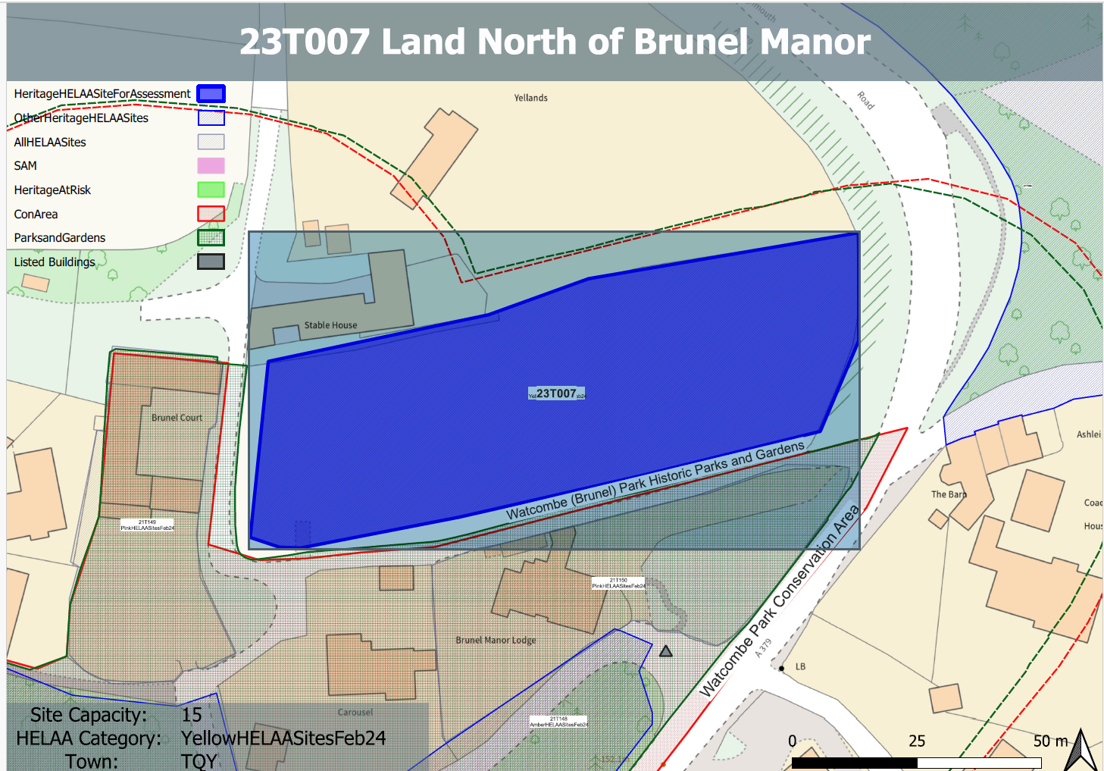
Site overview and heritage context:
The site is rectangular in shape and has a slight rise in ground levels to the west and north. It is accessed from a narrow lane off Teignmouth Road. It is currently laid to pasture and bounded by hedgerow to the north, mature trees to the east and timber post and rail fencing to the west.
The Watcombe Park Registered Park and Garden can be found adjacent to the site to the south and west, Watcombe Park Conservation Area is to the south and Brunel Manor and associated garden features are Grade II listed buildings located within their own grounds to the south.
The site has remained undeveloped and appears to be an open space historically associated with a stable bordering the site to the north and Brunel Court to the west.
With regards to archaeology, it is described as being a modern enclosure which has been created by adapting earlier fields of probable post-medieval date.

Planning History:
P/1980/1856 – One dwelling – Refused: 26/08/1980

Heritage Asset Affected by Allocation | Designation | Contributing Elements to Significance | Impact of Development on Significance | Mitigation Measures for any Identified Harm /Opportunities to Enhance Significance | Impact on Significance with Mitigation in place
Watcombe Park and Brunel Manor (S and W of site)  Watcombe Park Conservation Area  (S of site)  Gate Piers and wall at entrance to Brunel Manor  Brunel Court  ‘ | Registered Park and Garden  Conservation Area  Grade II listed building  Non-designated heritage asset | Mid C19 parkland, arboretum and gardens laid out by Isambard Kingdom Brunel and his head gardener with many principal features surviving. The northern boundary of the RPG can be found immediately to the south and west of the site. The site contributes to the rural setting of the RPG and likely has a historic relationship with Brunel Court, the former stable block to Brunel Manor. Although the site is now separated from the former stable, their historic relationship can still be read and therefore it makes a demonstrable positive influence to the significance of the RPG  Conservation area incorporating Brunel Manor and its historic parkland and elements of the settlement of Watcombe, including Mayfield School. The northern boundary of the conservation area can be found immediately to the south and west of the site. The site contributes to the rural setting of the conservation area and likely has a historic relationship with Brunel Court which is identified as a key building within the conservation area. This is the former stable block to Brunel Manor. Although the site is now separated from the former stable, their historic relationship can still be read and therefore it makes a demonstrable positive influence to the significance of the conservation area.  Constructed in 1870 and contemporary with Brunel Manor. Have a clear group value with Brunel Manor, also Grade II listed. The site forms a rural backdrop to the piers and makes a minor positive contribution to its significance.  Late 19th century stable block now converted to apartments. Built around three sides of a rectangular courtyard with a tall arched entrance. Has demonstrable architectural and historic value and group value with Brunel Manor and its associated estate. Although the site is now separated from the former stable, their historic relationship can still be read and therefore it makes a clear demonstrable positive influence to its significance. | The development of the site would further divorce it from its historic relationship with Brunel Court and would permanently alter its character and the contribution that the site as undeveloped open space makes to the significance of the asset. Its development would cause a degree of less than substantial harm to this significance.  The development of the site would further divorce it from its historic relationship with Brunel Court and would permanently alter its character and the contribution that the site as undeveloped open space makes to the significance of the asset. Its development would cause a degree of less than substantial harm to this significance.  The development of the site would have a detrimental impact to the rural setting of the asset and would erode the readable historic landscape within the immediate area. This would cause a minor degree of less than substantial harm to its significance.  The development of the site would further divorce it from its historic relationship with this asset and would permanently alter its character and the contribution that the site as undeveloped open space makes to its significance. Its development would cause a high degree of less than substantial harm to this significance. | As any quantum of proposed development would have a detrimental impact to the significance of the asset, it is not considered that any mitigation could be employed to remove the harmful impacts of the development.  As any quantum of proposed development would have a detrimental impact to the significance of the asset, it is not considered that any mitigation could be employed to remove the harmful impacts of the development.  As any quantum of proposed development would have a detrimental impact to the significance of the asset, it is not considered that any mitigation could be employed to remove the harmful impacts of the development.  As any quantum of proposed development would have a detrimental impact to the significance of the asset, it is not considered that any mitigation could be employed to remove the harmful impacts of the development. | Less than substantial harm  Less than substantial harm  Less than substantial harm  Less than substantial harm

