Heritage Impact Assessment: Land Between Rock House Land and Brim Hill, Maidencombe, Torquay
HELAA2021 Ref: | 23T006
Site Address: | Land Between Rock House Land and Brim Hill, Maidencombe, Torquay
Site Area (ha): | 1.17
Site Yield: | 10
HIA Assessment

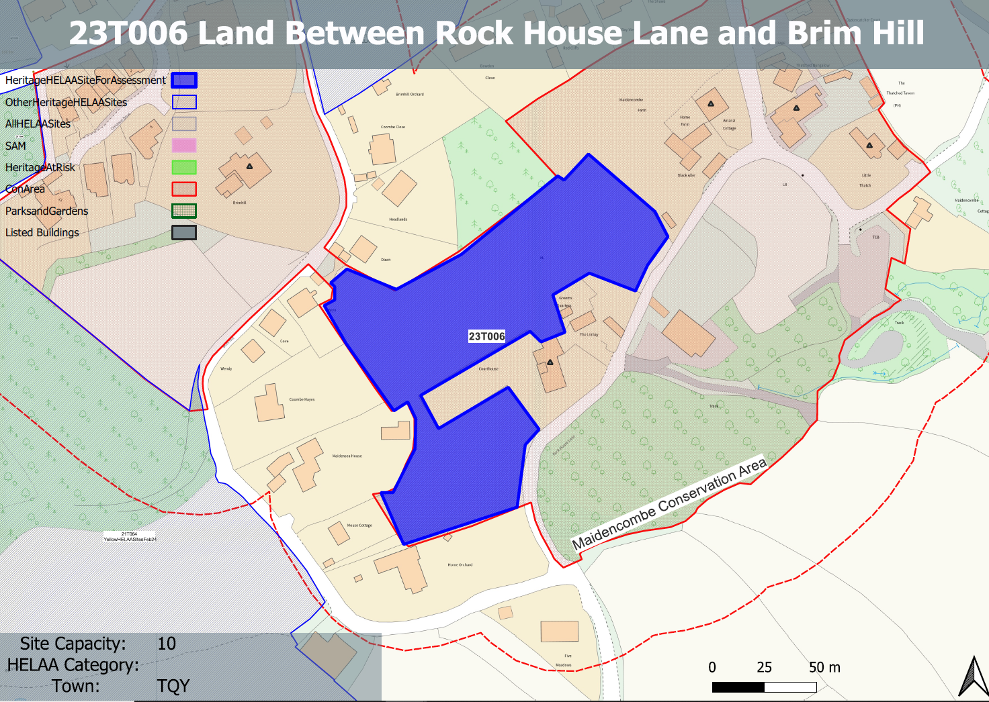
Site overview and heritage context:
The site is a piece of undeveloped land in centre of Maidencombe and would be accessed from Rock House Lane. The site wraps around the Grade II listed Court House to the north, west and south and sits in an elevation position above it. The site is sloped with the highest points on its northern boundary.
The site has a close relationship with the Court House and historic shows that its forms part of its curtilage. It is characteristic of the landscape of small fields enclosed by hedgerows found within the area.
It sits within the Maidencombe Conservation Area and there are a number of designated heritage assets nearby to the NW and NE. The site also includes trees identified as being of some value within the Maidencombe Conservation Area Character Appraisal.
Court House is presumed to contain the remains of an earlier Manor House, parts of which may date back to the 14th century and so the site may hold some archaeological potential.
The Courthouse’s former farm outbuildings: ‘Grooms’ Quarters’ and ‘The Linhay’ have been converted, the former for holiday use; the three all form an attractive group.

Planning History:
P/1988/0796 – Conversion of Linhay to a dwelling – Approved: 22/06/1988

Heritage Asset Affected by Allocation | Designation | Contributing Elements to Significance | Impact of Development on Significance | Mitigation Measures for any Identified Harm /Opportunities to Enhance Significance | Impact on Significance with Mitigation in place
Maidencombe Conservation Area  Brimhill  (W of site)  Court House  (S an E of site)  Maidencombe Farmhouse  (N of site)  The Thatched Tavern Public House  (NE of site)  Little Thatch  (NE of site) | Conservation Area  Grade II listed building  Grade II listed building  Grade II listed building  Grade II listed building  Grade II listed Building | The conservation area comprises two distinct areas; the original settlement and historic hamlet, which is mostly grouped around Rock House Lane and Steep Hill, and a scattering of 19th century villas in landscaped grounds to the north. The steeply sloping wooded hillsides create an imposing skyline which encloses the  village, especially to the south and west including the large expanse of Sladnor Park.  The character of much of the conservation area hinges upon its ability to retain the  strong sense of geographical isolation and historic continuity in a setting of great natural  beauty and landscape importance. The landscape value of the conservation area and its rural surroundings is a key special characteristic. The site, sits within the conservation and makes a positive contribution to the rural character of the conservation area. It makes a positive contribution to the asset’s significance.  Villa constructed in the 1830s. The site forms part of the wider rural and historic setting of the asset and makes a minor contribution to its significance.  Late 16th century house, extended and altered in the 20th century. The site forms part of the immediate setting of the asset and shares a close relationship with it. It makes a clear positive contribution to its significance.  Late 18th century farmhouse. The site forms part of the rural and historic setting of the asset and makes a positive contribution to its significance.  18th century house with likely earlier core, constructed as a house but now in use as a public house. The site forms part of the wider rural and historic setting of the asset but makes a limited contribution to its significance.  18th century house. The site forms part of the wider rural and historic setting of the asset but makes a limited contribution to its significance.  . | The development of the site would have a detrimental impact on the rural character of the conservation area and would be contrary to the pattern of development found within the area. This would cause less than substantial harm to the significance of the asset.  Development on the site could have an impact on the rural setting of the asset, the degree of impact would be dependent on the scale, massing, appearance and layout of the proposal along with any associated infrastructure. This is could impact on how the asset is experienced in middle and long distance views and therefore is likely to cause a degree of less than substantial harm to its significance.  The development of the site would have a clear detrimental impact on the setting of the asset and its relationship with the asset. The historic links to the asset would be lost and its sense of visual isolation within the area would be lost. This would cause a high level of less than substantial harm to the asset.  The development of the site would have a detrimental impact on the rural and historic setting of the asset and would cause less than substantial harm to its significance.  The development of the site would have a neutral impact on the significance of the asset.  The development of the site would have a neutral impact on the significance of the asset. | The loss of the open character of the site as a result of any built development would still result in a level of less than substantial harm to the significance of the conservation area.  A small quantum of development on the southern parcel of the land which is landscape-led and is of limited scale and massing could mitigate harm to the point where the development would have a neutral impact.  The detrimental impact as a result of any built development on the site would still result in a level of less than substantial harm to the significance of the asset.  A small quantum of development on the southern parcel of the land which is landscape-led and is of limited scale and massing could mitigate harm to the point where the development would have a neutral impact.  n/a  n/a | Less than substantial harm  Neutral  Less than substantial harm.  Neutral  Neutral  Neutral

