Heritage Impact Assessment: Steps Cross Playing Field, Moor Lane, Watcombe, Torquay
HELAA2021 Ref: | 23T005
Site Address: | Steps Cross Playing Field, Moor Lane, Watcombe, Torquay
Site Area (ha): | 2.14
Site Yield: | 40
HIA Assessment

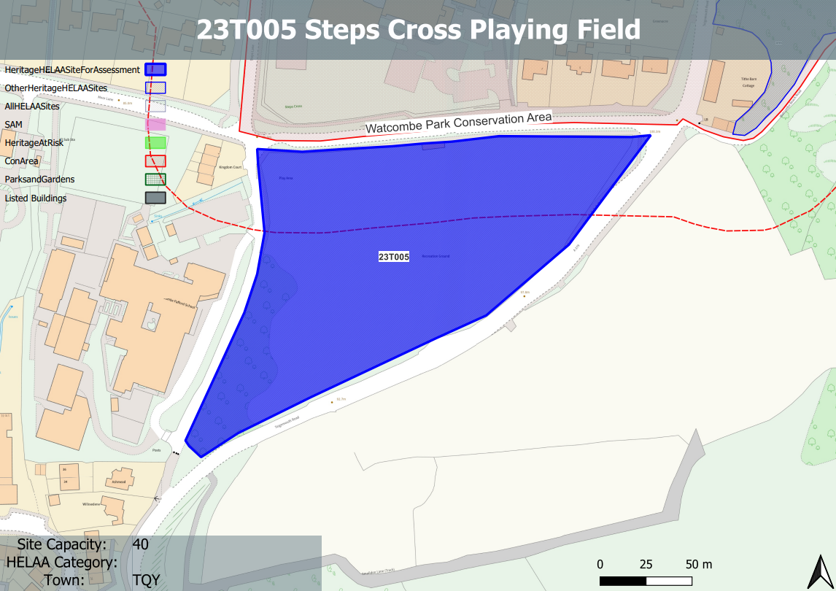

Site overview and heritage context:
The site is located between Teignmouth Road and Moor Lane in Watcombe. It is a piece of undeveloped open land currently used as a playing field. The area is bounded by hedges which screen views to the site from two schools to the immediate north and west. The site is relatively flat with a small slope up towards Teignmouth Road on the eastern side.
The site is bordered on the northern side by Watcombe Conservation Area. There are no other designated heritage assets in the immediate vicinity.
The area has some archaeological potential, with the Historic Environment Record identifying an area of several curvilinear banks and ditches that are interpreted as the remains of medieval field boundaries which intersect the southern part of the site and continue southwards towards Torquay Golf Course. 4th Century Roman coins have been found approx. 200m south of the site.

Planning History:

Heritage Asset Affected by Allocation | Designation | Contributing Elements to Significance | Impact of Development on Significance | Mitigation Measures for any Identified Harm /Opportunities to Enhance Significance | Impact on Significance with Mitigation in place
Watcombe Park Conservation Area | Conservation Area | The conservation area has demonstrable historic value through its association with Brunel, architectural value through the surviving historic built environment and artistic value through its designed landscape in association with Brunel Manor.  The site is an area of open space just outside the conservation area which contributes to the rural character of the area and makes a positive contribution to the significance of the asset. | The development of the site to the stated quantum would have a detrimental impact on the existing open space within the site and would dilute its rural character. This would cause less than substantial harm to the significance of the conservation area. | A reduction in the quantum of development with dwellings set within open space would retain the rural character of the site could reduce the level of harm to result in a neutral impact. | Neutral

