Heritage Impact Assessment: Land at Nutbush Lane, Torquay
HELAA2021 Ref: | 23T002
Site Address: | Land SW of Nutbush Lane and west of Armada Park
Site Area (ha): | 18.5
Site Yield: | 200
HIA Assessment

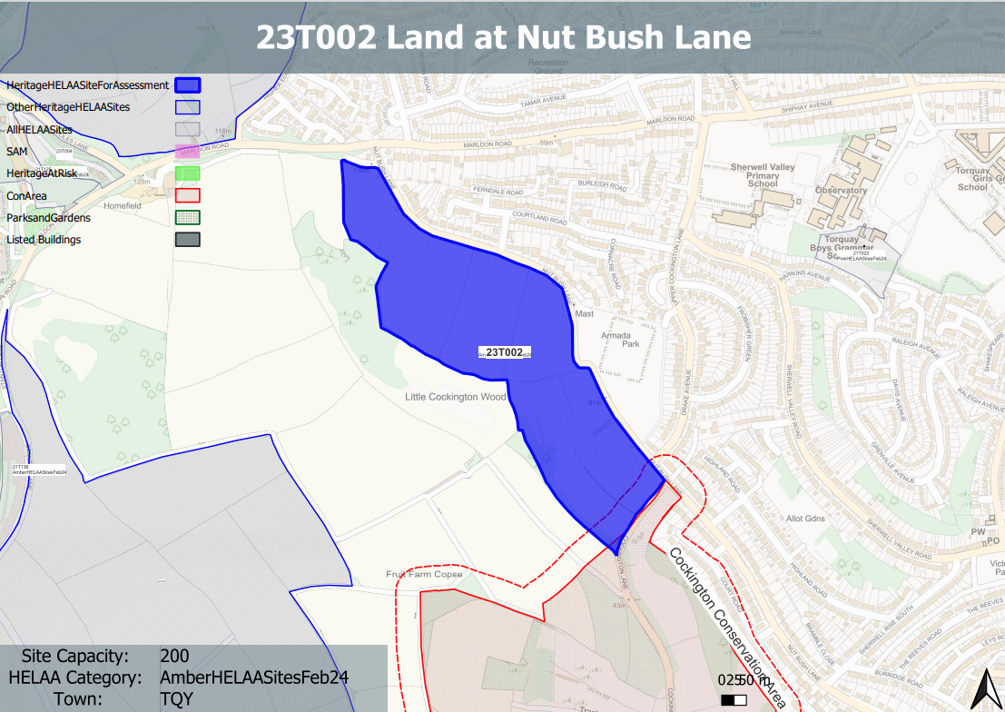
Site overview and heritage context:
The site is part of the wider area of Cockington Country Park and is located on the eastern slope of Cockington Valley, to the north of the Cockington Conservation Area. The site slopes gently up towards the north-east.
The northern half of the site is in agricultural use, with the remaining consisting of a mixture of open land, woodland and scrub. Views to the site are shielded on most sides by mature hedges, with the exception of the southern side where a footpath runs close to the site.
There is some archaeological potential with regards to evidence of medieval field patterns. Historic Environment identifies a linear earthwork bank within the agricultural part of the site which is interpreted as a medieval field boundary. The southern border of the site is bounded by Cockington Lane which retains characteristics of a typical Devon holloway, with the site sitting above the level of the road.

Planning History:

Heritage Asset Affected by Allocation | Designation | Contributing Elements to Significance | Impact of Development on Significance | Mitigation Measures for any Identified Harm /Opportunities to Enhance Significance | Impact on Significance with Mitigation in place
Cockington Conservation Area (S of site)  Barn South West of Shiphay Manor (NE of site) | Conservation Area  Grade II Listed Building | The conservation area is defined by the estate village of Cockington and extensive designed parkland which surround Cockington Court and the Parish Church. The area retains a sense of isolation and rural tranquility. A large part of the conservation area lies away from the village and outside the park, it consists of a network of hedged, or walled, fields; enclosed copses; or mixed woodland and scrub.  The site in its undeveloped form makes a positive contribution to the rural characteristics and setting of the conservation area.  Late C15 barn south-west of Shiphay Manor.  The asset is currently in use as part of Torquay Girls Grammar School, and is separated from the site by an area of residential development. | The development of the site to the quantum proposed would have a demonstrable impact on the open, rural character of the site and the adjacent conservation area. This would cause ‘less than substantial’ harm to its significance.  The development of the site to the quantum proposed would have a limited impact on the direct setting and significance of the asset. The impact of the development would likely be neutral. | A significantly reduced quantum of development limited to the S boundary of the site with a significant landscape buffer between the development and the conservation area and the surrounding rural landscape may reduce the level of harm to its significance so as to have a neutral impact.  n/a | Neutral  Neutral

