Heritage Impact Assessment: Manor Farm, Galmpton
HELAA2021 Ref: | 21B030
Site Address: | Manor Farm, Galmpton
Site Area (ha): | 31.81
Site Yield: | 500
HIA Assessment

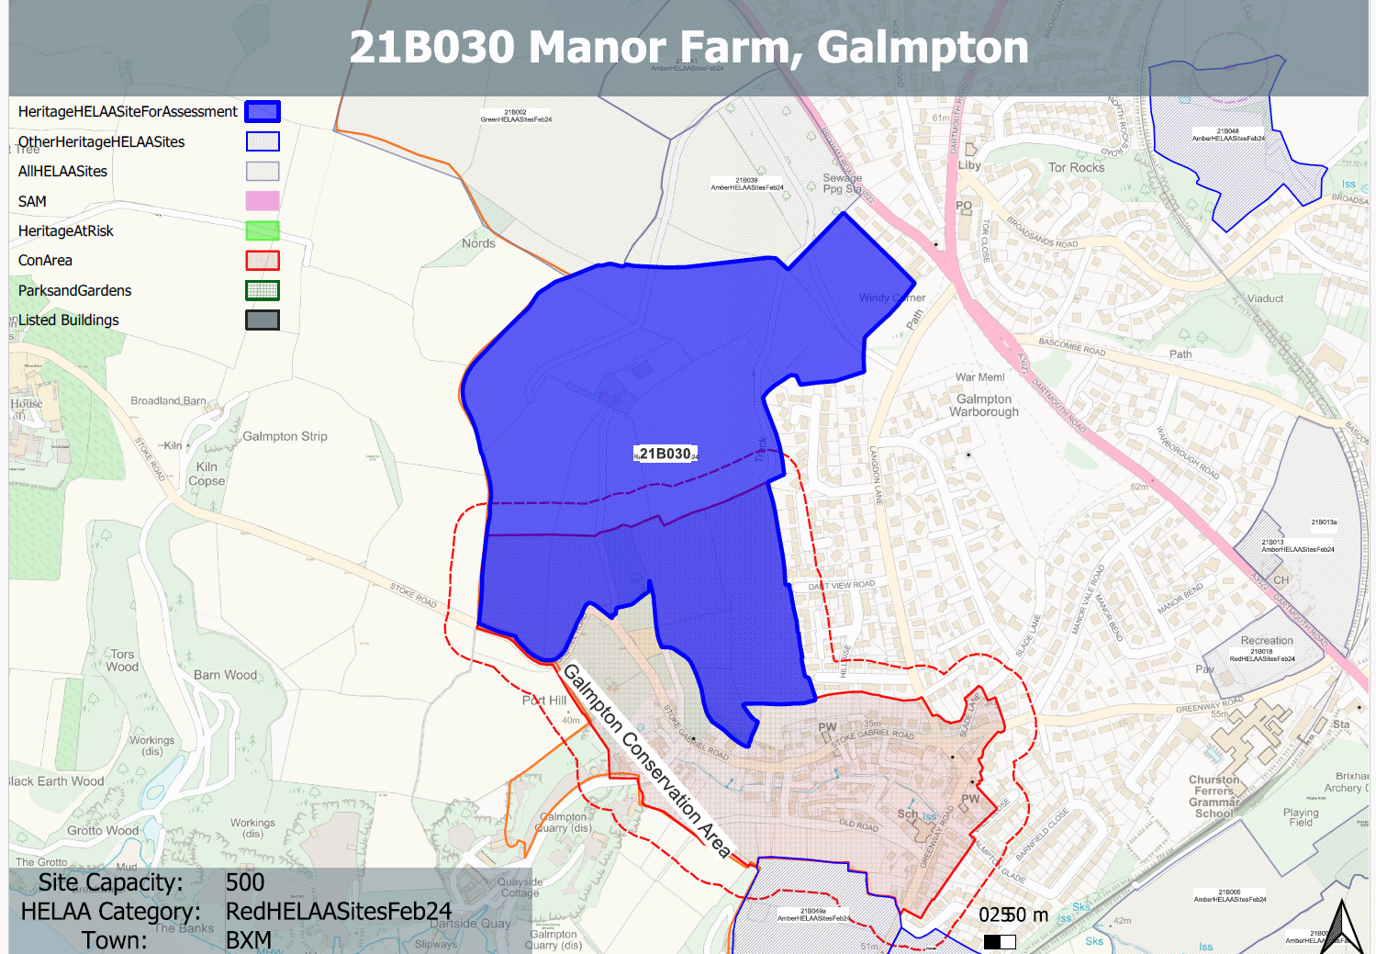
Site overview and heritage context:
The site includes land between the approved and under construction Inglewood development (P/2017/1133) and Galmpton and is currently in agricultural use.
The site includes large areas of green open space within the Galmpton Conservation Area and is boarded by development facing Brixham Road to the north east, existing development to the east and south and open countryside to the north and west.
The site includes possible settlement enclosure of prehistoric or Roman date and there is archaeological potential for this site and the wider area.

Heritage Asset Affected by Allocation | Designation | Contributing Elements to Significance | Impact of Development on Significance | Mitigation Measures for any Identified Harm /Opportunities to Enhance Significance | Impact on Significance with Mitigation in place
Galmpton Conservation Area  Milestone at SX 8846 5627 | Conservation Area  Grade II listed building | The fine landscape setting of the CA and the well balanced relationship between the C19 development and the associated landscape features are features of special importance within the CA.  The site makes a considerable positive contribution to this special characteristic and the overall significance of the conservation area.  Early C19 milestone relating to distance to Totnes. Site makes limited contribution to the setting or significance of the listed milestone | Substantial harm to identified special characteristics of the conservation area  Neutral | Substantial reduction in yield and size of site. Possible siting of landscape led development to northern section of the site a distance outside of the conservation area  n/a  . | Significant mitigation required to reduce impact to less than substantial harm.  Neutral

