**Heritage Impact Assessment:** Lupton Park Estate, Brixham

|  |  |
| --- | --- |
| **HELAA2021 Ref:** | 21B028 |
| **Site Address:** | Lupton Park Estate, Brixham |
| **Site Area (ha):** | 38.39 |
| **Site Yield:** | 500 |
| **HIA Assessment** |  |

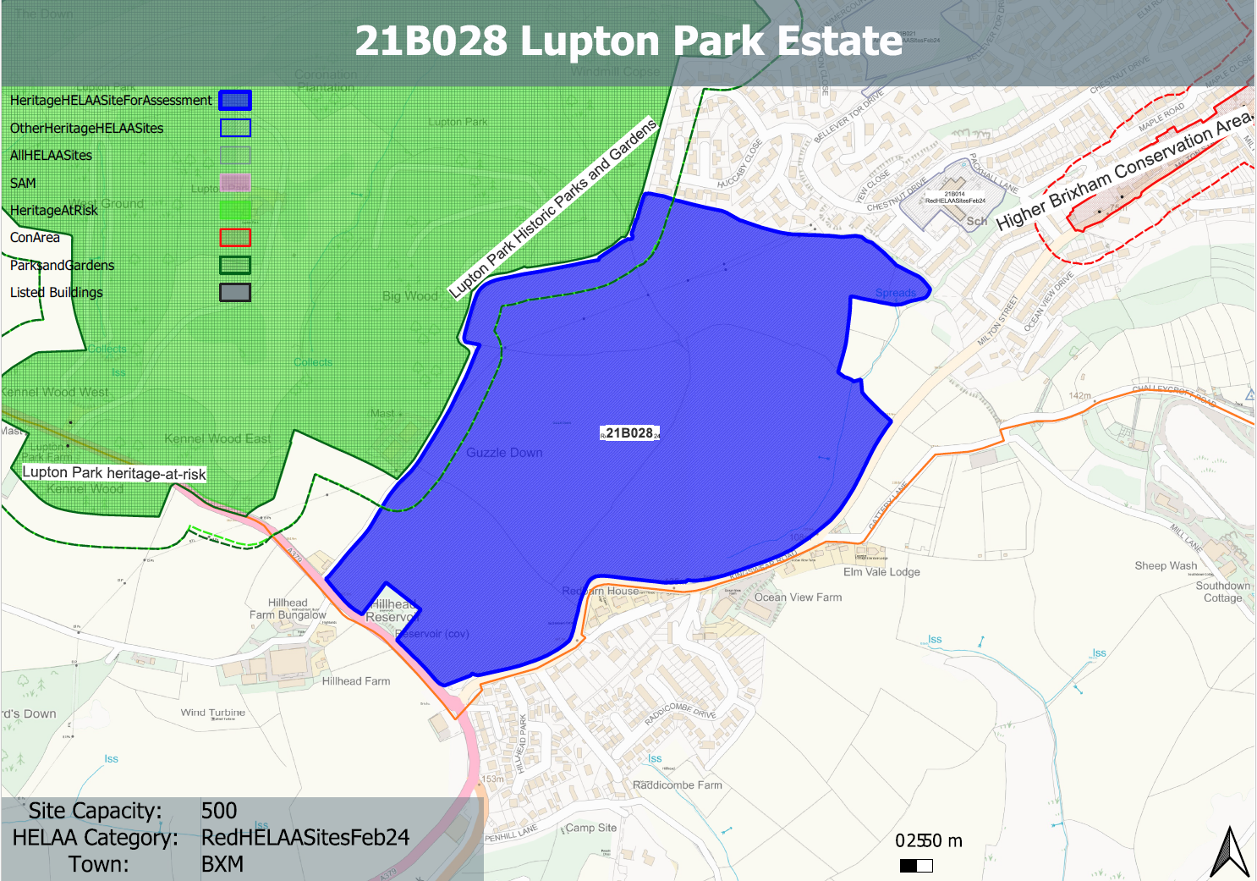

**Site overview and heritage context:**

Large open field adjacent to Lupton Park Estate (RPG) which hosts the Grade II* listed Lupton House and associated ancillary buildings and structures. Located on the south eastern edge of the town of Brixham and within a National Landscape. The boundary of the Higher Brixham Conservation Area can be found to the northeast.

The centre of the site sits in an elevated position in the landscape which slopes down in all directions from the centre. The site sits above the Lupton Park Estate which is located within a depression in the landscape to the west.

The site is constrained by the A379 to the south, Kingswear Road to the east and an agricultural access track to the west which separates the site form the Lupton Park Estate.

It is an alleged site of a Roman camp, or possible earlier defensive earthworks and therefore is of potential archaeological value.

|  |  |  |  |  |  |
| --- | --- | --- | --- | --- | --- |
| **Heritage Asset Affected by Allocation** | **Designation** | **Contributing Elements to Significance** | **Impact of Development on Significance** | **Mitigation Measures for any Identified Harm /Opportunities to Enhance Significance** | **Impact on Significance with Mitigation in place** |
| Lupton Park  Higher Brixham Conservation Area  Lupton House  Stables, former aviary and other ancillary buildings/structures | Grade II* Registered Park and Garden  Conservation Area  Grade II* listed building  Grade II listed building | A late C18 parkland landscape and mid C19 formal gardens associated with a late C18 mansion remodelled in the mid C19. A mid C20 country house designed by Oswald Milne is set in mid C20 formal gardens within the park.  The undeveloped nature of the site contributes to the rural setting of the park and acts as a ‘green buffer’ to built environs of Higher Brixham to the north and east.  The site contributes to the extended rural setting of the conservation area to the south of the historical development of the town, and sits in an elevated position to the south west of the CA.  Late 18th century country house set within extensive parkland. The undeveloped nature of the site contributes to the rural setting of the house and its estate and acts as a ‘green buffer’ to built environs of Higher Brixham to the north and east.  Late C18 stables, coach house, brew house, kennels and other outbuildings including former aviary. | Introduction of built form would erode rural setting causing a high level of harm to the significance of the asset.  Introduction of built form would erode the rural backdrop of this western edge of the conservation area thereby causing a low level of harm to the significance of the asset.  Introduction of built form would erode rural setting causing a moderate to high level of harm to the significance of the asset.  Introduction of built form would erode rural setting causing a moderate level of harm to the significance of the asset. | Substantial reduction in yield to reduce impact, however, a significant level of harm would likely remain.  Substantial reduction in yield to reduce impact, however, a level of harm would likely remain.  Substantial reduction in yield to reduce impact, however, a significant level of harm would likely remain.  Substantial reduction in yield to reduce impact, however, a level of harm would likely remain. | High level of less than substantial harm    Low level of less than substantial harm  High level of less than substantial harm  Moderate level of less than substantial harm |