Heritage Impact Assessment: Brokenbury Field, Bridge Rd, Brixham
HELAA2021 Ref: | 21B023
Site Address: | Brokenbury Field, Bridge Rd, Brixham
Site Area (ha): | 1.97
Site Yield: | 15
HIA Assessment

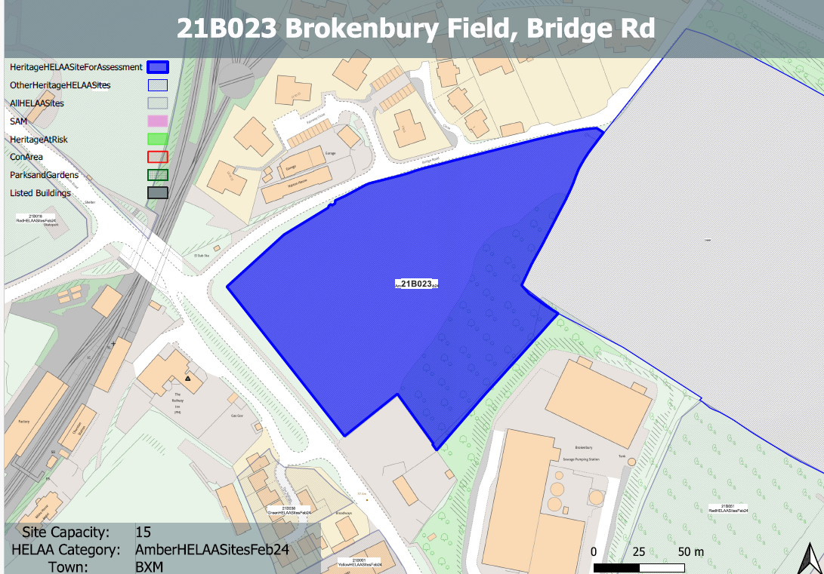
Site overview and heritage context:
Field between Brixham Road and Bascombe Road to the north of Brokenbury Quarry waste water treatment works, access would be via Bascombe Road or Bridge Road. The site is relatively level with a rise to the east and south. It is bounded by sporadic vegetation and a mature wooded area to the south.
The Torbay and Brixham Railway, which ran from here to Brixham, was opened in 1868 and is in close proximity to the site to the north.
A grade II listed building is located to the west and is separated from the site by Dartmouth Road.
A former quarry is present in historic mapping to the SE of the site and the area has high archaeological potential due to its proximity to a known prehistoric settlement site.

Planning History:
No relevant planning history.

Heritage Asset Affected by Allocation | Designation | Contributing Elements to Significance | Impact of Development on Significance | Mitigation Measures for any Identified Harm /Opportunities to Enhance Significance | Impact on Significance with Mitigation in place
Weary House Ploughman Public House (W of site) | Grade II listed building | Public house. Probably early 1860s. Now known as The Railway Inn which demotes its history as a railway hotel.  The site sits directly opposite the asset and forms part of its semi-rural setting. Historically the asset was isolated and surrounded by open countryside and a small number of sporadic individual buildings. It had a strong relationship with Churston station. This isolated setting has been diluted as a result of surrounding 20th century development. The site remains as one of the few undeveloped parcels of land surrounding the asset which denotes its former isolated location and relationship with the urrounding landscape. It makes a positive contribution to its significance. | The development of the site and all associated infrastructure would significantly dilute the semi-rural setting of the asset which makes a positive contribution to its significance. This would cause a minor degree of ‘less than substantial’ harm. | Any quantum of development of the site would significantly dilute the semi-rural setting of the asset which makes a positive contribution to its significance. It is not considered that this could be mitigated to the point where harm to the asset would be removed. | Less than substantial harm

