**Heritage Impact Assessment:** Field off Summercourt Way, Brixham

|  |  |
| --- | --- |
| **HELAA2021 Ref:** | 21B021 |
| **Site Address:** | Field off Summercourt Way, Brixham |
| **Site Area (ha):** | 1.7 |
| **Site Yield:** | 30 |
| **HIA Assessment** |  |

**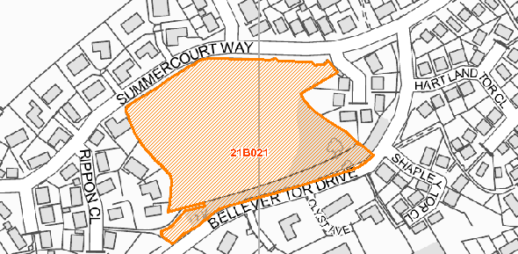  
Site overview and heritage context:**

The site is a small, undeveloped piece of land set within an area of 20th century development. It is currently in use as a public open space. The site is bounded by Summercourt Way on the north and Bellever Tor Drive on the south, with hedging screening the view from the road in most places.

170m to the east is GII* Lupton Park, and development on this site is likely to affect its setting.

Field-names recorded here in the 19th century tithe map contain the element ‘burrough’ which may be derived from Old English *burh* ‘fortification, earthwork’. As such, archeological investigation here would be appropriate.

**Planning History:**

|  |  |  |  |  |  |
| --- | --- | --- | --- | --- | --- |
| **Heritage Asset Affected by Allocation** | **Designation** | **Contributing Elements to Significance** | **Impact of Development on Significance** | **Mitigation Measures for any Identified Harm /Opportunities to Enhance Significance** | **Impact on Significance with Mitigation in place** |
| Lupton Park | GII* Registered Park | Lupton Park is an area of parkland dating back to Domesday (1086) when it was likely an area used for deer hunting. Development in the 19th century saw the creation of formal gardens close to Lupton House, and extensive tree planting on the edges of the parkland. The parkland retains its rural character, with most areas remaining open land.  The site is within the wider setting of the Park, and has a neutral impact on its significance. | Due to the raised elevation of the site, development to any quantum in likely to be visible from the Park. The site is set within existing development, and further development is unlikely to have a high level of impact on the Park. Development of the site is therefore considered to have a neutral impact on the Park. | N/A | Neutral |