Heritage Impact Assessment: Land at Monksbridge, Brixham
HELAA2021 Ref: | 21B015a
Site Address: | Land at Monksbridge, Brixham
Site Area (ha): | 9.88
Site Yield: | 70
HIA Assessment

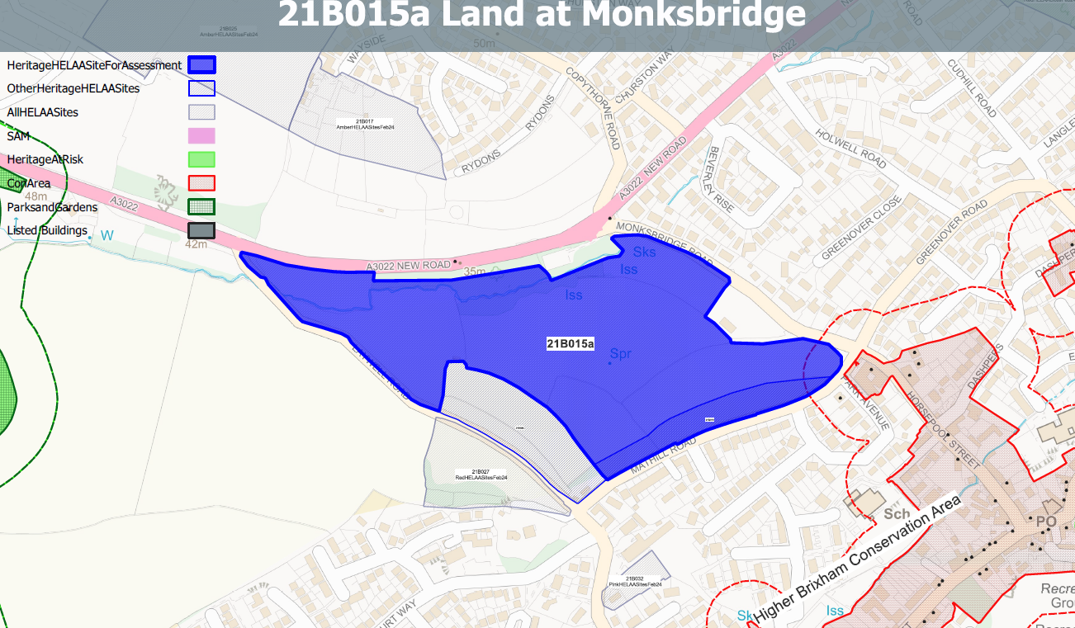
Site overview and heritage context:
Fields on the outskirts of Brixham bounded by New Rd to the north, Monksbridge Rd to the east, Mathill Rd to the south and Laywell Rd to the west. The site rises to a ridge to the south with New Rd running along the bottom. The site is undeveloped and is bounded by mature vegetation with sporadic tree cover throughout the site. As a result, the site is a prominent feature when travelling to Brixham along New Rd.
The site is outside but in close proximity to the Higher Brixham Conservation Area and a number of listed buildings to the east and north.
The site may have been part of a medieval field system and therefore may have some archaeological potential.

Planning History:
No relevant planning history.

Heritage Asset Affected by Allocation | Designation | Contributing Elements to Significance | Impact of Development on Significance | Mitigation Measures for any Identified Harm /Opportunities to Enhance Significance | Impact on Significance with Mitigation in place
Higher Brixham Conservation Area (E of site) | Conservation Area | The conservation area retains a village character to its western half and a more urban character to the eastern and northern parts related to the outward expansion of Lower Brixham in the later 19th century. The site sits outside, but adjacent to, the conservation area. The large site denotes the historic edge of the settlement and its semi-rural setting. It makes a positive contribution to its significance. | The development of the site to the quantum proposed would fundamentally change its character and the contribution it makes to the significance of the Higher Brixham Conservation Area. This would result in ‘less than substantial’ harm. | A significantly reduced quantum of development limited to the western elements of site 21B015 could reduce the level of harm to a neutral impact, however, the development of other parts of the site with its associated infrastructure would still result in a degree of less of substantial harm. | Less than substantial harm
Sunpark (SE of site) | Grade II listed building | House. 1930s. Modern Movement house to the designs of Melville H. Aubin. The site is separate to the asset and is outside of its curtilage. It can be seen in context with the asset and forms part of its semi-rural setting on the edge of the settlement of Brixham. The semi-rural setting of the asset has been compromised by surrounding late 20th development, nevertheless, the original edge of settlement location of the asset can still be read through the undeveloped nature of the site. The openness of the site also contributes to the prominence of the asset within street scene. It therefore makes a minor positive contribution to its significance. | The development of the site to the quantum proposed would potentially impact on the semi-rural setting of the asset and the contribution this makes to its significance. This would have a minor detrimental impact on its significance. | Reduction in the quantum of development to allow built development and associated infrastructure to be located to the western side of the 21B015 site and the retention of open space to the eastern side of the site could reduce the level of harm to a neutral level. | Neutral
Hillhouse nursing home including front wall and gate piers (SE of site) | Grade II listed building | Detached house, now nursing home. C16 or C17, altered C17/C18 and mid C19. The site is separate to the asset and is outside of its curtilage. It can be seen partly in context with the asset but makes a limited contribution to its significance. | The development of the site to the quantum proposed could be achieved with minimal impact on the setting of the asset through the siting of development towards the central and western areas of the21B015 site and the maintaining of a landscape buffer on the eastern boundary. This would have neutral impact on the asset’s significance. | n/a | Neutral
Greenover Farmhouse including front garden walls, gate, pump and barn (E of site) | Grade II listed building | Farmhouse, now private house. Early or mid C17; possibly earlier. The site does not contribute to the significance of the asset. | No impact | n/a | None
Former stable immediately north east of No.25, Greenover Farmhouse (E of site) | Grade II listed building | Stable. C18 or C19. The site does not contribute to the significance of the asset. | No impact | n/a | None
Greenover Orchard (E of site) | Grade II listed building | Former shippon belonging to Greenover Farmhouse (qv); now a house. C18 or C19, converted to house in 1980s. The site does not contribute to the significance of the asset. | No impact | n/a | None
Milepost Plaque | Grade II listed building | Milepost. Probably early C19. The site forms the rural setting of the milepost which denotes the historic edge of the settlement of Brixham. It makes a positive contribution to the significance of the asset. | The development of the site and all associated infrastructure would fundamentally change its character and would dilute the rural/edge of settlement setting of the asset which makes a positive contribution to its significance. This would cause ‘less than substantial’ harm. | A significantly reduced quantum of development limited to the western elements of site 21B015 could reduce the level of harm to a neutral impact, however, the development of other parts of the site with its associated infrastructure could still result in the dilution of the rural setting of the asset resulting in a degree of less of substantial harm. | Less than substantial harm
Tollgate House | Grade II listed building | Shown as Monksbridge Cottage on OS map. Former toll house. Probably about 1838. The site forms the rural setting of the asset which denotes the historic edge of the settlement of Brixham. The location on the edge of settlement and its rural setting makes a clear positive contribution to the significance of the asset. | The development of the site and all associated infrastructure would fundamentally change its character and would dilute the rural/edge of settlement setting of the asset which makes a positive contribution to its significance. This would cause ‘less than substantial’ harm. | A significantly reduced quantum of development limited to the western elements of site 21B015 could reduce the level of harm to a neutral impact, however, the development of other parts of the site with its associated infrastructure could still result in the dilution of the rural setting of the asset resulting in a degree of less of substantial harm. | Less than substantial harm

