Heritage Impact Assessment: Land at Mathill Road, Brixham
HELAA2021 Ref: | 21B015
Site Address: | Land at Mathill Road, Brixham
Site Area (ha): | 0.83
Site Yield: | 15
HIA Assessment

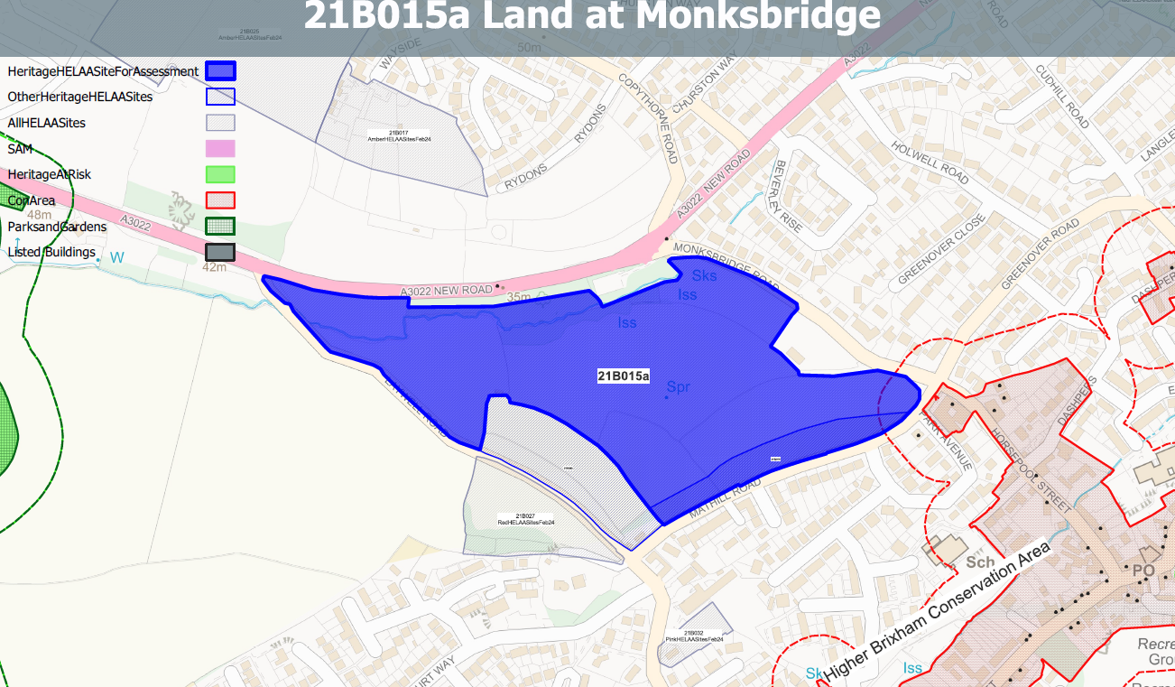
Site overview and heritage context:
Fields on the outskirts of Brixham to the north of Mathill Road and West of Monksbridge Road. The site is relatively level and is bounded by hedgerows and timber post and rail fence to the south and mature trees to the north.
The site is outside but in close proximity to the Higher Brixham Conservation Area and a number of listed buildings to the east.
The site may have been part of a medieval field system and therefore may have some archaeological potential.

Planning History:
P/2004/1916 - Change Of Use To Temporary Site Compound Area – APPROVED 11/02/2005 (covers only eastern portion of site)

Heritage Asset Affected by Allocation | Designation | Contributing Elements to Significance | Impact of Development on Significance | Mitigation Measures for any Identified Harm /Opportunities to Enhance Significance | Impact on Significance with Mitigation in place
Higher Brixham Conservation Area (E of site) | Conservation Area | The conservation area retains a village character to its western half and a more urban character to the eastern and northern parts related to the outward expansion of Lower Brixham in the later 19th century. The site sits outside, but adjacent to, the conservation area and makes a limited contribution to its significance but does denote the edge of the settlement and its semi-rural setting. | The development of the site to the quantum proposed could be achieved with minimal impact on the setting of the conservation area through the siting of development towards the central and western areas of the site and the maintaining of a landscape buffer on the eastern boundary. This would have neutral impact on the asset’s significance. | n/a | Neutral
Sunpark (SE of site) | Grade II listed building | House. 1930s. Modern Movement house to the designs of Melville H. Aubin. The site is separate to the asset and is outside of its curtilage. It can be seen in context with the asset and forms part of its semi-rural setting on the edge of the settlement of Brixham. The semi-rural setting of the asset has been compromised by surrounding late 20th development, nevertheless, the original edge of settlement location of the asset can still be read through the undeveloped nature of the site. The openness of the site also contributes to the prominence of the asset within street scene. It therefore makes a minor positive contribution to its significance. | The development of the site to the quantum proposed would potentially impact on the semi-rural setting of the asset and the contribution this makes to its significance. This would have a minor detrimental impact on its significance. | Reduction in the quantum of development to allow built development and associated infrastructure to be located to the western side of the site and the retention of open space to the eastern side of the site could reduce the level of harm to a neutral level. | Neutral
Hillhouse nursing home including front wall and gate piers (SE of site) | Grade II listed building | Detached house, now nursing home. C16 or C17, altered C17/C18 and mid C19. The site is separate to the asset and is outside of its curtilage. It can be seen partly in context with the asset but makes a limited contribution to its significance. | The development of the site to the quantum proposed could be achieved with minimal impact on the setting of the asset through the siting of development towards the central and western areas of the site and the maintaining of a landscape buffer on the eastern boundary. This would have neutral impact on the asset’s significance. | n/a | Neutral
Greenover Farmhouse including front garden walls, gate, pump and barn (E of site) | Grade II listed building | Farmhouse, now private house. Early or mid C17; possibly earlier. The site does not contribute to the significance of the asset. | No impact | n/a | None
Former stable immediately north east of No.25, Greenover Farmhouse (E of site) | Grade II listed building | Stable. C18 or C19. The site does not contribute to the significance of the asset. | No impact | n/a | None
Greenover Orchard (E of site) | Grade II listed building | Former shippon belonging to Greenover Farmhouse (qv); now a house. C18 or C19, converted to house in 1980s. The site does not contribute to the significance of the asset. | No impact | n/a | None

