**Heritage Impact Assessment:** Churston Golf Club, Brixham

|  |  |
| --- | --- |
| **HELAA2021 Ref:** | 21B013a |
| **Site Address:** | Churston Golf Club |
| **Site Area (ha):** | 4.3 |
| **Site Yield:** | 80 |
| **HIA Assessment** |  |

**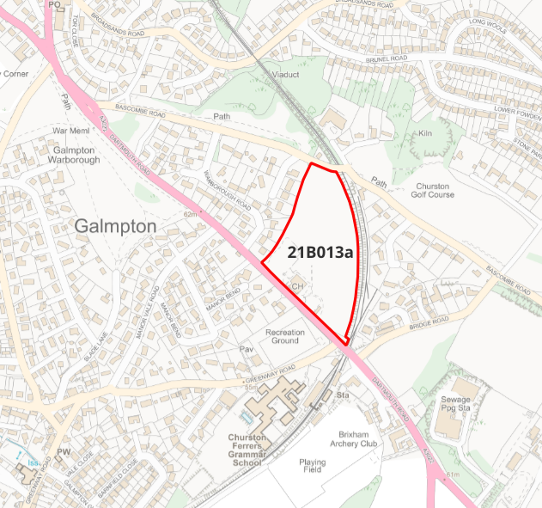  
Site overview and heritage context:**

The site is a triangular, level piece of land that has been in use as a golf course from 1890 to present day. It is bordered by the railway line and modern development to the east, Dartmouth Road to the south, Bascombe Road to the north and 20th century development to the west. The site is screened from the development to the east and west by trees, but views in from the road are unobstructed.

The site is not within or nearby any Conservation Areas, and is within the setting of one listed building – the Weary Ploughman Public House (Railway Inn) which lies approx. 100m to the south of the site.

**Planning History:**

P/2011/0829 – Demolition of clubhouse, outbuildings and car park and development comprising up to 90 dwellings. Approved but not implemented.

|  |  |  |  |  |  |
| --- | --- | --- | --- | --- | --- |
| **Heritage Asset Affected by Allocation** | **Designation** | **Contributing Elements to Significance** | **Impact of Development on Significance** | **Mitigation Measures for any Identified Harm /Opportunities to Enhance Significance** | **Impact on Significance with Mitigation in place** |
| Weary Ploughman Public House (S of site) | GII Listed Building | Mid 19th century public house, marked on early OS maps as Churston Links Hotel. The building adjoins Churston Station and was likely constructed as a hotel associated with the station. Many original features retained.  The site forms part of the wider setting of the listed building and has a neutral impact on its significance. | Development of the site is likely to be visible from the listed building and have a negative impact on its setting. | Vegetation screening on the Dartmouth Road side of the site would limit the impact of the development on the listed building. | Neutral |