**Heritage Impact Assessment:** Northcliff Hotel, Brixham

|  |  |
| --- | --- |
| **HELAA2021 Ref:** | 21B008 |
| **Site Address:** | Northcliff Hotel, Brixham |
| **Site Area (ha):** | 0.29 |
| **Site Yield:** | 15 |
| **HIA Assessment** |  |

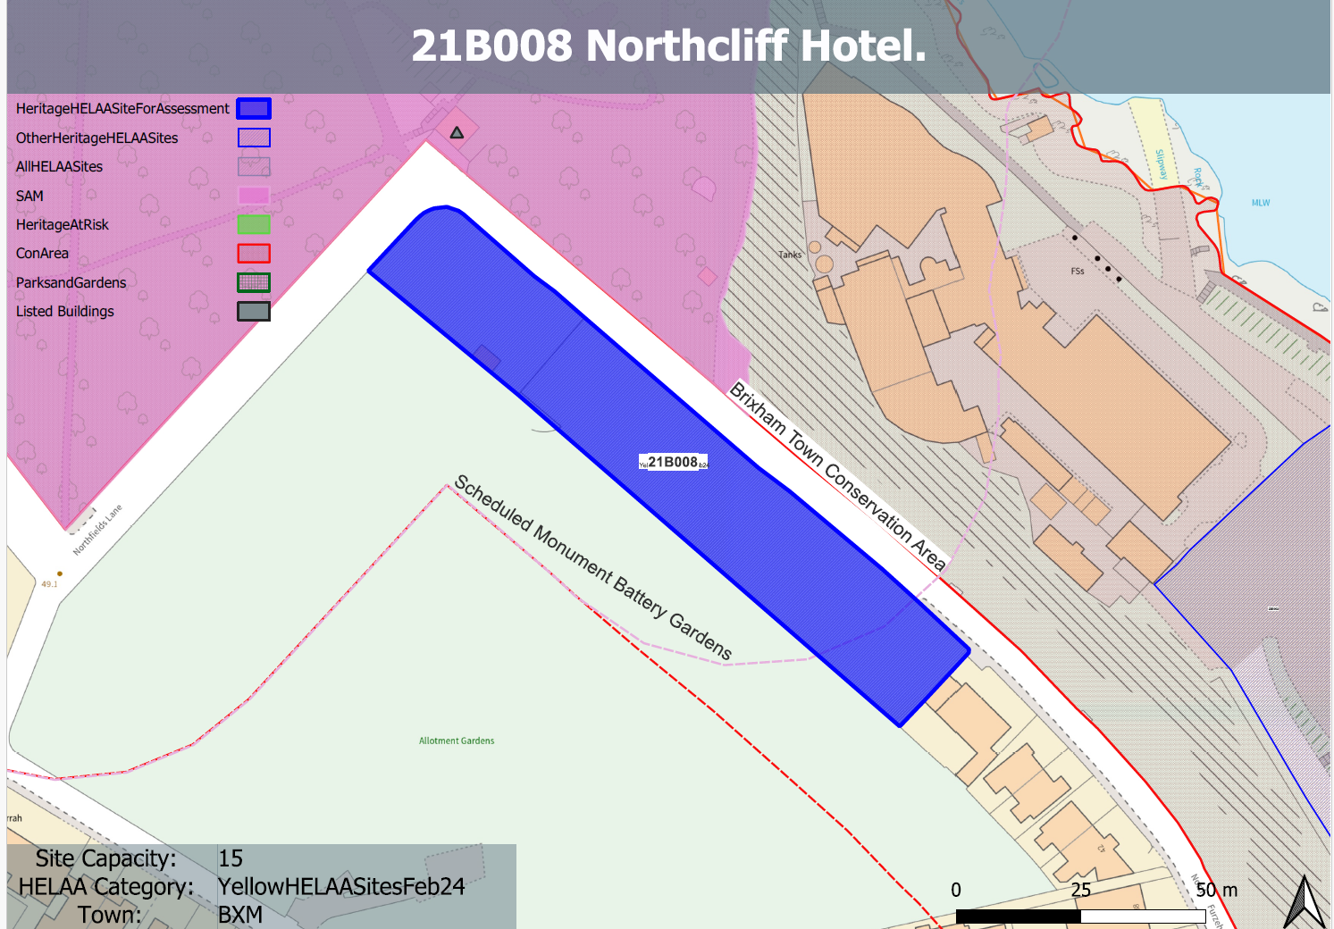 **Site overview and heritage context:**

The site is located adjacent to the border of the Brixham Town Conservation Area which can be found to the east of the site incorporating Oxen Cove. To the north of the site lies the Battery Gardens Scheduled Monument which includes the Grade II listed Observation Post. To the immediate west of the site is a large area of allotments which appear to have been in place since the late 19th century. Existing development along N Furzeham Road ends to the south of the site and dates from around the mid-20th century.

The site is relatively flat and runs alongside N Furzeham Road, it currently comprises overgrown scrub and is separated from the road by a single metal fence and an area of stone walling.

**Planning History:**

P/1991/0552 - Change Of Use To Residential Care Home – Refused: 10/07/1991

|  |  |  |  |  |  |
| --- | --- | --- | --- | --- | --- |
| **Heritage Asset Affected by Allocation** | **Designation** | **Contributing Elements to Significance** | **Impact of Development on Significance** | **Mitigation Measures for any Identified Harm /Opportunities to Enhance Significance** | **Impact on Significance with Mitigation in place** |
| Brixham Town Conservation Area (to N, E and S of site)  WW2 Emergency Coastal Battery and remains of a Victorian practice battery, at Battery Gardens  Battery Observation Post, Battery Gardens | Conservation Area  Scheduled Monument  Grade II listed building | The conservation area predominantly comprises the built environs of the town of Brixham focused around the harbour. Its significance is derived from its historic and architectural value related to its medieval origins, its use as a harbour from the 18th century and its subsequent growth around the port area and an economy based on the fishing industry. The site sits outside of the conservation area and has historically remained undeveloped as part of Furzeham Common. undeveloped form. The site is read in context with the adjacent allotments which date from the late 19th/early 20th century and which make a positive contribution to the evolution of the area and the relationship with neighboring historic development. It therefore makes a positive contribution to the significance of the conservation area.  A rare surviving emergency coastal battery. Has great historical value as a visible reminder of the measures taken to protect England against the threat of invasion during the 1940s, and of the degree to which earlier defence sites were often adapted to serve that need. The site can be seen in context with southern boundary of the asset. It has a historical relationship with the asset, both forming part of Furzeham Common up until the late 19th century. The site therefore makes a minor positive contribution to its significance and the evolution of the asset from open common ground to including a Victorian practice battery to a WW2 emergency coastal battery.  Battery observation post dating from 1940. The site can be seen in context with southern boundary of the asset. It has a historical relationship with the asset, both forming part of Furzeham Common up until the late 19th century. The site therefore makes a minor positive contribution to its significance and the evolution of the asset from open common ground to including a Victorian practice battery to a WW2 emergency coastal battery. | The development of the site would have a detrimental impact on the existing open space, its relationship with the adjacent allotments that the contribution this makes to the surrounding historic environment. This would cause a minor level of less than substantial harm to the significance of the conservation area.  The development of the site would have a detrimental impact on the existing open space and the readability of its historic relationship with the asset. This would cause a minor level of less than substantial harm to the significance of the asset.  The development of the site would have a detrimental impact on the existing open space and the readability of its historic relationship with the asset. This would cause a minor level of less than substantial harm to the significance of the asset | The loss of the open character of the site as a result of any built development would still result in a minor level of less than substantial harm to the significance of the conservation area.  The loss of the open character of the site as a result of any built development would still result in a minor level of less than substantial harm to the significance of the asset.  The loss of the open character of the site as a result of any built development would still result in a minor level of less than substantial harm to the significance of the asset. | Minor harm  Minor harm  Minor harm |