Heritage Impact Assessment: Town Centre Car Park, Brixham
HELAA2021 Ref: | 21B006
Site Address: | Town Centre Car Park, Brixham
Site Area (ha): | 0.79
Site Yield: | 25
HIA Assessment

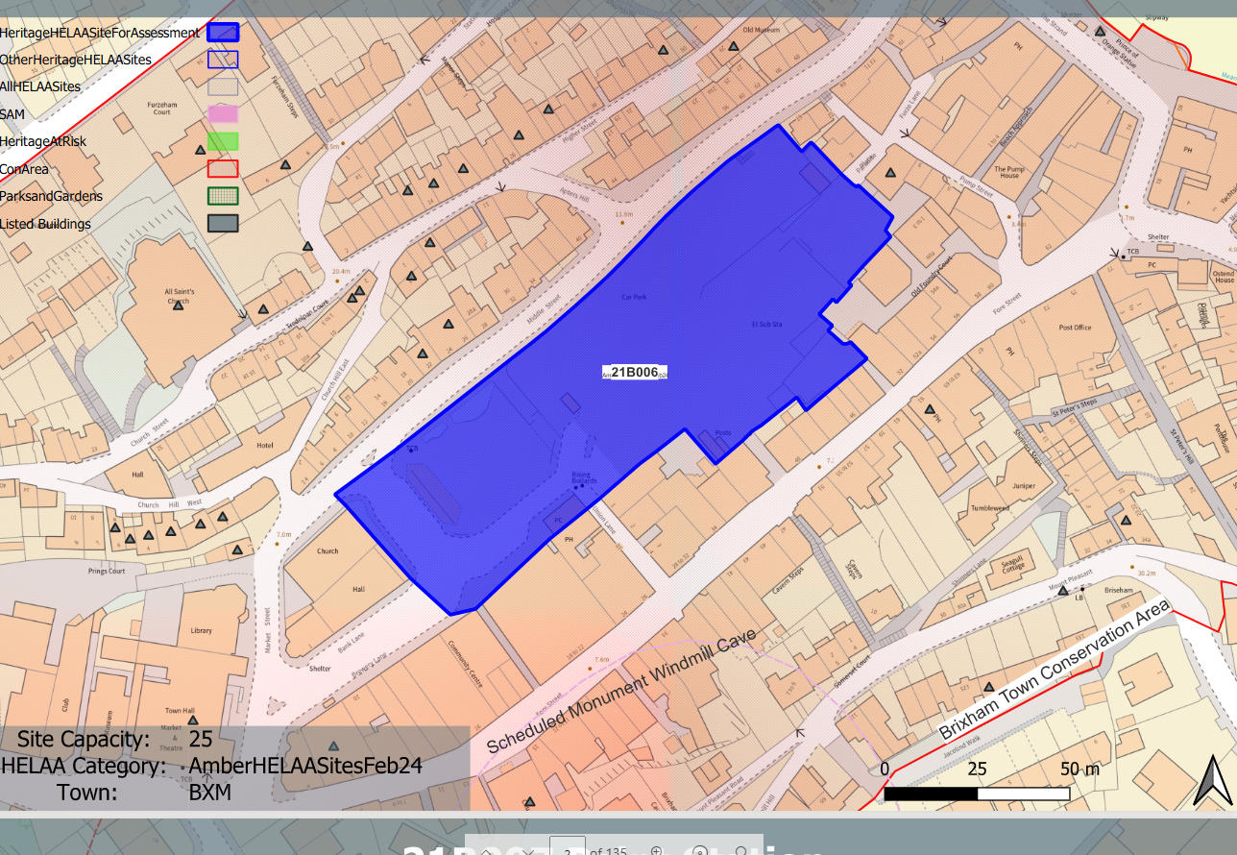
Site overview and heritage context:
Surface level car park, Middle Street. Brixham Town Centre. The site comprises the existing town centre car park and Town Square. Originally part of the Old Harbour, the site was historically reclaimed and used for a range of commercial uses including the town centre gas works. It formerly houses a multi-storey car park and is currently a surface level car park and a hard paved area with seating and a bus shelter.
The site occupies a valley bottom with rises up steeply on all sides but the seaward side facing the harbour.
The site is located within the Brixham Town Conservation Area, is surrounded by a high number of designated heritage assets and has some archaeological potential.

Planning History:
P/2004/1080 - Demolition Of Multi Storey Car Park– Approved 12/08/2004
P/2007/1299 – Remaking of GF Area Of Multi Storey Car Park To Remain As Car Park And Temporary Use Of Part Of Town Square As Car Park – Approved 23/09/2004
P/2012/1309 - Provision of a 4 storey building containing a Class A1 supermarket [net sales 2791m2], 8 A1 and A2 retail units [ GIA 218m2] including a shopmobility unit on the ground floor level, 338 car parking spaces on levels 1-3, 14 residential dwellings on Middle Street and c/o Bank Lane/ Brewery Lane , associated public realm improvements, highway alterations and access provision. Remediation of land and all necessary infrastructure provision – Approved 02/04/2014
Heritage Asset Affected by Allocation | Designation | Contributing Elements to Significance | Impact of Development on Significance | Mitigation Measures for any Identified Harm /Opportunities to Enhance Significance | Impact on Significance with Mitigation in place
Brixham Town Conservation Area  Paradise Place (NE of site)  Nos 25, 27 and 29 including building adjoining No 29 (N of site)  48 and 50, Higher Street (N of site)  30 and 32 Higher Street (N of site)  The Manor House (N of site)  20 and 22 Higher Street (N of site)  16 and 18 Higher Street (N of site)  12 and 14 Higher Street (N of site)  Sunnybank (N of site)  Gate Piers approximately 35 metres SE of Furzeham Court House (N of site)  Furzeham Court House including garden walls and gate (N of site)  1,3 and 5 Church Street (N of site)  Church of All Saints, including front churchyard wall, gates and gate piers (NW of site)  No 2 including short retaining wall abutting left side wall (N of site)  4 Church Street (N of site)  6, 6A and 6B, Pring’s Court (W of site)  5 Pring’s Court (W of site)  Crocus Cottage, 4 Pring’s Court (W of site)  3 Pring’s Court (W of site)  Marjon, 2 Pring’s Court (W of site)  1 Pring’s Court (W of site)  Brixham Town Hall and Market Hall (W of site)  6 Fore Street (SW of site) | Conservation Area  Grade II listed building  Grade II listed building  Grade II listed building  Grade II listed building  Grade II listed building  Grade II listed building  Grade II listed building  Grade II listed building  Grade II listed building  Grade II listed building  Grade II listed building  Grade II listed building  Grade II listed building  Grade II listed building  Grade II listed building  Grade II listed building  Grade II listed building  Grade II listed building  Grade II listed building  Grade II listed building  Grade II listed building  Grade II listed building  Grade II listed building | The conservation area has historic interest through its origins as a small fishing port and naval supply station, a distinctive topography with tightly clustered development and a surviving historic environment which tells the story of its industrial past and evolution over the course of the 19th century. The site is identified as being an ‘opportunity for enhancement’ which currently results in a gap in the urban grain of the area. It currently makes a negative contribution to the significance of the conservation area.  Fisherman's store, now a shop store. Probably early/mid C19, with earlier fabric. The site forms part of the immediate setting of the asset but in its current form makes a neutral to minor negative impact on its significance.  Range of 3 cottages with former pilchard cellar and fish store, latterly museum, abutting. Probably late C18 or early C19. The site forms part of the wider setting of the asset but makes a neutral impact on its significance.  Mirrored pair of houses. Mid C19. The site forms part of the wider setting of the asset but makes a neutral to minor negative impact on its significance.  Mirrored pair of houses. Early C19. The site forms part of the wider setting of the asset but makes a neutral to minor negative impact on its significance.  Public house. Early/mid C19; could be a remodelling of an earlier structure. The site forms part of the wider setting of the asset but makes a neutral to minor negative impact on its significance.  Pair of terrace houses and shop of one build. Early C19, has group value with other assets on the street. The site forms part of the wider setting of the asset but makes a neutral to minor negative impact on its significance.  Pair of houses. Early/mid C19, has group value with other assets on the street. The site forms part of the wider setting of the asset but makes a neutral impact on its significance.  Pair of houses. Early/mid C19, has group value with other assets on the street. The site forms part of the wider setting of the asset but makes a neutral impact on its significance  House. Early/mid C19. The site does not form part of the setting of the asset and does not contribute to its significance.  Gate piers. Probably early/mid C19, have group value with Furzeham Court House. The site does not form part of the setting of the asset and does not contribute to its significance.  Detached house, standing on the hillside above All Saints Church (qv). 1832. At its foot is a garden enclosed by stone rubble walls on the other 3 sides. To the right of the garden is a flight of steps leading up to the house, with spear-head uprights to C19 iron gate with twisted shaft. The site forms part of the wider setting of the asset but makes a neutral to minor negative impact on its significance.  Range of 3 cottages; Nos 1 & 3 possibly a single house originally. C17 or earlier, superficially remodelled early/mid C19, have group value. The site does not form part of the setting of the asset and does not contribute to its significance.  Parish church. 1884-1906, possibly incorporating parts of the original church of c1819-24. The site forms part of the wider setting of the asset but makes a neutral to minor negative impact on its significance.  House. Mid C19. The site forms part of the wider setting of the asset but makes a neutral to minor negative impact on its significance.  House, possibly with former shop. Early or mid C19. The site forms part of the wider setting of the asset but makes a neutral to minor negative impact on its significance  House, now sub-divided. Early or mid C19, has group value with surrounding designated assets. The site does not form part of the setting of the asset and does not contribute to its significance.  House. Early C19, has group value with surrounding designated assets. The site does not form part of the setting of the asset and does not contribute to its significance.  House. Probably C18, has group value with surrounding designated assets. The site does not form part of the setting of the asset and does not contribute to its significance.  House. Dated 1783 with mid C19 alterations; probably a remodelling of an earlier house. Has group value with surrounding designated assets. The site does not form part of the setting of the asset and does not contribute to its significance.  House. Probably early C18, with minor late C19 alterations, has group value with surrounding designated assets. The site forms part of the wider setting of the asset but makes a neutral to minor negative impact on its significance  House. Mid C19, has group value with surrounding designated assets. The site forms part of the wider setting of the asset but makes a neutral to minor negative impact on its significance  Town hall and market hall. 1886. By GS Bridgman of Torquay. The site forms part of the wider setting of the asset but makes a neutral to minor negative impact on its significance  Large house, now shops. Early C19; possibly a remodelling of an earlier house, The house occupies an important position near the junction with Bolton Street and New Road. | Development of the site for 25 residential units could have a positive impact on the significance of the conservation area if sensitively designed to be respectful of the surrounding historic environment and established character of the area. This could be reflective of the historic built form and tight urban grain of the site as evidenced within historic mapping.  Development of the site for 25 residential units could have a neutral or minor positive impact on the significance of the asset if sensitively designed to be respectful of the surrounding historic environment and established character of the area. This could be reflective of the historic built form and tight urban grain of the site as evidenced within historic mapping.  Development of the site for 25 residential units could have a neutral impact on the significance of the asset if sensitively designed.  Development of the site for 25 residential units could have a neutral to minor positive impact on the significance of the asset if sensitively designed.  Development of the site for 25 residential units could have a neutral to minor positive impact on the significance of the asset if sensitively designed.  Development of the site for 25 residential units could have a neutral to minor positive impact on the significance of the asset if sensitively designed.  Development of the site for 25 residential units could have a neutral to minor positive impact on the significance of the asset if sensitively designed.  Development of the site for 25 residential units could have a neutral impact on the significance of the asset if sensitively designed.  Development of the site for 25 residential units could have a neutral impact on the significance of the asset if sensitively designed.  Development of the site for 25 residential units could have a neutral impact on the significance of the asset if sensitively designed.  Development of the site for 25 residential units could have a neutral impact on the significance of the asset if sensitively designed.  Development of the site for 25 residential units could have a neutral to minor positive impact on the significance of the asset if sensitively designed.  Development of the site for 25 residential units could have a neutral impact on the significance of the asset if sensitively designed.  Development of the site for 25 residential units could have a neutral to minor positive impact on the significance of the asset if sensitively designed.  Development of the site for 25 residential units could have a neutral to minor positive impact on the significance of the asset if sensitively designed.  Development of the site for 25 residential units could have a neutral to minor positive impact on the significance of the asset if sensitively designed.  Development of the site for 25 residential units could have a neutral impact on the significance of the asset if sensitively designed.  Development of the site for 25 residential units could have a neutral impact on the significance of the asset if sensitively designed.  Development of the site for 25 residential units could have a neutral impact on the significance of the asset if sensitively designed.  Development of the site for 25 residential units could have a neutral impact on the significance of the asset if sensitively designed.  Development of the site for 25 residential units could have a neutral to minor positive impact on the significance of the asset if sensitively designed.  Development of the site for 25 residential units could have a neutral to minor positive impact on the significance of the asset if sensitively designed.  Development of the site for 25 residential units could have a neutral to minor positive impact on the significance of the asset if sensitively designed. | n/a  n/a  n/a  n/a  n/a  n/a  n/a  n/a  n/a  n/a  n/a  n/a  n/a  n/a  n/a  n/a  n/a  n/a  n/a  n/a  n/a  n/a  n/a | Enhancement  Neutral/enhancement  Neutral  Neutral/enhancement  Neutral/enhancement  Neutral/enhancement  Neutral/enhancement  Neutral  Neutral  Neutral  Neutral  Neutral/enhancement  Neutral  Neutral/enhancement  Neutral/enhancement  Neutral/enhancement  Neutral  Neutral  Neutral  Neutral  Neutral/enhancement  Neutral/enhancement  Neutral/enhancement

