Heritage Impact Assessment: Land at Churston (Brokenbury), Brixham
HELAA2021 Ref: | 21B003
Site Address: | Land at Churston (Brokenbury), Brixham
Site Area (ha): | 8.03
Site Yield: | 150
HIA Assessment

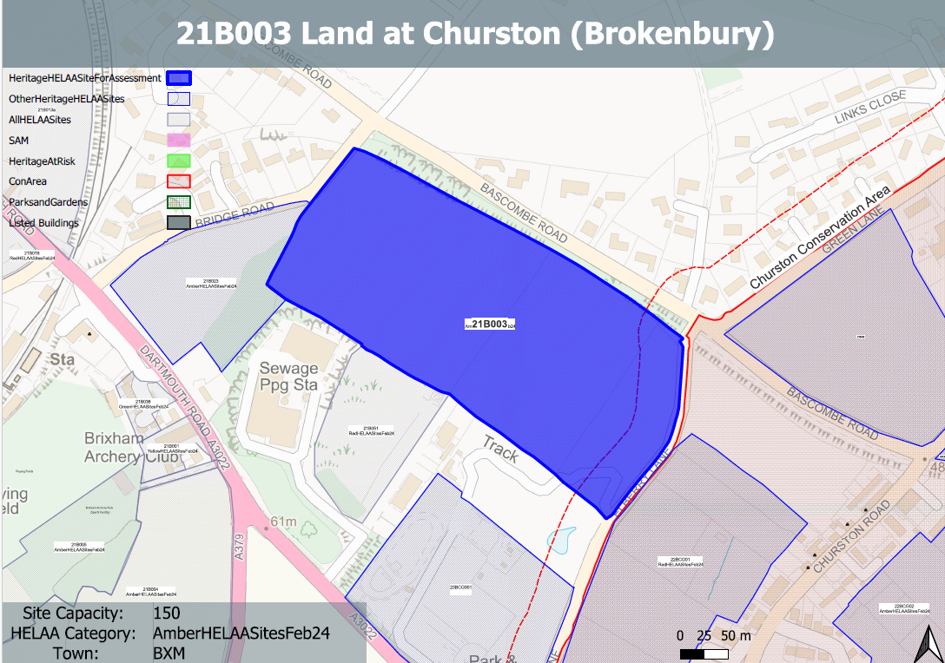
Site overview and heritage context:
The site is located to the south of Bascombe Road and to east of Bridge Road and comprises wo arable agricultural fields with no existing structures on site. It is bound on all sides by established hedgerows and trees which screen views to the site from the residential environment to the west off Bridge Road, and north off Bascombe Road.
The Churston Ferrers Conservation Area is located in close proximity to the east and it has high archaeological potential with evidence of Bronze age works within the site boundaries.

Planning History:
P/2021/0658 - Formation of solar farm & associated equipment to include installation of fencing, CCTV, landscaping & ecological mitigation - Land At Brokenbury Farm Galmpton Brixham – Approved 18/11/2022

Heritage Asset Affected by Allocation | Designation | Contributing Elements to Significance | Impact of Development on Significance | Mitigation Measures for any Identified Harm /Opportunities to Enhance Significance | Impact on Significance with Mitigation in place
Churston Ferrers Conservation Area (E of site) |  | The conservation area has a ‘traditional English Village’ character set within a distinct rural setting in-between the settlements of Galmpton and Brixham. It contains a high concentration of listed buildings for a small settlement.  The site in its undeveloped form makes a positive contribution to the rural characteristics and setting of the conservation area. | The development of the site to the quantum proposed would have a demonstrable impact on the open, rural character of the site and the adjacent conservation area. This would cause ‘less than substantial’ harm to its significance. | A significantly reduced quantum of development limited to the northern boundary of the site with a significant landscape buffer between the development and the conservation area may reduce the level of harm to its significance so as to have a neutral impact. | Neutral
Weary House Ploughman Public House (W of site) | Grade II listed building | Public house. Probably early 1860s. Now known as The Railway Inn which demotes its history as a railway hotel.  The site sits directly opposite the asset and forms part of its semi-rural setting. Historically the asset was isolated and surrounded by open countryside and a small number of sporadic individual buildings. It had a strong relationship with Churston station. This isolated setting has been diluted as a result of surrounding 20th century development. The site forms part of the wider rural setting of the asset but makes a limited contribution to its significance. | The development of the site to the quantum proposed would have a demonstrable impact on the open, rural character of the site. However, this would only have a limited impact on the direct setting and significance of the asset. The impact of the development would likely be neutral. | n/a | Neutral
Avenue Terrace 1-7, Churston Road (SE of site) | Grade II listed building | A row of mid-19th century estate cottages. The site forms part of the wider rural setting of the asset but is visually and physically separated from the site by a parcel of land and a band of mature planting. The site makes a limited contribution to the significance of the asset. | The development of the site would have limited impact on the significance of this asset. | n/a | Neutral
Myrtle Cottage (SE of site) | Grade II listed building | Mid-19th century cottage. The site forms part of the wider rural setting of the asset but is visually and physically separated from the site by a parcel of land and a band of mature planting. The site makes a limited contribution to the significance of the asset. | The development of the site would have limited impact on the significance of this asset. | n/a | Neutral
Lower Court (Terrace) including gate pier and wall to south west, 1, 2 and 3 Churston Road (SE of site) | Grade II listed building | A terrace of 3 mid-a9th century estate cottages. The site forms part of the wider rural setting of the asset but is visually and physically separated from the site by a parcel of land and a band of mature planting. The site makes a limited contribution to the significance of the asset. | The development of the site would have limited impact on the significance of this asset. | n/a | Neutral
John’s Cottage Ridgeway including gate piers to the north east (SE of site) | Grade II listed building | Mirrored pair of cottages. Mid C19. The site forms part of the wider rural setting of the asset but is visually and physically separated from the site by a parcel of land and a band of mature planting. The site makes a limited contribution to the significance of the asset. | The development of the site would have limited impact on the significance of this asset. | n/a | Neutral

