**Heritage Impact Assessment:** Site Opposite Paignton Train Station, Victoria Street, Paignton

|  |  |
| --- | --- |
| **HELAA2021 Ref:** | 21P048 |
| **Site Address:** | Site Opposite Paignton Train Station, Victoria Street, Paignton |
| **Site Area (ha):** | 0.07 |
| **Site Yield:** | 10 |
| **HIA Assessment** |  |

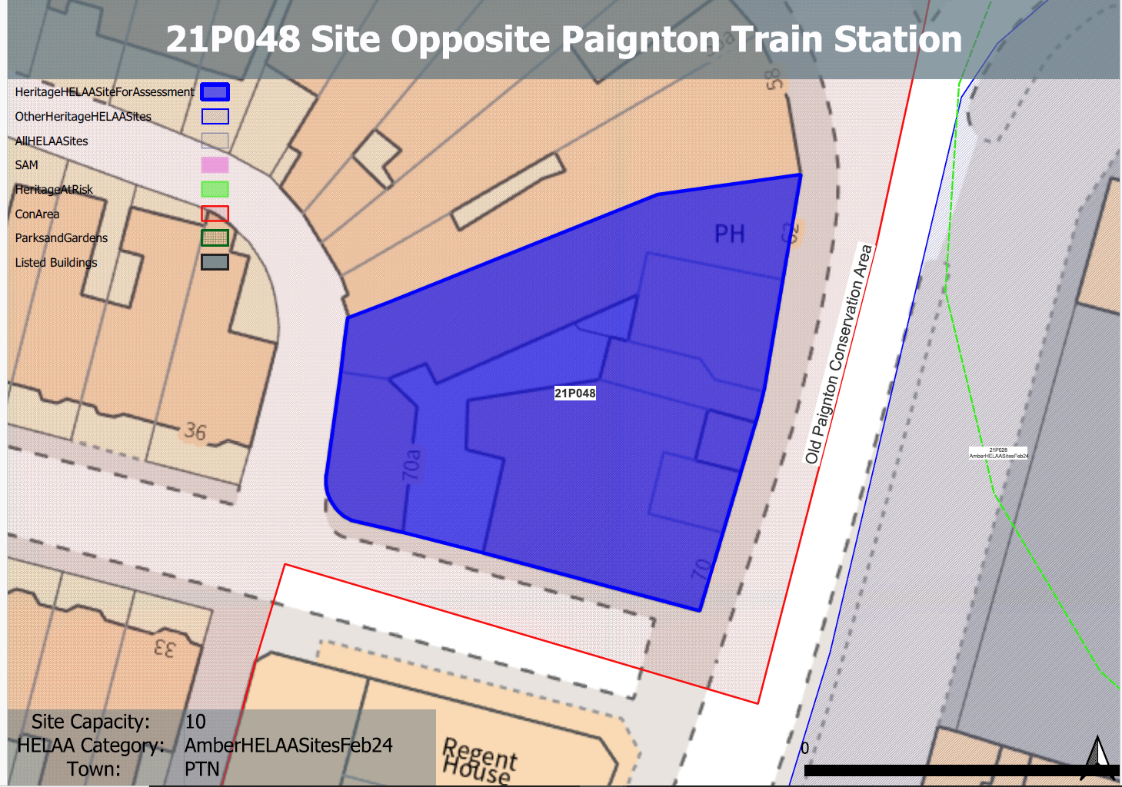 **Site overview and heritage context:**

The building on the site dates from the 19th century and is the former Bailey’s Hotel, it is identified as making a positive contribution to the Old Paignton Conservation Area.

The site is in a key and prominent location opposite Paignton railway station, with the existing building turning the corner from Victoria Street to Gerston Road to the west. Adjoining development to the east along Victoria Street is of a similar age and style to the existing building and are identified within the conservation area appraisal as forming an important group. Existing development along Gerston Road comprises 19th century residential terracing

A group of Grade II listed buildings along Torbay/Queens Park Road can be found to the east, along with the Grade II* listed Paignton Picture House. A Grade II listed church and hall on the corner of Dartmouth Road can be found to the west

**Planning History:**

Various relating to the commercial use of the building.

|  |  |  |  |  |  |
| --- | --- | --- | --- | --- | --- |
| **Heritage Asset Affected by Allocation** | **Designation** | **Contributing Elements to Significance** | **Impact of Development on Significance** | **Mitigation Measures for any Identified Harm /Opportunities to Enhance Significance** | **Impact on Significance with Mitigation in place** |
| Paignton Old Town Conservation Area  Paignton Picture House | Conservation Area  Grade II* listed building | The building on the site was  built as a hotel with retail premises to part of the ground floor. It dates from 1894 and is identified as a key building in a prominent location within the conservation area. It is of strong local interest and makes a positive contribution to the conservation area’s significance through its architectural and historic value.  Purpose built cinema and one of the most intact, opened in 1912 and designed by Hyams and Hodgen of Paignton. The site sits within the urban setting of this asset and contributes to the overall quality of the historic environment within the area. It makes a minor positive contribution to its significance. | The retention and sensitive conversion of the existing building to accommodate 10 residential units would allow its current condition to be improved and would have a positive impact on the significance of the conservation area.  The noted yield of 10 units could be adequately achieved through the conversion of the existing buildings which would have a neutral or minor positive impact on the asset’s significance | The positive contribution of the building to the significance of the conservation area could be further enhanced through its sensitive conversion, improvement of its condition and removal of detrimental additions and shopfronts to the front and rear of the site.  Sensitive conversion which included the removal of detrimental additions/extensions would have a neutral or minor positive or impact on the significance of the heritage asset. | Positive  Neutral/positive |