Heritage Impact Assessment: Station Lane and Great Western Car Park, Paignton
HELAA2021 Ref: | 21P028
Site Address: | Station Lane/ Great Western Car Park, Paignton
Site Area (ha): | 2.94
Site Yield: | 30
HIA Assessment

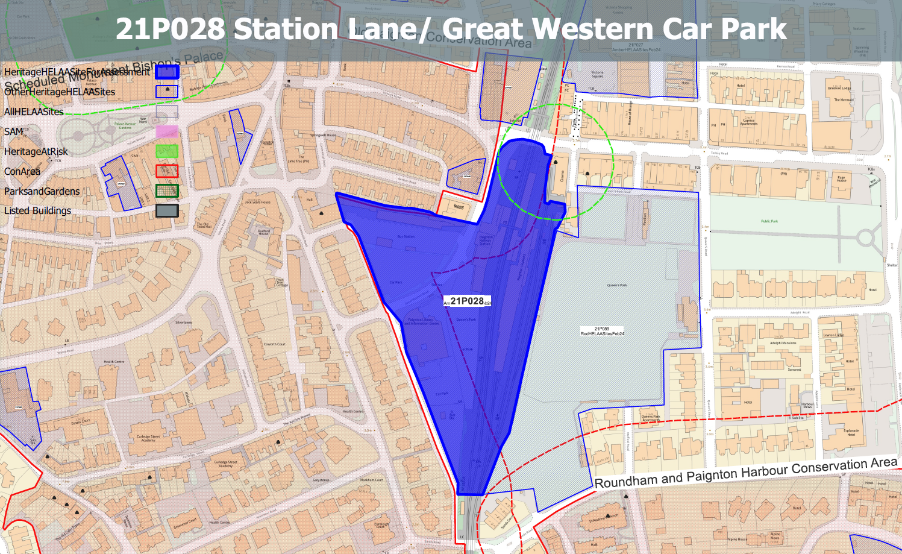
Site overview and heritage context:
Large area within Paignton’s town centre located between the railway line which forms the eastern part of the site and Station Lane which forms the western boundary. Great Western Road bisects the site into a western portion comprising the bus station and associated car park and an eastern portion comprising the railway station and car park, a taxi rank, and a recent contemporary building containing the Paignton Library and Information Centre.
The site sits on the border of the Paignton Old Town Conservation Area and is surrounded by a number of designated heritage assets.
Archaeology: Historic settlement core and industrial archaeological potential. Requires programme of archaeological mitigation.

Planning History:
P/2008/1000 - Proposed Community Library and Customer/Community Services Hub – APPROVED 08/12/2008

Heritage Asset Affected by Allocation | Designation | Contributing Elements to Significance | Impact of Development on Significance | Mitigation Measures for any Identified Harm /Opportunities to Enhance Significance | Impact on Significance with Mitigation in place
Paignton Old Town Conservation Area (SW of site) | Conservation Area | The conservation area evidences the origins of Paignton from its medieval core to the expansive developments of the 19th and 20th century’s which illustrate its growth as a popular seaside resort. It has a wide range of architectural typologies, predominantly 19th century which evidence the expansion of the town.  The site sits outside of the boundary of the conservation area but is visible from numerous points within it and is within its urban setting. It currently makes a negative contribution to the asset’s significance in its current form as a bus station and car park. | The development of the site to the quantum stated could be achieved through sensitive design which respects the surrounding historic environment and improves on the existing architectural quality of the site. This would have a positive impact on the significance of the asset. | n/a | Positive
Paignton Picture House (Torbay Cinema) (S of site) | Grade II* listed building | Purpose built cinema dating from the early 20th century in a free Baroque style with Art Nouveau decorative details. The site sits within the urban setting of the asset. It elements of the site containing the steam railway make a positive contribution to the asset’s significance. | The loss of the railway infrastructure and associated buildings adjacent to the asset as a result of development would cause less than substantial harm to the significance of the asset. | Development should be sited away from the steam railway and its associated infrastructure and be located west of the existing railway line. This would result in a neutral impact to the asset. | Neutral
4-16 Torbay Road (S of site) | Grade II listed building | Row of 7 shops with accommodation over and to the rear. c1890-1900.  The site sits within the urban setting of the asset and makes a neutral contribution to its significance. | The development of the site to the quantum stated could be achieved through sensitive design which respects the surrounding historic environment and improves on the existing architectural quality of the site. This would have a neutral impact on the significance of the asset. | n/a | Neutral
United Reformed Church and adjoining school (immediately W of site) | Grade II listed building | Non-conformist chapel. 1886 to the designs of GS Bridgman, contractor HP Raddich. The site sits within the urban setting of the asset. It currently makes a negative contribution to the asset’s significance in its current form as a bus station and car park. | The development of the site to the quantum stated could be achieved through sensitive design which respects the surrounding historic environment and improves on the existing architectural quality of the site. This would have a positive impact on the significance of the asset. | n/a | Positive

