Heritage Impact Assessment: Victoria Square Multi Storey Car Park, Paignton
HELAA2021 Ref: | 21P027
Site Address: | Victoria Square Multi Storey Car Park, Paignton
Site Area (ha): | 1.56
Site Yield: | 60
HIA Assessment

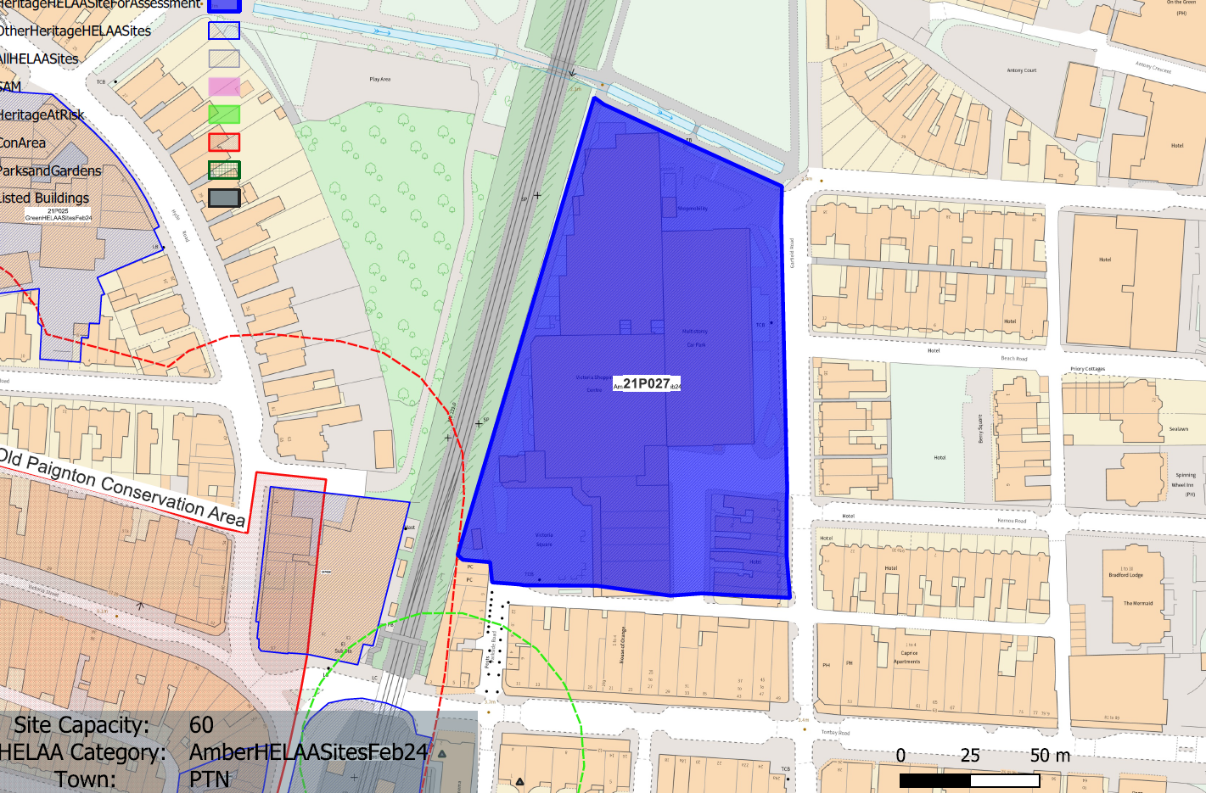
Site overview and heritage context:
Vacant car park at Victoria Square, facing onto Garfield Road and range of buildings facing Victoria Square.
The site is nearby to the Paignton Old Town Conservation Area and Paignton Picture House and a Grade II listed terrace on Torbay Road to the south.
Archaeology: Former marsh. Potential for palaeoenvironmental evidence if groundworks deep. May require programme of archaeological mitigation.

Planning History:
P/2024/0690 - Demolition of Victoria Centre and Victoria Car Park West to facilitate redevelopment of site as per Torbay Local Plan – PRIOR APPROVAL GRANTED – 29/10/2024

Heritage Asset Affected by Allocation | Designation | Contributing Elements to Significance | Impact of Development on Significance | Mitigation Measures for any Identified Harm /Opportunities to Enhance Significance | Impact on Significance with Mitigation in place
Paignton Old Town Conservation Area (SW of site) | Conservation Area | The conservation area evidences the origins of Paignton from its medieval core to the expansive developments of the 19th and 20th century’s which illustrate its growth as a popular seaside resort. It has a wide range of architectural typologies, predominantly 19th century which evidence the expansion of the town.  The site sits outside of the boundary of the conservation area but is visible from within it from vantage points along Victoria Rd. It currently makes a neutral contribution to the significance of the conservation area. | The development of the site to the quantum stated could be achieved through sensitive design which respects the surrounding historic environment and improves on the existing architectural quality of the site. This would have a neutral impact on the significance of the asset. | n/a | Neutral
Paignton Picture House (Torbay Cinema) (S of site) | Grade II* listed building | Purpose built cinema dating from the early 20th century in a free Baroque style with Art Nouveau decorative details. The site sits within the urban setting of the asset and currently presents a visually unappealing face to it, although this is only glimpsed through views along Parkside Rd, this results in a neutral impact to its significance. | The development of the site to the quantum stated could be achieved through sensitive design which respects the surrounding historic environment and improves on the existing architectural quality of the site. This would have a neutral impact on the significance of the asset. | n/a | Neutral
4-16 Torbay Road (S of site) | Grade II listed building | Row of 7 shops with accommodation over and to the rear. c1890-1900.  The site sits within the urban setting of the asset and currently presents a visually unappealing face to it, although this is only glimpsed through views along Parkside Rd on the western end of the terrace, this results in a neutral impact to its significance. | The development of the site to the quantum stated could be achieved through sensitive design which respects the surrounding historic environment and improves on the existing architectural quality of the site. This would have a neutral impact on the significance of the asset. | n/a | Neutral

