Heritage Impact Assessment: Corner of Hyde Rd and Torbay Rd, Paignton
HELAA2021 Ref: | 21P026
Site Address: | Corner of Hyde Rd and Torbay Rd, Paignton
Site Area (ha): | 0.27
Site Yield: | 50
HIA Assessment

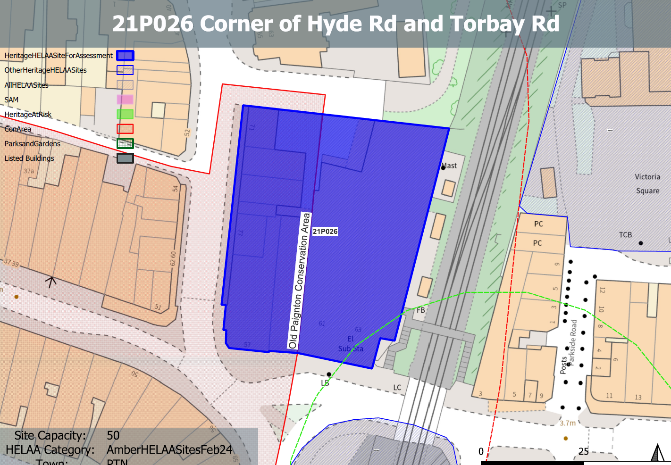
Site overview and heritage context:
A block of buildings in Paignton’s town centre, located between Hyde Road, Torbay Road, and the railway line, with a service lane to the rear. The ground floor comprises of retail frontages onto Hyde Road and Torbay Road. The eastern half of the site comprises a triple storey utilitarian building with a flat roof, while the southwestern part of the site comprises a triple storey Victorian building that has some degree of heritage value.
The western part of the site is included within the boundaries of the Paignton Old Town Conservation Area and the Grade II* Paignton Picture House is located to the south east of the site along Torbay Rd.
Archaeology: Former marsh. Potential for palaeoenvironmental evidence if groundworks deep. May require programme of archaeological mitigation.

Planning History:
Various related to minor changes to shopfronts.

Heritage Asset Affected by Allocation | Designation | Contributing Elements to Significance | Impact of Development on Significance | Mitigation Measures for any Identified Harm /Opportunities to Enhance Significance | Impact on Significance with Mitigation in place
Paignton Old Town Conservation Area | Conservation Area | The conservation area evidences the origins of Paignton from its medieval core to the expansive developments of the 19th and 20th century’s which illustrate its growth as a popular seaside resort. It has a wide range of architectural typologies, predominantly 19th century which evidence the expansion of the town.  The site sits partly within the conservation area and is identified as a positive contributor due to the architectural details, materiality  and historic proportions of the  building contributing to the historic character of the streetscape. | The development of the site to the quantum stated could be achieved through the sensitive use of the Victorian structures on the site and the redevelopment of the remaining structures whilst utilizing an urban grain, scale and overall design approach which responds to the history of the site, and which sensitively relates to the surrounding townscape.  This would have a positive impact on the significance of the conservation area. | n/a | minor positive
Paignton Picture House (Torbay Cinema) (SE of site) | Grade II* listed building | Purpose built cinema dating from the early 20th century in a free Baroque style with Art Nouveau decorative details. The site sits within the urban setting of the asset and currently presents a visually unappealing face to it, resulting in a minor negative impact to its significance. | The development of the site to the quantum stated could be achieved through the sensitive use of the Victorian structures on the site and the redevelopment of the remaining structures whilst utilizing an urban grain, scale and overall design approach which responds to the history of the site, and which sensitively relates to the surrounding townscape.  This would have a minor positive impact on the significance of the asset. | n/a | Minor positive
4-16 Torbay Road (SE of site) | Grade II listed building | Row of 7 shops with accommodation over and to the rear. c1890-1900.  The site sits within the urban setting of the asset and currently presents a visually unappealing face to it, resulting in a minor negative impact to its significance. | The development of the site to the quantum stated could be achieved through the sensitive use of the Victorian structures on the site and the redevelopment of the remaining structures whilst utilizing an urban grain, scale and overall design approach which responds to the history of the site, and which sensitively relates to the surrounding townscape.  This would have a minor positive impact on the significance of the asset. | n/a | Minor positive

