Heritage Impact Assessment: Land South of Totnes Road, Collaton St Mary Paignton
HELAA2021 Ref: | 21P015
Site Address: | Land South of Totnes Road, Collaton St Mary, Paignton
Site Area (ha): | 14.6
Site Yield: | 310
HIA Assessment

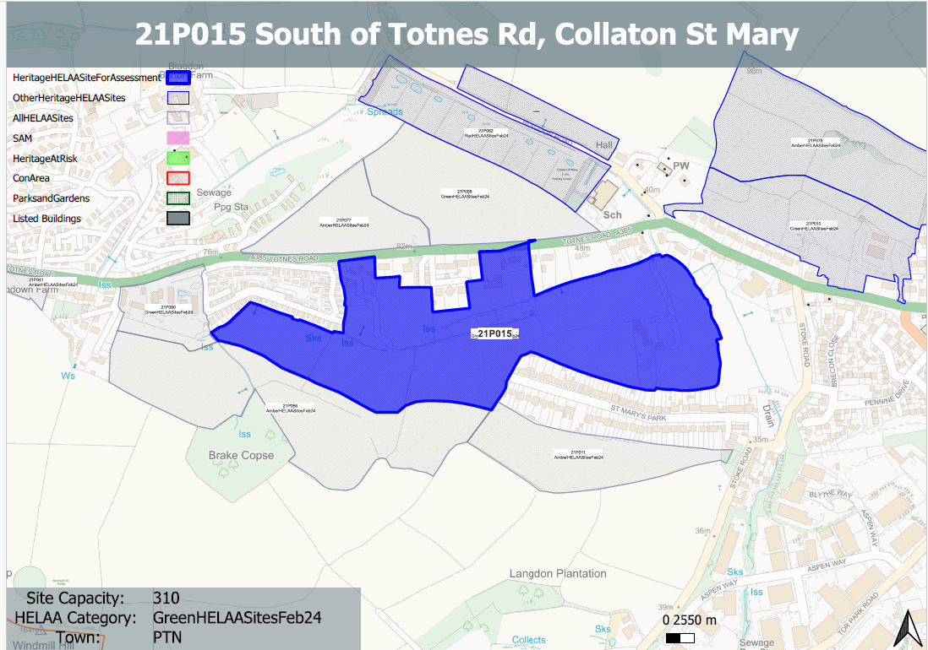
Site overview and heritage context:
A number of fields located to the south of Totnes Road.
The existing field system is largely laid to pasture with hedge borders and the occasional small copse.. The general character is a transitional one from an edge of town, residential character to the east and south to a rural character with more intermittent development (largely residential ribbon development and holiday parks) to the west. The topography of the site comprises a relatively steep rise to the south.
There are a number of designated heritage assets nearby, predominantly a cluster of listed buildings to the north centred around the Church of St. Mary, and a farmhouse to the east.

Planning History
Various relating to minor/household developments for existing properties on the site

Heritage Asset Affected by Allocation | Designation | Contributing Elements to Significance | Impact of Development on Significance | Mitigation Measures for any Identified Harm /Opportunities to Enhance Significance | Impact on Significance with Mitigation in place
Church of St Mary (N of site)  Memorials within churchyard (N of site)  Old Vicarage (N of site)  Lych Gate (N of site)  Drinking fountain at the junction of Totnes and Blagdon Road (N of site)  Collation Farmhouse  and associated farmyard (E of site)  Collaton St. Mary School (N of site)  391-393 Totnes Road (N of site) | Grade II* listed building  Grade II listed buildings  Grade II listed building  Grade II listed building  Grade II listed building  Grade II listed building  Grade II listed building  Grade II listed building | Mid 19th century parish church, set on edge of built development in a rural setting. Group value with lych gate, rectory and school. The site is separated from the church and its churchyard by a band of vegetation to the front of the site, Totnes Road and existing development to the south of the road. The undeveloped fields contribute to the wider rural setting of the parish church but do not share intervisibility with it.  Monuments of varying ages within churchyard. Setting is limited to the immediate area within the churchyard and the church itself.  Rectory, now in use as house and offices dating from 1864. Has clear relationship and group value with neighbouring church, lych gate and school. The site is separated from the asset and its grounds by a band of vegetation to the front of the site, Totnes Road and existing development to the south of the road. The undeveloped fields contribute to the wider rural setting of the asset.  Mid 19th century lych gate in association with church, rectory and school which have group value. The undeveloped fields contribute to the wider rural setting of the asset but do not share intervisibility with it.  C1900 drinking fountain. The site would make a small contribution to the rural setting of the asset.  located to the east of the site and separated from it by existing development and existing bands of mature vegetation. In terms of the setting of these building this is now very much influenced by main road and what is largely now a semi urban character. The site makes a very limited contribution to its significance by providing a continued semi-rural setting to an historic farmhouse and farmyard.  Mid 19th century school which has group value with the church, lych gate and vicarage. The site is somewhat divorced from the heritage asset and makes little contribution to its setting or significance.  Pair of late 18th century cottages. The cottages principal elevations face away from the site. The site forms a rural backdrop to the asset; however, the rural setting of the asset is diluted by the presence of existing development immediately to the west and further to the south. The site in its undeveloped form does make a positive contribution to the rural setting of the asset and its significance. | Neutral impact on significance  Neutral impact on significance  Neutral impact on significance  Neutral impact on significance  Neutral impact on significance  Neutral impact on significance  Neutral impact on significance  Less than substantial harm | Provide a green buffer to the site and appropriate landscaping to retain a rural character of the site. Adopt a landscape-led approach to ensure that the proposed development of the site sits comfortably within its surroundings.  n/a  Provide a green buffer to the site and appropriate landscaping to retain a rural character of the site. Adopt a landscape-led approach to ensure that the proposed development of the site sits comfortably within its surroundings.  n/a  n/a  Provide a green buffer to the site and appropriate landscaping to retain a rural character of the site. Adopt a landscape-led approach to ensure that the proposed development of the site sits comfortably within its surroundings.  n/a  Provide a green buffer to the site and closest to the asset and install appropriate landscaping to retain a rural character of the site. Adopt a landscape-led approach to ensure that the proposed development of the site sits comfortably within its surroundings. | Neutral  Neutral  Neutral  Neutral  Neutral  Neutral  Neutral  Neutral

