Heritage Impact Assessment: Land North of Totnes Road, Paignton
HELAA2021 Ref: | 21P010
Site Address: | Land North of Totnes Road, Paignton
Site Area (ha): | 4.7
Site Yield: | 100
HIA Assessment

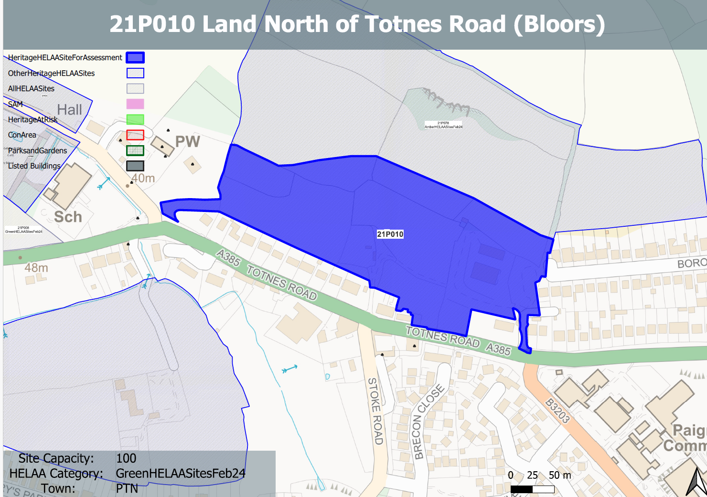
Site overview and heritage context:
The site is open land that slopes steeply from the road at 40.00 AOD to 88.0AOS at the north boundary of the site up to 93.0AOD at the crown of the hillside beyond. The site running east to west is an even slope from the Church to the west to Borough Park Road in the east following the contours in a fairly regular manner. One of the principal features of the sloping site is the natural ‘valley’ that forms a clear ‘shallow scoop’ at the centre of the site
Although largely contained behind the existing frontage development there is a section of the site that fronts directly onto the Totnes Road, comprises a hedge-lined frontage of approximately 64 metres forming a gap between existing residential plots. There is also an access to the existing developed area within the site further east, close to the brow of the hill and the junction with Borough Road.
The existing field system is largely laid to pasture with hedge borders and the occasional small copse. The site is quite steep in places and there is a considerable rise in ground levels across the site. The general character is a transitional one from an edge of town, residential character to the east to a rural character with more intermittent development (largely residential ribbon development and holiday parks) to the west.
There are a number of designated heritage assets nearby and immediately to the south of the site across the Totnes Road lies the Grade 2 listed Collaton Farm building and (converted) barns. To the west, off Blagdon Road there is the Grade 2* listed Church of St Mary, Grade 2 Old School House and Old Vicarage, and a further four Grade 2 listed properties, 391-393 Totnes Road.

Planning History
P/2024/0368 - Major Reserved Matters relating to outline consent application P/2019/0281: Development of up to 100 dwellings, including affordable and market housing. Associated landscaping, open space, drainage and highways infrastructure at Land North of Totnes Road together with new access onto Totnes Road. Matters relating to condition 01 (RM): (i) layout, (ii) scale, (iii) appearance, (iv) landscaping. – Under consideration
P/2022/0888 – Reserved matters relating to P/2019/0281 (Up to 100 dwellings) - relating to (i) layout, (ii) scale, (iii) appearance; and (iv) landscaping. at Land North of Totnes Road Collaton St Mary Paignton TQ3 3TZ – Approved (3rd May 2023
P/2019/0281 - Development of up to 100 dwellings, including affordable and market housing. Associated landscaping, open space, drainage and highways infrastructure at Land North of Totnes Road together with new access onto Totnes Road. – Approved 18th June 2021)

Heritage Asset Affected by Allocation | Designation | Contributing Elements to Significance | Impact of Development on Significance | Mitigation Measures for any Identified Harm /Opportunities to Enhance Significance | Impact on Significance with Mitigation in place
Church of St Mary  Memorials within churchyard  Old Vicarage (west of site)  Lych Gate  Drinking fountain at the junction of Totnes and Blagdon Road  Collation Farmhouse  and associated farmyard  Collaton St. Mary School  391-393 Totnes Road | Grade II* listed building  Grade II listed buildings  Grade II listed building  Grade II listed building  Grade II listed building  Grade II listed building  Grade II listed building  Grade II listed building | Mid 19th century parish church, set on edge of built development in a rural setting. Group value with lych gate, rectory and school The site is separate from the church and its churchyard by a band of vegetation and partly by the existing vicarage. The undeveloped fields contribute to the rural setting of the parish church.  Monuments of varying ages within churchyard. Setting is limited to the immediate area within the churchyard and the church itself.  Rectory, now in use as house and offices dating from 1864. Has clear relationship and group value with neighbouring church, lych gate and school. The site borders the asset to the east and south and makes a positive contribution to its rural setting.  Mid 19th century lych gate in association with church, rectory and school which have group value. The site is separate from the lych gate by a band of vegetation and is not readily seen in context with this asset, however, the undeveloped fields so make a contribution to its rural setting.  C1900 drinking fountain. The site would make a small contribution to the rural setting of the asset to the NE, dependent on the level of foliage coverage of nearby band of mature vegetation  located to the south of the site, opposite the site entrance and on the opposite side of the Totnes Road. In terms of the setting of these building this is now very much influenced by main road and what is largely now a semi urban character. The site makes a limited contribution to its significance by providing a continued semi-rural setting to an historic farmhouse and farmyard.  Mid 19th century school which has group value with the church, lych gate and vicarage. The site is somewhat divorced from the heritage asset and makes little contribution to its setting or significance.  Pair of late 18th century cottages. The cottages principal elevations face the site which is located on the opposite side of Totnes Road, however the areas of the site which are laid to pasture are not experienced from the asset due to existing built development. | Less than substantial level of harm  Neutral impact on significance  Less than substantial level of harm  Neutral impact on significance  Neutral impact on significance  Less than substantial harm  Neutral impact on significance  Neutral impact on significance | Provide a green buffer to the site and appropriate landscaping to retain a rural setting to the asset and design the appearance of any new development within this area of the site to reflect the details and materials of the church and surrounding assets in order to reference and respect the historic character of the area.  n/a  Provide a green buffer to the site and appropriate landscaping to retain a rural setting to the asset and design the appearance of any new development within this area of the site to reflect the details and materials of the church and surrounding assets in order to reference and respect the historic character of the area  n/a  n/a  Soft landscaping within and bordering the site to provide a softer setting to reference the assets former rural surroundings  n/a  n/a | Neutral  Neutral  Neutral  Neutral  Neutral  Neutral  Neutral  Neutral

