Kitchen Entrance

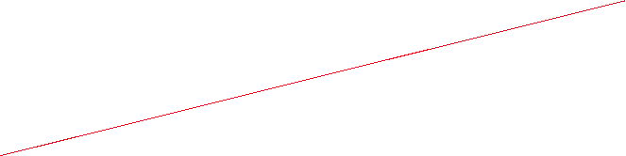

Prezzo Torquay

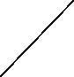

Front Entrance

Side Entrance

1m

7 m

10 tables of 4 – 40 covers