Notice of Making
Borough of Torbay
(Street Parking Places {Pay & Display}) Amendment Order No1 2024
Torbay Council made the above Order on 1st May 2025 under the provisions of the Road Traffic Regulation Act 1984, to come into force on 9th May 2025. The effect is to implement the following measures in the specified roads:-
Revocation of Pay & Display Parking 8am to 6pm
Torwood Street.
Revocation of Pay & Display Parking 11am to 6pm
Torwood Street.

Documents giving more detailed particulars of the Order may be inspected between 9:00am and 5:00pm each working day at the Torbay Council Connections Office, Paignton Library and Information Centre, Great Western Road, Paignton, TQ3 3HZ. The documentation may also be viewed online at the following web address: www.torbay.gov.uk/proposedtros

If any person wishes to question the validity of the order or of any of its provisions on the grounds that such is not within the powers conferred by the Act, or that any requirement of the Act or of any instrument made under the Act has not been complied with, that person may within six weeks from the appearance of this advertisement apply to the High Court for this purpose.
Date: 8th May 2025  Anne-Marie Bond  Chief Executive  Torbay Council  Town Hall, Castle Circus  TORQUAY TQ1 3DR | 

DATED: 1st May 2025

BOROUGH OF TORBAY,
(STREET PARKING PLACES {PAY & DISPLAY})
AMENDMENT ORDER No1 2024

ANNE-MARIE BOND
Chief Executive
Torbay Council
Town Hall
Torquay
TQ1 3DR

On Street Order.

BOROUGH OF TORBAY
(STREET PARKING PLACES {PAY & DISPLAY})
AMENDMENT ORDER No1 2024

Torbay Council (hereinafter referred to as ‘the Council’) in exercise of their powers under Sections1 (1), 2(1) – (3), 4(2), 45, 46, 46C, 49, 53 and Part IV of Schedule 9 of the Road Traffic Regulation Act 1984 (“the Act”) and of all other enabling powers and after consultation with the Chief Officer of Police in accordance with Part III of Schedule 9 of the hereby make the following Order:-
Part I

1. This Order shall come into operation on the 9th day of May 2025 and may be cited as “Borough of Torbay (Street Parking Places {Pay & Display}) Amendment Order No1 2024”.

- Without prejudice to anything done before or to any liability incurred before the coming into force of this Order, the Orders specified in Schedule 1 are hereby revoked.

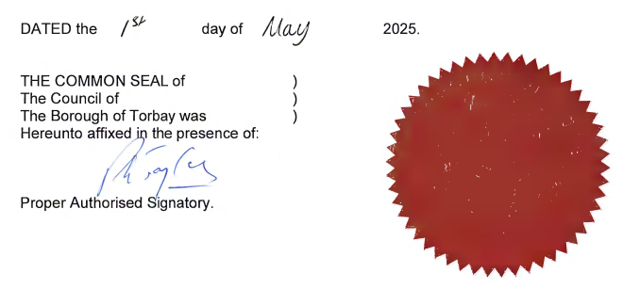

Schedule 1: Revocations

Pay & Display Parking 8am to 6pm

Torwood Street
The south side Lay-by opposite Nos. 26-32.

Pay & Display Parking 11am-6pm

Torwood Street
The north side from a point 57 metres west of its junction with The Terrace in a westerly direction for a distance of 15 metres.

