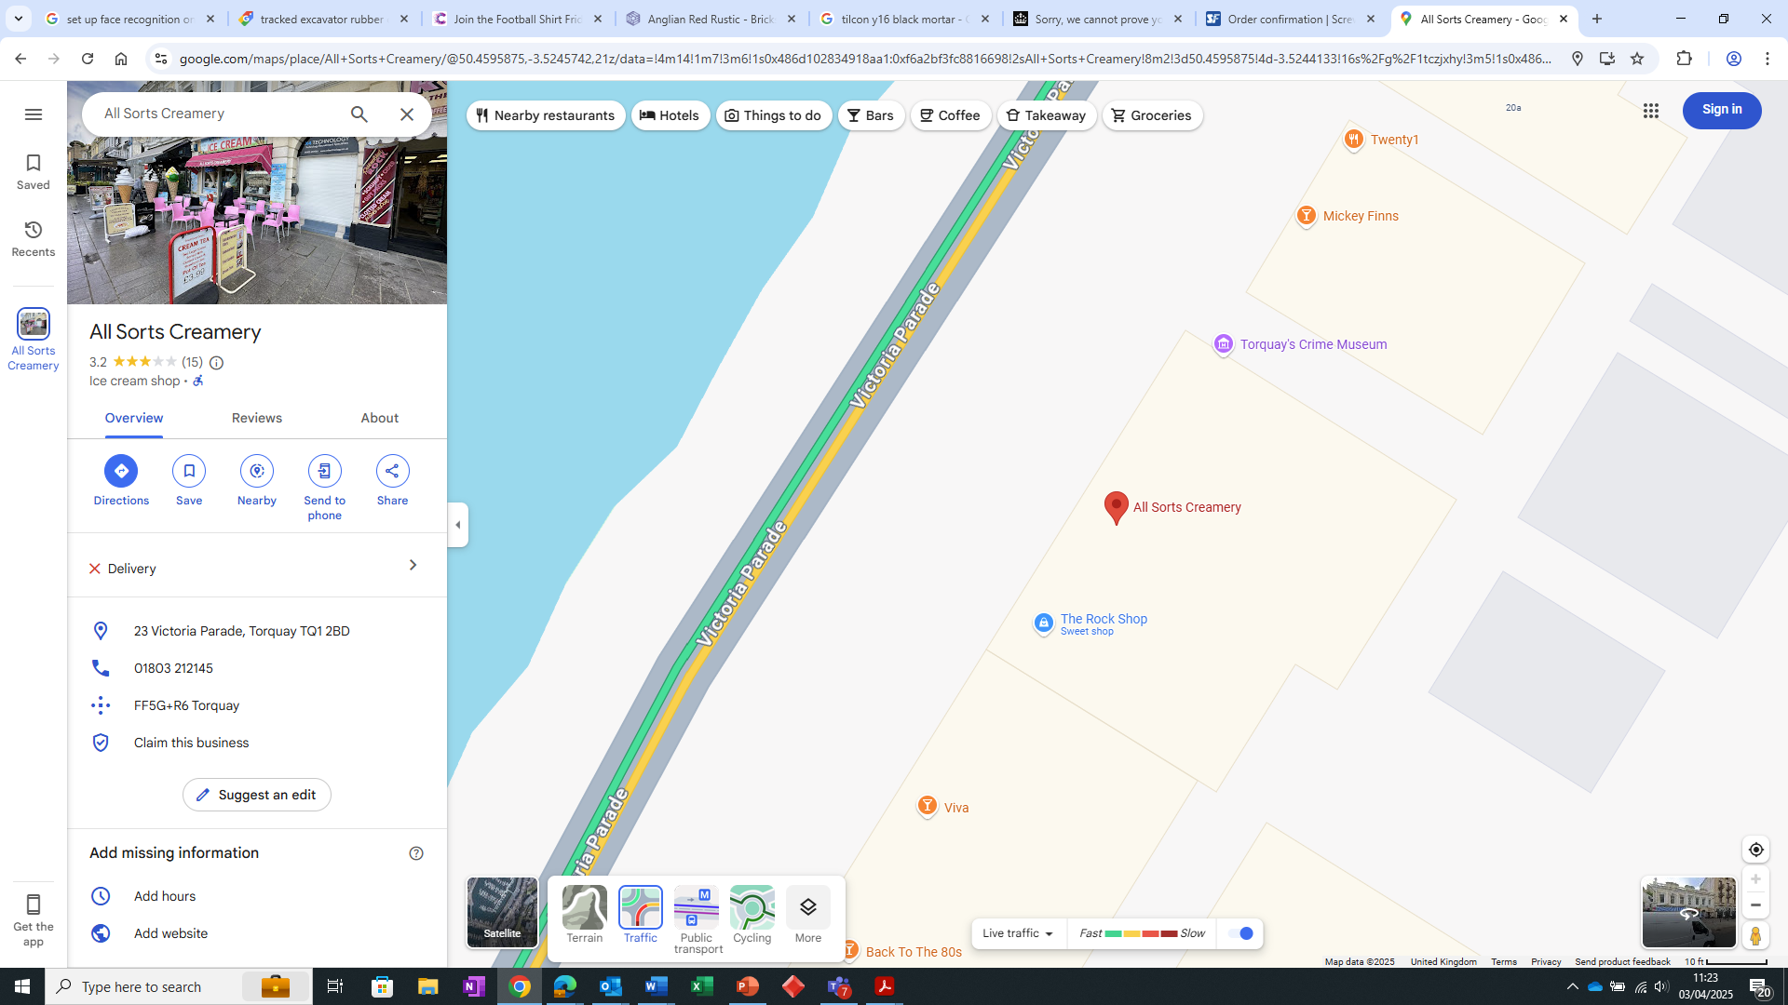

Area to site 6nr tables & 18nr chairs

6m

2.5m