Notice of Variation
Borough of Torbay
(Controlled Parking Zones & Resident Permit Parking Places) Variation Order 2025
Notice is hereby given under section 46A of the Road Traffic Regulation Act 1984 by Torbay Council that it is proposed to vary its parking charges from 25th April 2025, as follows.
Residents Parking Permits
The charge for a Resident Parking Permit as per Article 17(4)(a) of the “Borough of Torbay (Controlled Parking Zones & Resident Permit Parking Places) Consolidation Order 2025” shall be varied from £30 to £35.
Documents giving more detailed particulars of the Order may be inspected between 9:00am and 5:00pm each working day on the self-service computers at the Torbay Council Connections Office, Paignton Library and Information Centre, Great Western Road, Paignton, TQ3 3HZ. The documentation may also be viewed online at the following web address: www.torbay.gov.uk/parking/tro/on-street-tros/

If any person wishes to question the validity of this Order or any of its provisions on the grounds that such is not within the powers conferred by the Act, or that any requirement of the Act or of any instrument made under the Act has not been complied with, that person may within six weeks from the appearance of this advertisement apply to the High Court for this purpose.
Date: Wednesday 2nd April 2025  Anne-Marie Bond  Chief Executive  Torbay Council  Town Hall, Castle Circus  TORQUAY TQ1 3DR | 

DATED: 26th. March 2025

BOROUGH OF TORBAY
(CONTROLLED PARKING ZONES & RESIDENT PERMIT PARKING PLACES)
VARIATION ORDER 2025

ANNE-MARIE BOND
Chief Executive
Torbay Council
Town Hall
Torquay
TQ1 3DR

On Street Order.

BOROUGH OF TORBAY
(CONTROLLED PARKING ZONES & RESIDENT PERMIT PARKING PLACES)
VARIATION ORDER 2025

Notice is hereby given under section 46A of the Road Traffic Regulation Act 1984 by Torbay Council that it is proposed to vary its parking charges.

1. This Order shall come into operation on the 25th April 2025 and may be cited as “Borough of Torbay (Controlled Parking Zones & Resident Permit Parking Places) Variation Order 2025”.

2. Without prejudice to the validity of anything done or to any liability incurred in respect of any act or omission before the coming into force of this Order, the charge for a Resident Parking Permit contained within Article 17(4)(a) of the “Borough of Torbay (Controlled Parking Zones & Resident Parking Permit Places) Consolidation Order 2025” shall be varied from £30 to £35.

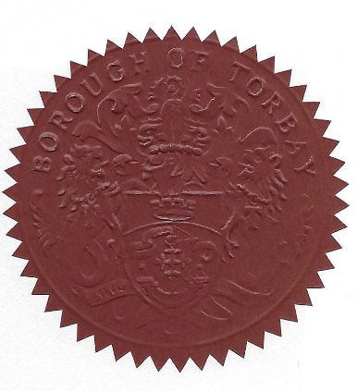
DATED the 26th. day of March 2025

THE COMMON SEAL of )
The Council of )
The Borough of Torbay was )
Hereunto affixed in the presence of:


Proper Authorised Signatory.

