Briefing Note
Torbay Local Plan
A Strategic Study of the Best and Most Versatile Land
Required for Housing and Employment (August 2024

Torbay Council has appointed Environmental Planning (Chris Stapleton BSc, PIEMA, BSSS) to assess the impact of potential future development upon Best and Most Versatile (BMV) agricultural land in Torbay. Natural England requested a strategic study of potential loss of BMV agricultural land due to housing and employment allocations in the Local Plan. This study has now been completed and is available online at: The local plan update: a landscape to thrive - Torbay Council. It does not form council policy, but will help to inform the forthcoming Local Plan.

The study considers four potential growth scenarios based on the emerging local plan and the Housing and Economic Land Availability Assessment (HELAA, 2021):
- Regulation18 Housing Site Options Consultation October 2022 (equal to about 300 dwellings a year).
- Regulation 18 plus a limited number of additional sites, (Difficult to give a precise number but about 320 dwellings per year).
- Regulation 18 plus significant additional sites not ruled out in principle by the HELAA; (Difficult to give a precise number but about 400 dwellings per year); and
- All sites in the HELAA. Necessary to achieve the “Standard Method” of about 600 dwellings a year.
(Please note that the likely number of dwellings arising from each scenario is very approximate, and dependent upon which sites are actually selected. Reference to the Standard Method local housing need figure relates to the current method, rather than the revised standard method, proposed by the government in July 2024).

The study found that Torbay has a largely developed urban coastline, with agricultural land covering just under 30% of the area (1826 ha), located mainly to the west of Torbay. About 47% (just under 858ha) of Torbay’s agricultural land is assessed to be of BMV quality, which is higher than the national average of 42%.

There is no single answer about an acceptable level of loss of BMV land. Factors such as climate change, the world situation, emerging best practice and government guidance will all need to be kept under review. Under the Regulation 18 scenario (2022), the projected annual BMV land loss over the plan period (18 year) is 6.63 hectares, constituting 0.32% of annual loss in comparison to the 1% national threshold for significant cumulative impact.

Housing and employment allocations in the Local Plan (Reg 18) would result in the loss of 119.4 hectares of BMV land. Under the Regulation 18 (Scenario 1), the projected annual BMV land loss over the plan period (18 year) is 6.63 hectares, constituting 0.32% of annual loss in comparison to the 1% national threshold for significant cumulative impact. The Council's approach to land allocation has been found to be reasonable and proportionate given environmental and geographical constraints.

The study indicated some limited headroom for additional land loss associated with options 1, 2 and 3. i.e. some limited scope to exceed the 300 dwellings a year in the Regulation 18 Housing Site Options consultation (2022). However, Option 4 beaches this figure. Meeting the Standard Method level of growth would significantly exceed the level of BMV loss deemed to be sustainable.
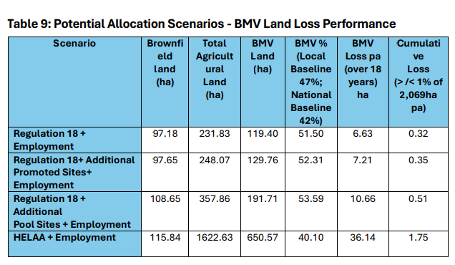
The study recommends that developers should be required to provide a detailed site-specific agricultural land classification (ALC) survey (if it is unknown) and soil resource survey .This will:
- Assist promoting sites with a lower agricultural land quality,
- Identify opportunities to reduce hard development on BMV land, and
- Allow for soil conservation measures (e.g. removal of soils) where land is proposed for development.

The National Planning Policy Framework (NPPF) (2023) acknowledges the value of BMV land and the need for its preservation. Broad principles and methodologies for evaluating BMV land loss are set out in the IEMA guidelines “A New Perspective on Land and Soils in EIA” (2022). Detailed Agricultural Land Classification (ALC) surveys conducted in 1985 and 1994 provide a foundational picture of land quality in Torbay. Natural England produced predictive maps in 2017, based on desktop modelling rather than onsite assessment.
A contribution of more than say 1% of the 5-year average land loss could be deemed potentially significant at a national scale, but because the loss of land cannot be mitigated, it is the rate of change in this figure that is significant. Determining the rate of change requires the comparison of a rolling sequence of 5-year averages.

