

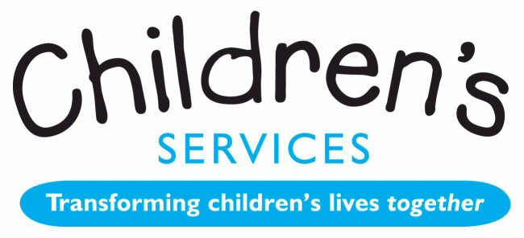
Quick Reference Guide for Schools:
Pupil Premium Plus for Children Looked After
Financial year 2014-2015

It is advised that you read the Pupil Premium Plus policy in full and use this as a quick reference guide only once familiar with the policy.
Changes
PPP is £1,900 per child.
- PPP payments based on a fully costed high quality PEP AP. Schools may need to provide evidence of what is being funded from their own resources before PPP can be allocated.
- Grant allocation overseen by VSHT to improve outcomes and “narrow the gap” as identified in the PEP.
- PEPs will need to be monitored even more closely by DTs, the VS team, SWs, team leaders and IROs.
- Therefore, our allocation of PPP needs to move to a “child’s needs driven model”, managed through high quality PEPs.
- YP eligible as soon as they enter care.
- VSHTs make effective arrangements for allocating PPP.
- Overall grant allocated to each LA calculated on a per capita basis. LA does not have to distribute on a per capita basis, given that YP have differing levels of need at different stages.
- All PEPs need to be sent to claire.jones@torbay.gov.uk as well as the social worker to enable the VSHT to check the APs.
- The PEP paperwork must be received by the SW and the VS no later than 10 days after the PEP meeting.

PEPs
- PEP APs will act as the application for PPP funding.
- Clear quantitative [and exceptionally qualitative] targets for improvement, underpinned by well-targeted support must be provided.
- The PPP must be used to improve outcomes for children in the following areas:
- academic achievement and progress
- wider achievement e.g. in an area in which the child is G and T
- attendance
- inclusion by reducing internal and external exclusion
- social skills
- transition into the next key stage and/or a new learning provider
- The PEP AP will show the baseline data, target for improvement, expected outcomes and cost of support:
  - e.g. Sam is below National Age Related Expectations in reading. To enable Sam to accelerate progress in reading, he will have 40 hours of one to one support at £30 per hour, membership of Letterbox Club (provided by VS) and 15 minutes a night of reading with foster carers recorded in his reading log. Time period for achievement of this target: September 2014 - July 2015. Measured by: progress from 2c to 3c.

- Studies have shown 1-1 tuition has positive impact for CLAs. We will fund 1-1 tuition at a standard rate of £30 per hour with a qualified teacher from the PPP.
- For YP who start reception or yr 7 in Sep 14, schools can apply for a max. of £1260 to cover the period Sep14 - March 15 unless the needs of the YP are such that they need an enhanced package of intervention.
- For all other learners, schools can apply for a maximum of £1,900 unless the needs are such that they need an enhanced package of intervention.
- PEPs remain 6 monthly

PPP Policy

How and why will the amount of PPP vary?
- YP’s needs vary and can ‘spike’
- For some £1900 is only a fraction of the cost of the support they need e.g.:
- YP in emergency placements who are behind academically
- Children who have to move into or out of city in an emergency
- YP placed out of Torbay where the level of support may not be the same
- where there is delayed reaction to abuse and neglect resulting in behavioural ‘spikes’
- Therefore, there may be a significant difference in the amount of PPP distributed.
- Proposals to pool PPP in a school to enhance services, providing its use is directly linked to CLAs needs via the PEP, are allowed.

Circumstances in which PPP will not be provided
- PPP will not be used to double fund or replace funding which should already have been allocated to the school:
- to fund services that should be provided via a statement, or EHC plan
- other statutory work e.g. statutory assessment or support from health
- The interventions put in place do not require any funding
- The school’s own funding covers the cost of the interventions
- The PEP AP does not meet requirements
- Interventions which have no link to CLA’s needs will no longer be permitted.

Recoupment policy
- We reserve the right to recoup the funding if there is evidence that the funding is not being used to address the CLA’s needs
- We will not recoup PPP where a child moves during the term, unless the termly amount is greater than £630

- Please refer to the full PPP policy for the details of the allocation of funding to different types and locations of schools.
Please ensure you have read the policy in full before contacting
the VS with any queries.
- Glossary
- AP- action plan PEP- personal education plan
- CLA- children looked after PPP- pupil premium plus
- DTs - designated teachers
- G and T- gifted and talented SWs- social workers
- IROs- independent reviewing officers VS- Virtual School
- LAs- local authorities VSHT- Virtual School Head Teacher
- VSGB- Virtual School Governing Body

