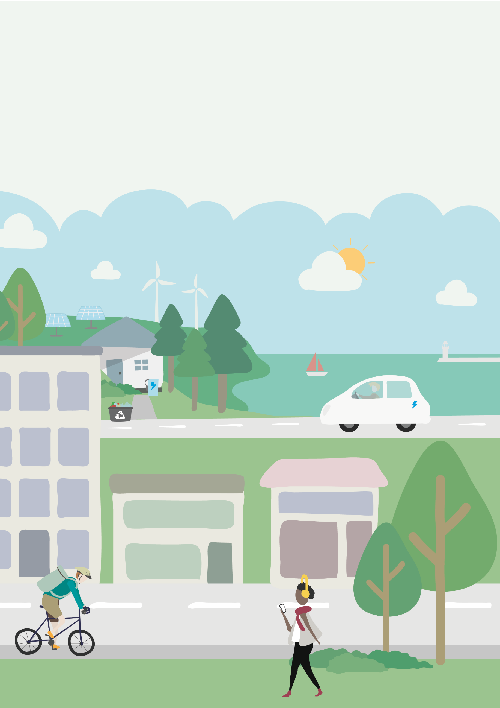

A Greener way for our Bay
  - Framework and Action Plan

Consultation Draft

Contents
Executive Summary 5
Unprecedented Global Warming 5
Torbay’s climate initiatives 5
Strategic Framework and Action Plan for Climate Action 6
The immediate plans 8
Pathway to 2050 12
Background 14
Climate change evidence 14
Impact on the UK and Torbay 15
Mitigation and adaptation action at a national level 16
Mitigating Carbon emissions 16
Adapting to a changing climate 17
A Network of action plans 17
Local and regional action plans 17
Devon Cornwall and Isles of Scilly Adaptation Strategy 17
Devon Carbon Plan 18
Torbay's climate initiatives 18
The importance of a coordinated plan 18
Torbay Climate Partnership 18
The Partnership's Role 18
Action Focused Partnership 18
Community and Stakeholder Engagement 19
The Greener Way for our Bay Framework 19
The Greener Way for our Bay Framework - a transitional plan to 2050 19
The need for a coordinated framework 19
Current Carbon emissions in Torbay 20
Headline Targets 21
Ambitions 21
Achieving Net Zero Carbon by 2050 21
Sector-specific actions 22
Areas of focus 22
Interim progress by 2035 22
Outcomes for Torbay by 2050 23
Benefits 23
Conclusion and next steps 23
The Greener Way for our Bay Action Plan 2023 - 2027 24
Priorities 24
Built Environment 24
Power Sector 25
Transport 26
Waste Minimisation and Food 27
Nature Based Actions 28
Net zero businesses, skills, and jobs 28
Behaviour Change and Community Engagement 29
Adapting to a changing climate 30
Other or Cross cutting actions 31
Summary of timelines and tasks 31
Vision for 2027 to 2035 and pathway to 2050 35
Anticipated actions and barriers 2027 - 2035 36
Built environment 36
Power sector 36
Transport 36
Waste minimisation and food 36
Nature-based actions 36
Net zero businesses, skills, and jobs 37
Behavior change and community engagement 37
Adapting to climate change 37
Progress by 2035 37
Summary table of actions from 2027 - 2035 37
Summary of action - Torbay’s pathway to 2050 40
Financing a Balanced Transition 42
A Complex Challenge 42
Overview 42
Transition costs 42
Costs 42
Cost of action 42
Cost of Inaction 43
Household Costs 43
What Can I Do? 43
What Organisations Can Do? 43
Measuring Success 43
Glossary 45

Executive Summary
In response to input from our community and businesses, the Torbay Climate Partnership (TCP) has developed a comprehensive plan to collaboratively achieve a fair for everyone, deliverable plan to tackle climate change and transition to net-zero carbon by 2050 at the latest: the result is this Greener Way for Our Bay Framework and Action Plan.
This framework and action plan strike a balance between immediate actions and long-term strategies, recognising that some measures can be implemented swiftly, while others require careful planning and resource allocation. The framework sets a direction for the long haul, with a series of short-term action plans to guide Torbay through incremental steps towards the 2050 net-zero target.
This plan serves as a framework for action towards Torbay's commitment to becoming a net-zero carbon community by 2050 at the latest. Recognising the distance to this target, we have outlined immediate steps to be taken up to 2027, and a long-term pathway to detailing further actions needed up to 2050 as we progress.
The plan and pathway are designed to be dynamic, with some measures guided by government policies and others driven by local initiatives. These plans are our commitment to making Torbay’s journey to net-zero transparent, fair for all, and flexible to ever changing circumstances.

Unprecedented Global Warming
The current rate of global warming is unparalleled in the Earth’s 4.6 billion year history. The Earth's surface temperature has risen by about 1.1 degrees Celsius since the pre-industrial era, significantly impacting weather patterns, ecosystems and how we live. According to the IPCC, it is unequivocal that human influence has warmed the atmosphere, ocean, and land.
The UK has experienced a 1°C rise in average temperatures since the 1950s, with 2022 being the warmest year on record. Torbay has also observed a warming trend. Regionally, if unchecked, the predicted changes in climate are likely to increase the risk of coastal flooding and surface water flooding, increase heat related health issues and increase disruption to the local transport system.
Torbay, along with the broader UK, is actively developing strategies to both mitigate further climate change and adapt to the changing climate. This involves taking action to protect infrastructure and ecosystems, highlighting the need for urgent and coordinated action.

Torbay’s climate initiatives
Devon and Torbay are committed to achieving net-zero emissions by 2050 at the latest, with interim targets and strategic plans engaging local stakeholders in various sectors. The TCP plays a pivotal role, uniting a wide array of local actors to implement a strategic framework addressing both mitigation and adaptation.
Engagement with the community has shaped Torbay's climate action plans, which are designed to be adaptable and responsive to ongoing developments. Looking forward, the partnership's framework and action plans anticipate emerging challenges, emphasising the importance of a collective approach to local and national climate strategies.

Strategic Framework and Action Plan for Climate Action
A comprehensive framework is vital for Torbay's climate goals, integrating immediate actions with long-term planning and funding strategies. This ensures fair implementation across Torbay and alignment with broader government policies and their legally binding net zero targets. The Framework will work toward Torbay's becoming net-zero emission by 2050 at the latest. The Framework also identifies long term ambitions and outcomes and an interim target to work towards by 2035.
Work undertaken identifies a pathway, which could lead to a 90% reduction through bold local and governmental actions by 2050.
The Framework and Action Plan will aim to do 10 key things.
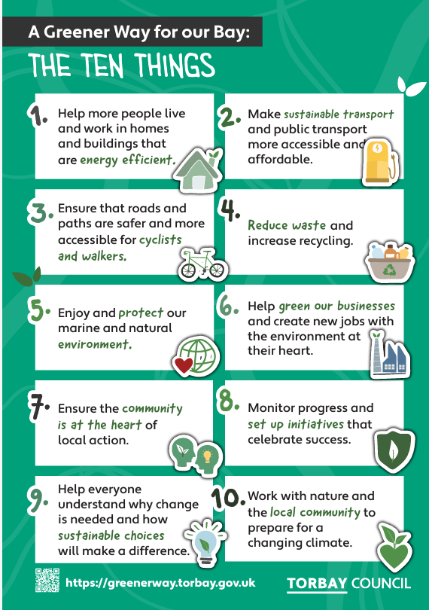
- Help more people live and work in homes and buildings that are energy efficient.
- Make sustainable transport and public transport more accessible and affordable.
- Ensure that roads and paths are safer and more accessible for cyclists and walkers.
- Reduce waste and increase recycling.
- Enjoy and protect our marine and natural environment.
- Help green our businesses and create new jobs with the environment at their heart.
- Ensure the community is at the heart of local action.
- Monitor progress and set up initiatives that celebrate success.
- Help everyone understand why change is needed and how sustainable choices will make a difference.
- Work with nature and the local community to prepare for a changing climate.

Help more people live and work in homes and buildings that are energy efficient.
It will help more people live and work in homes and buildings that are energy efficient with low-carbon heating technologies. Addressing fuel poverty and improving buildings energy ratings are vital for healthy, affordable living spaces. The action plan prioritises insulation for homes and energy reduction in non-domestic buildings, transitioning to heat pumps and setting high standards for new constructions.

Make sustainable transport and public transport more accessible and affordable, and

Ensure that roads and paths are safer and more accessible for cyclists and walkers
The Action Plan focuses on shifting towards sustainable, low-carbon travel options. This transition is not only essential for reaching our net-zero targets but also for improving air quality and public health, and for providing accessible, affordable, and efficient travel options for all residents.

Reduce waste and increase recycling
The amount of waste we create, especially food waste, needs to be reduced. The Action Plan aims to support reducing waste and the associated emissions by more local growing projects and better information and services to help us waste less by reusing, and repairing what we already have, and by recycling and recovering materials and energy.

Enjoy and protect our marine and natural environment
Nature-based actions, such as habitat restoration and rewilding, serve multiple purposes: they sequester carbon, enhance natural resilience against climate impacts, and provide community health benefits. Projects include a new comprehensive plan to restore and protect natural habitats within Torbay and projects to help our local sea grass thrive.

Help green our businesses and create new jobs with the environment at their heart.
Torbay's action plan prioritises the transition of businesses to net-zero operations to significantly reduce the area's emissions. It also recognises the potential for job creation and skills development in the community. Initiatives include aiding around 250 businesses in reducing emissions by 2025, led by the Torbay Development Agency, and launching a green tourism program. These efforts are fundamental for fostering a sustainable economy and aligning business practices with environmental sustainability.

Community Engagement and Innovation
The TCP champions inclusivity and innovation in climate action, emphasising community involvement and support for sustainable technologies and business models. Strengthened collaboration across sectors and regular progress reviews are instrumental. Educational programs aim to instill sustainability values, while adaptation strategies focus on creating a resilient Torbay against climate adversities.

Business Emissions and Economic Opportunities
Torbay's action plan prioritises the transition of businesses, particularly in construction, tourism, and fishing, to net-zero operations to significantly reduce the area's emissions. It also recognises the potential for job creation and skills development in the community. Initiatives include aiding around 250 businesses in reducing emissions by 2025, led by the Torbay Development Agency, and launching a green tourism programme. These efforts are fundamental for fostering a sustainable economy and aligning business practices with environmental sustainability.

Behaviour Change for Climate Goals
The plan stresses the importance of helping us all to understand what we can do to help take action and the wider benefits this action can have for us and Torbay. Actions involve community engagement to raise awareness and promoting sustainable waste, energy, and transport practices. Actions include community, schools and business engagement to raise awareness and promote saving energy, reducing waste, growing food, protecting and enhancing the natural world and walking and cycling.

Work with nature and the local community to prepare for a changing climate.
While reducing carbon emissions is essential, Torbay's plan also includes adaptation measures to prepare for climate impacts. This involves assessing risks to public health, infrastructure, and biodiversity, and enhancing resilience. By 2026, insights from the Met Office and local strategies will inform targeted initiatives to prepare the community and businesses for expected changes in climate.
Torbay's plan features cross-cutting actions to bolster sector-specific efforts, such as fostering a culture of behavioural change, exploring innovative financing, and lobbying for government support.

The immediate plans
Year | Responsible Organisation | Item | Action | KPI | Note
2024 | Various | Waste Minimisation and Food | In 2024, various partners to reduce waste, explore establishing a community repair café. | Number of repair cafés established. | In line with waste reduction goals.
 | Torbay Communities | Waste Minimisation and Food | In 2024 Torbay Communities to explore more local community based growing projects. | Number of food growing projects initiated. | Supports local food production and reduces food miles.
 | Various | Power Sector | Develop a local energy plan with National Grid and partners. | Completion and adoption of a local energy plan. | Aims to ensure Torbay's energy system is ready for a low carbon future.
 | Torbay Council | Transport | In 2024, Torbay Council will develop a new long-term plan for how we travel about Torbay (a Local Transport Plan for Torbay) | Local transport plan developed and approved. | Aimed at encouraging active travel and sustainable forms of public transport.
2025 | Exeter Community Energy (ECOE) | Built Environment | By 2025, Exeter Community Energy (ECOE) to run energy saving clinics, give community talks, recruit, and train, 10 'Community Energy Champions' and visit over 250 homes in need of saving energy advice and grants. | Number of clinics conducted, champions trained, and households assisted. | Targets 250 households in need of energy-saving support.
 | TC and ECOE | Built Environment | By 2025, Torbay Council and ECOE to help more homes out of fuel poverty through advice and grants for energy efficiency and low carbon measures | Reductions in the number of homes that live fuel poverty. | Supporting more people to live in more affordable and energy efficient homes.
 | ECOE and Torbay Council (TC) | Built Environment | Torbay Council and ECOE to develop projects to help more of us to save energy through installing energy efficiency and low carbon measures in our homes. | Number of energy efficiency projects completed. | Aimed at enhancing energy efficiency in homes.
 | TC | Transport | By 2025, Torbay Council to invest in sustainable travel options including more cycling, wheeling, and walking routes. | Several new cycling, wheeling and walking routes have been created to enable more accessibility around Torbay. | Encourage active travel around the Torbay area.
 | Torbay Development Agency (TDA) | Net Zero Businesses, Skills, and Jobs | By 2025 Torbay Council and partners, to deliver Make it Net Zero Torbay business support programme and help just under 250 businesses to reduce their carbon emissions by saving energy, water, and waste + others. | Number of businesses supported to reduce emissions. | Targets around 250 businesses for energy, water, and waste savings.
 | Various | Net Zero Businesses, Skills, and Jobs | By 2025, various partners to develop a green tourism programme and Award and to showcase exemplars of good practice and supporting the overall reputation of Torbay as a sustainable tourism destination. | Programme and award are created and made accessible to those business showing best practice in sustainability. | Encourages local business to place a focus on sustainability and help to work towards climate goals within Torbay.
 | Marine Forum, Torbay Harbour Authority, Wild Planet Trust | Nature-Based Actions | By 2025, the Marine Forum, Wild Planet Trust and other partners to help protect our local sea grasses. | Area of seagrass habitats protected or restored. | Part of nature-based actions for carbon sequestration and marine biodiversity.
 | TCP | Behaviour Change and Community Engagement | By 2025, the TCP, led by the English Riviera UNESCO Global Geopark to tell positive stories of action happening across Torbay. | Number of stories shared and schools engaged. | Focuses on community engagement and environmental education.
 | Torbay Council | Nature-Based Actions | In 2025 Torbay Council and partners to develop a new plan to restore and protect nature. | Completion of a habitat restoration and protection plan. | Part of nature-based actions to tackle climate change and improve biodiversity.
 | Torbay Council | Adapting to a Changing Climate | Torbay Council and partners will use the results of the Met Office’s Torbay City Pack and Devon, Cornwall, and Isles of Scilly’s Adaptation Strategy to assess and ensure Torbay understands current and future vulnerability to a changing climate and takes actions to adapt and prepare. | Assessment completed and adaptation measures identified. | Aims to prepare Torbay for the impacts of a changing climate.
 | TCP | Behaviour Change and Community Engagement | By 2025, the TCP, will explore how to deliver more local campaigns in schools to encourage sustainable lifestyles | Delivery of several campaigns to encourage sustainable lifestyles. | Support the active understanding of the roles we can play in tackling climate change.
 | Various | Behaviour Change and Community Engagement | In 2025, various partners to explore setting up a Torbay Community Action Group or similar to create more local community projects | The creation of a community group with local projects being undertaken. | The development of new projects will support the collective to meet the climate goals within Torbay.
2026 | Torbay Council and Bus Partnership | Transport | By 2026, Torbay Council with the Bus Partnership to explore an affordable One Ticket option for all bus travel in the Bay. | Implementation of the 'One Ticket' system. | Intended to simplify public transport use and encourage its adoption.
 | Torbay Council | Transport | By 2026, set up community electric car and bike hire clubs to offer accessible low-emission travel. | Number of hire clubs established. | Promotes accessible, low-emission travel options for residents.
2027 | Torbay Council | Transport | By 2027, Torbay Council and the Bus Partnership to increase zero emission buses across Torbay. | Number of zero-emission buses introduced. | Reduces public transport emissions.
 | Torbay Council and DCC | Transport | By 2027, Torbay Council to place public electric vehicle charging points across Torbay and to increase support for the transition to EV. | Number of charging points installed. | Supports the transition to electric vehicles.
 | TC | Transport | By 2027, Torbay Council to encourage cycling and walking, improve the safety of our roads. | Providing accessible, affordable, and efficient travel options for all residents. | Enabling safer routes for active travel across the area.
 | TC | Built Environment | By 2027 Torbay Council to work in partnership with companies that use a lot of energy in Torbay and share best practice to help them work towards net zero. | Working with local business and organisation to identify their energy consumption and identify solutions to reduce their usage. | Helping to reduce the amount of energy and carbon emissions that they produce.
 | TC | Built Environment | By 2027, Torbay Council to strengthen rules required to make new developments net zero carbon with EV charging points. | Number of developments with EV charging points installed. | Improving homes in preparation for the future.
 | ECOE and TC | Built Environment | By 2027, Torbay Council and ECOE to promote Energy Saving Devon (a full support service that can help upgrade homes). | Number of residents using the service. | Encourages residents to make their homes more energy-efficient.
 | TC | Power | By 2027 Torbay Council to work with National Grid and partners on developing an local energy plan to ensure Torbay's energy system is ready for a low carbon future. | A local energy plan is developed and approved, enabling further renewable and low carbon energy sources. | Aligning Torbay with national plans for decarbonised energy and encouraging local renewable energy sources.
 | SWISCo | Waste Minimisation and Food | SWISCo to continue to reduce waste and increase recycling, working towards the national recycling target of 60% by 2030. | Recycling rate percentage increase. | Aligns with national waste reduction goals.
 | TCP | Cross-Cutting Actions | By 2027 TCP to review best practice innovative ways to encourage behaviour change. | Number of innovative strategies reviewed and implemented. | Supports the overarching strategy for community engagement and climate action facilitation.
 | TCP | Cross-Cutting Actions | By 2027, TCP to explore finance models to help accelerate climate actions. | Number of financial models reviewed and implemented. | Supports the overarching strategy for community engagement and climate action facilitation.
 | TCP | Cross-Cutting Actions | By 2027, TCP to develop a list of asks to lobby central government on, asking for more support to deliver this work. | Asks are identified and put to central government for policy or funding backing to enable actions to be delivered locally. | Supports the delivery of actions within the Torbay Area.

Pathway to 2050
A pathway to net zero by 2050 is summarised below. Some actions require the government to deliver them, whilst others will be delivered locally by a range of local partners.
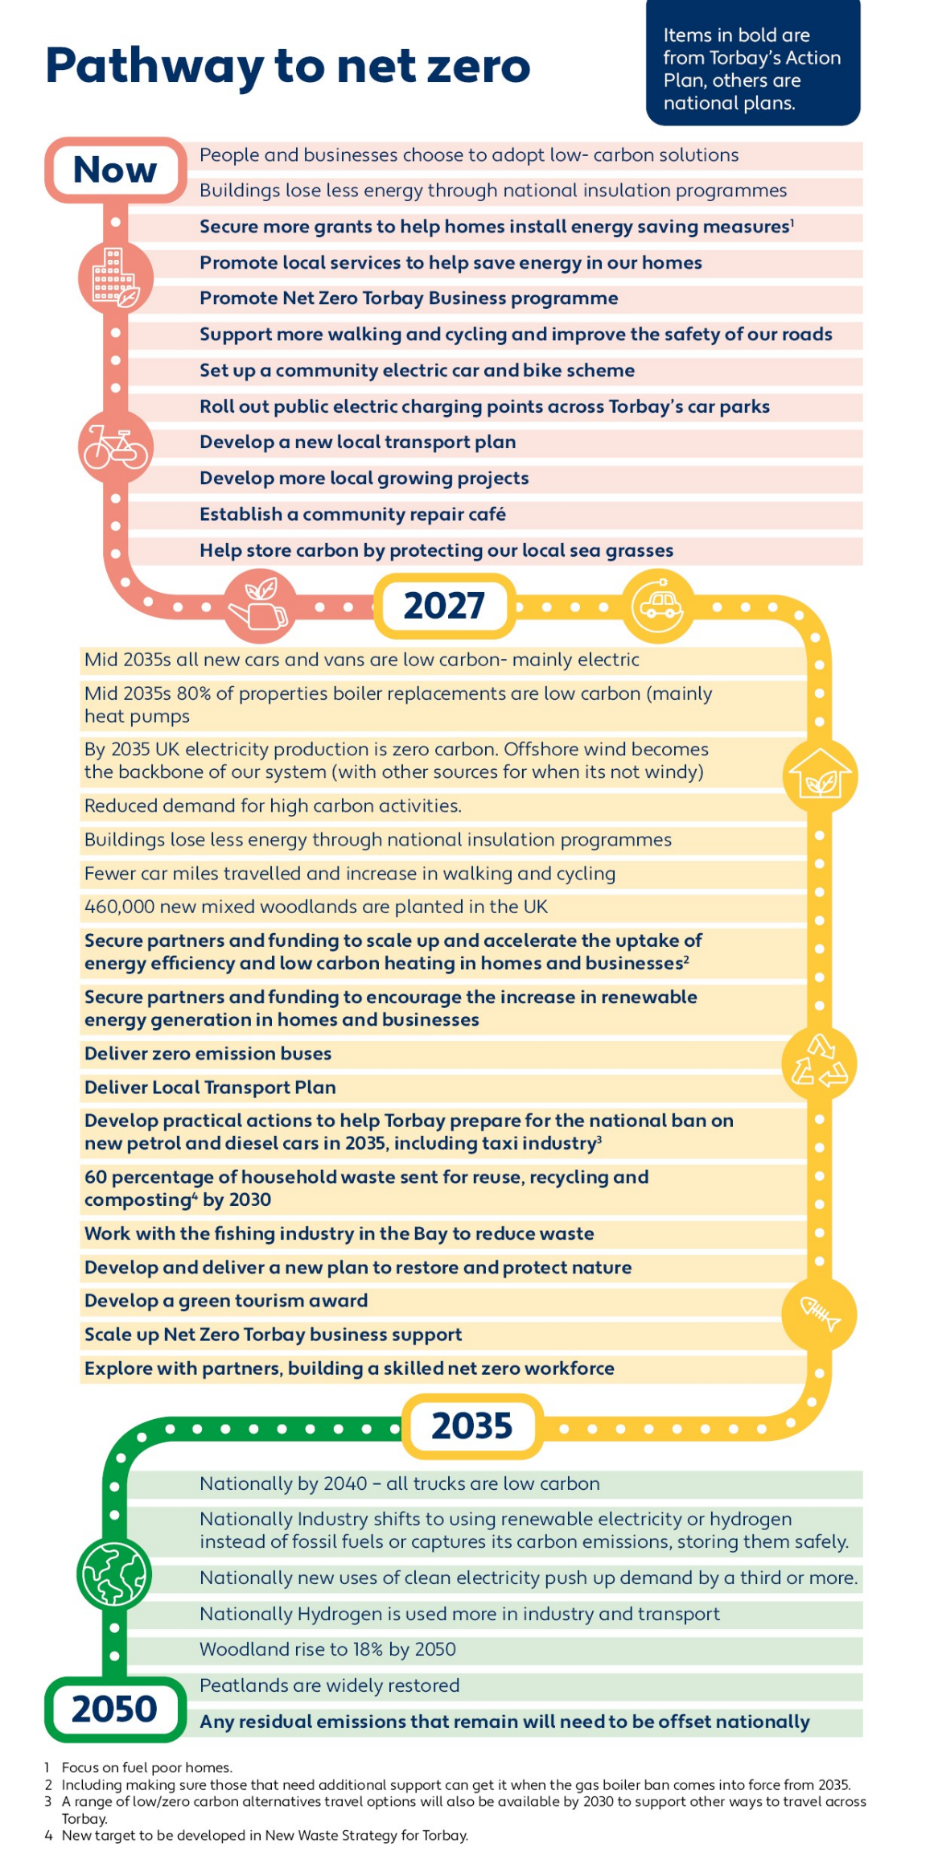

Background

Climate change evidence
Our planet's climate is in a state of unprecedented change. Throughout its history, Earth has experienced fluctuations between glacial (cold) and interglacial (warmer) periods, but the rapid warming observed in recent history is unlike anything in the past 4.6 billion years. The Intergovernmental Panel on Climate Change has provided unequivocal evidence that human activities are the dominant cause of global warming since the mid-20th century This conclusion is supported by rigorous research and an overwhelming consensus in the scientific community.
The most significant indicator of this change is the increase in global average temperatures. Since the pre-industrial era, the Earth’s surface temperature has risen by about 1.1 degrees Celsius, with profound implications for global weather patterns and ecosystems. The last three decades have consecutively been the warmest on record. This pattern of warming is an alarm bell that signals the need for urgent action.
One of the most striking examples of this warming is observed in the Arctic region, which is heating at a rate twice as fast as the global average. Despite the clear trend of rising temperatures, it is important to recognise that not every year will be warmer than the last, due to the natural variability of the Earth's climate system. This variability can still produce exceptionally cold years or seasons, but the overall trajectory is towards increasing temperatures.
The warming of our planet is not limited to the air around us. For example, our oceans are warming, glaciers and polar ice is melting, sea level is rising and we are seeing more extreme weather events. The melting of glaciers and polar ice caps is leading to a rise in sea levels and the alteration of oceanic currents and ecosystems. Furthermore, the frequency of extreme weather events, such as hurricanes, droughts, and heavy rain, has intensified, providing further evidence of a changing climate..
But what is driving these changes? The answer lies in the greenhouse effect, a natural process that is essential for life on Earth but is now being exacerbated by human activity. Greenhouse gases, primarily carbon dioxide (CO2), methane (CH4), and nitrous oxide (N2O), trap the Sun's energy in the atmosphere, warming the planet. The concentration of these gases has increased dramatically due to the burning of fossil fuels for energy, widespread deforestation, intensive agricultural practices, and industrial processes. While natural processes like photosynthesis and oceanic absorption do remove about half of the CO2 emitted by human activities, the remainder accumulates in the atmosphere, enhancing the greenhouse effect and leading to further warming.
By understanding the evidence of climate change and acknowledging the causes behind it, we can begin to formulate effective strategies to reduce its effects and adapt to the new environmental realities we face. This acknowledgment is the first step towards a coordinated global response that can steer us away from potential disaster.

Impact on the UK and Torbay
According to the MET Office, he United Kingdom (UK) is experiencing tangible and measurable effects of global warming. Since the 1950s, average temperatures across the UK have increased by approximately 1°C. This rise in temperature has been documented meticulously by the MET Office through a network of land-based weather stations, which serve as a barometer for the nation's changing climate.
The effects of this warming are multifaceted. Coastal seas surrounding the UK have experienced an increase in temperature, affecting marine biodiversity and fisheries. On land, the changing climate has led to shorter and less frequent cold spells, with a notable reduction in instances of frost and snow. Conversely, warm and hot spells have become longer and more frequent, contributing to breaking high temperature records. In July 2022, the UK recorded its highest ever temperature of 40.3°C. In line with these events, the MET Office concluded that 2022 was the warmest year on record in the UK.
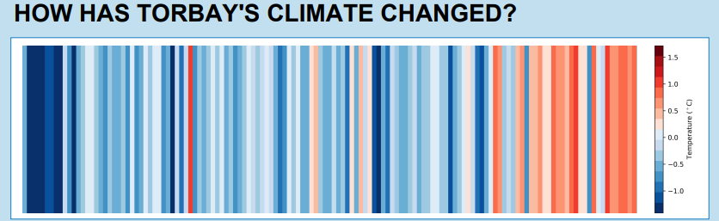
In Torbay, the climate is also changing. The MET Office's temperature graph depicts a clear upward trend in temperatures, with many of the hottest years recorded in the last few decades.
Figure 1. How Torbay’s climate has warmed. (Source: MET Office City Pack – Torbay 2022)
Looking forward, projections based on current greenhouse gas emission trends paint a concerning picture for the end of the 21st century. If emissions continue on their current trajectory, Devon's average summer temperature could rise by 5.6°C, and the average winter temperature by 3.4°C, compared to the 1961-1990 average. Such temperature changes will have significant implications for agriculture, water resources, and public health. Rainfall patterns are also expected to shift, with winter rainfall increasing by 28 percent, leading to a higher risk of flooding, while summer rainfall is forecast to decrease by 44 percent, raising concerns about droughts and water scarcity.
Sea levels are another critical concern. In Torbay, projections indicate a potential rise of over one meter within the next century, potentially threatening coastal infrastructure, ecosystems, and communities. This projected rise in sea levels necessitates comprehensive planning and responses to reduce the risks to coastal regions.
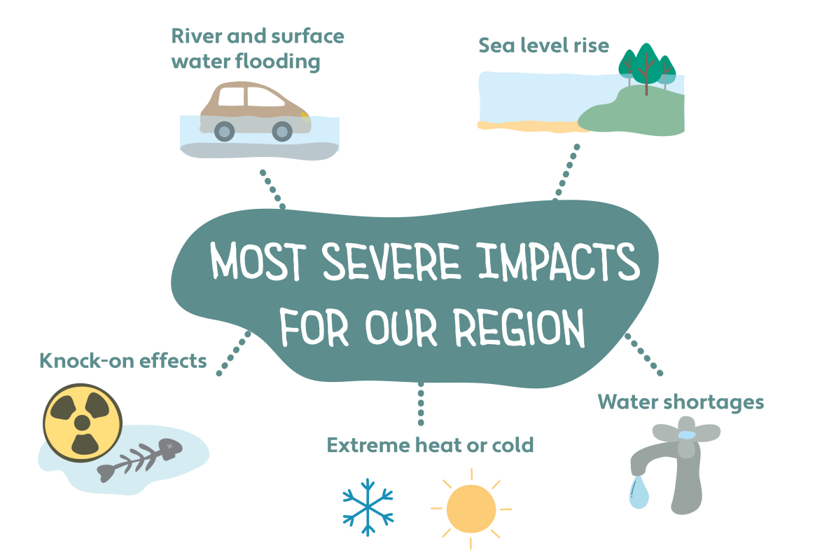
The overall impact of climate change in the UK, and particularly in Torbay, is clear and wide ranging. They include rising temperatures, changing rainfall patterns, and sea-level rise, each carrying its own set of challenges. While some short-term benefits, such as fewer cold-related illnesses, may arise, they are likely to be vastly outweighed by the negative consequences of these climatic shifts. Figure 2 summarises the most severe impacts for our region.
Figure 2: Five most severe impacts for the Region (Source: DCIoS Adaptation Strategy)
In recognising these impacts, Torbay, along with Devon and the wider UK, can take decisive action.

Mitigation and adaptation action at a national level
Mitigation and adaptation are two sides of the climate response coin. Mitigation involves reducing the emissions that contribute to climate change, while adaptation seeks to manage the impacts of a changing climate. Both are critical for a sustainable and thriving future, and the UK, including Torbay, is actively pursuing strategies to address these challenges. This framework and action plan will cover both elements.

Mitigating Carbon emissions
The scientific consensus is clear: rapid and significant reductions in carbon dioxide emissions are imperative to mitigate the worst effects of climate change. The landmark Paris Agreement in 2015 marked a global commitment to this cause, with nearly 200 countries, including the UK, pledging to limit global temperature increases to well below 2 degrees Celsius above pre-industrial levels and to pursue efforts to limit warming to 1.5 degrees Celsius. This target is crucial to preventing catastrophic climate scenarios and preserving the planet for future generations.
In the UK, the government has taken a legally binding stance and must achieve net-zero greenhouse gas emissions by 2050. To reach this ambitious goal, carbon dioxide emissions from homes, transport, agriculture, and industry must be drastically reduced or offset through measures such as afforestation or carbon capture and storage technologies. In support of this target, the UK has devised a suite of strategies that outline the path to decarbonisation, including sector-specific plans for energy, buildings, and transport.

For electricity, in the 2020s, the Government will phase out fossil fuels and decarbonise the electricity grid through increasing renewable energy generation. By 2035 UK electricity production will be zero carbon and by the 2040s low carbon hydrogen will be used for shipping and transport fuel and in industry.

In Buildings, in the 2020s, the Government will focus on energy efficiency and increased insulation in homes and businesses and promote the use of heat pumps and heat networks. By 2035 electrification will be widespread and all boiler replacements will be low carbon. The 2030-40 period will see heat networks expanding.

In Road Transport, in the 2020s, the Government will ramp up the electric vehicle market including charging infrastructure and plan how to make heavy goods vehicles (HGVs) low carbon. By 2035 all new cars and vans will be low carbon and by 2040 so will new HGVs. It is not being suggested that existing petrol and diesel vehicles will be band. The plan is to phase them out at the end of their useful life.

Despite progress, challenges remain. Nationally, emissions have fallen significantly from 1990 levels, yet the rate of reduction must increase to meet the interim targets set for 2035 (78% reduction in emissions) and to achieve the long-term target by 2050. The Climate Change Committee (CCC), the UK government's independent climate advisors, has highlighted a shortfall in current programmes to deliver net-zero by 2050. Yet, they maintain that achieving net-zero by 2050 is within reach with the right policies and actions.

Adapting to a changing climate
Beyond mitigation, the UK is also focusing on adaptation—preparing for the inevitable effects of climate change that are already in motion. The third National Adaptation Programme (NAP3), released in July 2023, outlines the government's vision for adaptive action over the next five years. It addresses the need to make the UK's infrastructure, built environment, water management, and food production systems resilient to the anticipated impacts of climate change.
The Government's adaptation measures include building robust flood defenses to combat rising sea levels, creating more green spaces in urban areas to provide cooling and resilience to heatwaves, and developing agricultural practices suited to the changing climate. Infrastructure planning is also accounting for extreme weather events, ensuring that future buildings and transportation networks can withstand the challenges posed by a warmer world.
Local authorities play a crucial role in adaptation, tasked with ensuring the resilience of services and informing communities about climate risks and responses. The dissemination of information and active community involvement are key to fostering understanding and action at the local level.

A Network of action plans

Local and regional action plans

Devon Cornwall and Isles of Scilly Adaptation Strategy
Regionally, the draft Adaptation Strategy for Devon, Cornwall, and the Isles of Scilly (DCIoS) is helping the Southwest region to understand future risks and prepare for the impacts of climate change. This strategy is currently in the process of being adopted across the three regions. The current draft is available online here.

Devon Carbon Plan
The Devon Carbon Plan is an ambitious blueprint for reaching net-zero emissions by 2050, with an interim goal of a 50% reduction by 2030. This plan is the result of a collaboration between all councils in Devon, including Torbay, and is led by the Devon Climate Emergency Response Group. It sets out eight objectives, covering essential sectors such as transportation, the built environment, agriculture, energy supply, and resource management. These objectives are broad, designed to touch every aspect of life in Devon, and call for a variety of actions that range from the simple and immediate to the complex and long-term. The Devon Carbon Plan (and a number of quick reads) can be accessed from the Devon Climate Emergency website.
Both regional documents reduce carbon emissions and adapt to the changing climate, recognising the critical role of local action in the broader context of global climate response.

Torbay's climate initiatives

The importance of a coordinated plan
A coordinated Torbay plan is essential, as the challenge of climate change cannot be tackled in isolation. Key partners must be aware of their roles and the timelines for action to ensure collective and effective progress. This coordination extends beyond just the implementation of actions; it also involves communication, education, and the fostering of a supportive environment where everyone is empowered to make a difference.
Torbay is already taking action including the delivery of solar farms, enhanced walking and cycling infrastructure, community-based energy efficiency projects, local growing initiatives, and various flood alleviation projects. These efforts not only reduce emissions but also serve to engage the public and foster a sense of shared responsibility and collective action. But much more action is needed.

Torbay Climate Partnership

The Partnership's Role
The Torbay Climate Partnership (TCP), which includes stakeholders from across Torbay, is dedicated to implementing a coordinated plan that involves everyone. From the Wild Planet Trust to local businesses, educational institutions, and healthcare providers, the partnership is a testament to the collaborative spirit needed to tackle climate change effectively.
The TCP stands as a beacon of local commitment and action in the battle against climate change. Formed in 2021, the partnership is a collective of key local actors, each bringing unique strengths to the table. More information on the TCP is available on the webpage.

Action Focused Partnership
The Partnership's role extends beyond advocacy; it is an active force in developing and implementing this strategic framework to mitigate and adapt to climate change impacts. The actions taken by the Partnership and its members are wide ranging, reflecting the broad scope of the climate challenge. They range from infrastructural projects like solar farm installations to community-level initiatives that promote energy efficiency in homes and businesses.
One of the most tangible outcomes of the Partnership's work was the creation of the Torbay Climate Emergency Action Plan (TCEAP). This plan served as a roadmap for the Bay's efforts to become carbon neutral by 2030 and adapt to the changing climate. It was informed by research, community engagement, and expert analysis, including the Net Zero Torbay Report by the University of Exeter (available on the Devon Climate Emergency website here. This report identifies key actions and the scale of the challenge ahead for Torbay, particularly to achieve ambitious net zero carbon targets for 2030 or 2050 at the latest.

Community and Stakeholder Engagement
The development of the TCEAP included community and stakeholder engagement and a public consultation. A series of climate conversations, business questionnaires, and a community conference provided forums for discussion and input, ensuring that the plan reflected the needs and perspectives of Torbay residents and businesses. A draft TCEAP went out to public consultation from December to February 2023, and is available here. All these consultations were crucial in shaping the TCEAP.
Despite the extensive consultation process, the TCEAP received polarised feedback, revealing a small part of the community divided on the urgency and approach to climate action. Those that did not support it expressed a range of views including there is no climate emergency, that climate change is a hoax and that it is a globalist agenda designed by World Economic Forum/others to restrict peoples’ freedoms. In response, the Partnership committed to ongoing public engagement, seeking to address some concerns and refine the plan to better align with local circumstances and national targets. More details on this are available here.
This revised framework and action plan will articulate a vision for Torbay's journey towards a sustainable and resilient future. It strikes a balance between immediate actions and long-term strategies, recognising that some measures can be implemented swiftly, while others require careful planning and resource allocation.

The Greener Way for our Bay Framework

The Greener Way for our Bay Framework - a transitional plan to 2050

The need for a coordinated framework
Recognising how difficult it is to reduce carbon emissions, the TCP understands the need for a long-term, strategic framework that extends to 2050. The framework sets a direction for the long haul, with a series of short-term action plans to guide Torbay through incremental steps towards the 2050 net-zero target (at the latest). This framework is not just about setting ambitious targets; it's about understanding the pathways to achieve them, ensuring equitable (fair for all) implementation, and aligning local actions with government policies that have a benefit for Torbay.
The Partnership acknowledges that not all actions fall within local control and that alignment with government plans is necessary for success. As such, the Greener way for our Bay aligns Torbay's targets with those of the national government and brings together partners across Torbay to ensure a coordinated effort that supports the broader UK climate strategy.

Current Carbon emissions in Torbay
In 2021 Torbay’s estimated total greenhouse gas emissions were 466,494 tonnes of carbon dioxide equivalent (t CO₂e) . For simplicity, and throughout the rest of this document we will use the term 'carbon emissions' as shorthand for carbon dioxide equivalent emissions. These carbon emissions are produced within the geographic boundary of Torbay.
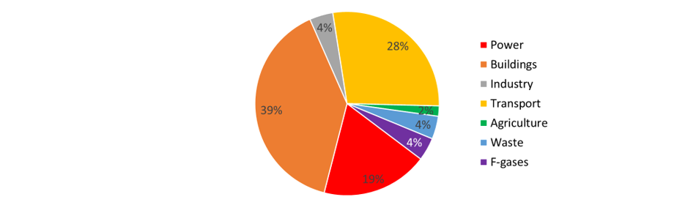
Figure 3. Estimated total greenhouse gas emissions for Torbay 2021 (Source: University of Exeter Torbay’s 2021 Greenhouse Gas Inventory 2023)
Buildings (which includes heating homes, businesses, schools, and other public buildings), transport (meaning all emissions from road and rail travel in Torbay) and power (meaning the electricity we use in Torbay) are the largest sources of carbon emissions in Torbay, with buildings contributing 39 percent.
Torbay's journey toward reducing carbon emissions is well underway, with data showing a consistent decline since 2008. This is mainly due to large scale renewable energy projects coming online across the UK and feeding into our national electricity grid (as a result this sector has been responsible for a 71 percent reduction in Torbay’s carbon emission from 2008 – 2021), not local action. Gradual declines in transport sector carbon emissions accelerated in 2020 due to the travel restrictions imposed during the Covid 19 pandemic, but some reversal of this fall was evident in 2021. However, it is building carbon emissions where progress is most important. These are responsible for the largest portion of Torbay’s emissions (39%). Here, change since 2009 has been limited. This highlights the necessity for focused efforts on enhancing energy efficiency and transitioning to low-carbon heating solutions.

Headline Targets
Torbay will work towards becoming net zero carbon in line with our national target and will aim to reduce Torbay-wide carbon emissions by 100% by 2050 at the latest with a 78% reduction by 2035
Torbay will also take action to prepare for a changing climate.

Ambitions
This framework aims to:
- Help residents and businesses improve their homes and buildings so they use less energy, generate low carbon heat and are warm, healthy places with lower running costs
- Make new buildings that are nice to live and work in but designed to limit the impact on the environment
- Support the national plans to decarbonise electricity and promote and increase the uptake locally of renewable energy generation in our homes and businesses
- Provide a range of low / zero carbon, affordable and accessible transport options to support people to get about Torbay
- Avoid creating waste
- Make our naturally inspiring coast and countryside help us tackle climate change and its impacts
- Support businesses to go net zero carbon and create new training and job opportunities from the transition to net zero
- Promote action to tackle climate change locally
- Prepare for a changing climate

Achieving Net Zero Carbon by 2050 at the latest
Torbay's commitment to achieving net-zero carbon emissions by 2050 at the latest mirrors national ambitions, fostering a collective approach to this global challenge. The Centre for Energy and the Environment at the University of Exeter was commissioned by Torbay Council to create the Net Zero Torbay report. The report’s projections present two paths: a 'business as usual' scenario and one aligned with national policies aiming for net zero by 2050. They illustrate the potential for a 90 percent reduction in emissions, assuming the most ambitious government policies and local actions are adopted, with the remaining emissions offset by additional measures like national tree planting and carbon capture technologies. Given the size of Torbay, there is not enough land available for this to be achieved locally, so it is expected that various national carbon offsetting schemes will be set up to help. The full report is available here.

Sector-specific actions
Based on the recommendations within the Net Zero Torbay Report, this framework sets out clear directions for decarbonising Torbay's most emitting sectors by 2050 at the latest.
In buildings, a significant reduction in emissions is envisioned through a combination of technological upgrades, such as the installation of 12,400 cavity wall insulations and 40,000 heat pumps, alongside bbehavioural changes that promote energy conservation. New buildings must adhere to near-zero energy and carbon standards to prevent future emissions.
In transportation, a shift towards lower-carbon alternatives is crucial. An 80 percent reduction in emissions is targeted, necessitating a move towards electric vehicles, supported by the development of a public charging infrastructure. This sector's evolution also includes encouraging sustainable transport options, aiming to reduce car journeys significantly.
For the power sector, a dramatic 98 percent reduction in emissions is anticipated, primarily through national decarbonisation programs. Torbay must also explore local renewable energy opportunities like roof mounted solar panels to contribute to this goal.

Areas of focus
The following areas will be the focus of Torbay’s plans to reduce carbon emissions and adapt to a changing climate:
- Built Environment
- Power
- Sustainable Travel
- Waste minimisation and local food growing
- Nature based actions
- Net zero businesses, jobs, and skills
- Behaviour Change and Community Engagement
- Adapting to a changing climate
- Other (cross cutting action)
Given that 86 percent of Torbay’s carbon emissions in 2021 came from the way we heat and power our homes and buildings and the way we travel in Torbay, reducing these emissions will be a priority of this work, as too will be making sure we adapt to our changing climate over time.

Interim progress by 2035
As 2050 is 28 years away, we need some things to work towards along the way. Some trajectories (possible routes) to achieve net zero by 2050 at the latest are outlined in a new report by the University of Exeter. These have been broken down into annual incremental numbers to work towards in Torbay by 2035. Please see Action Plan 2027 – 2035 section below.
Working towards these will be heavily dependent on support from the UK Government in changing the national policy landscape, accelerating action on climate change, and supporting, where necessary, identified local initiatives.

Outcomes for Torbay by 2050 at the latest
The Framework, through its series of action plans will aim to create the following greener way for our bay:
- Torbay will have more homes and buildings that are energy efficient, generate renewable energy and are healthier to be in
- All new buildings will be energy efficient, generate renewable energy and be healthy to be in
- We will have more local energy generation with residents and businesses less susceptible to future global energy shocks and price volatility
- Torbay will have a choice of low carbon, sustainable ways to get about Torbay, and healthier residents
- We will create less waste
- We will have cleaner air and water, increased biodiversity, and less flooding in Torbay
- Businesses will be energy, water, and waste efficient, and net zero jobs will be created in Torbay
- Torbay is prepared for a changing climate and can recover quickly from future events
- Torbay will have more well informed communities taking action

Benefits
There are a range of benefits for residents and businesses if we take action. Below are just a few.
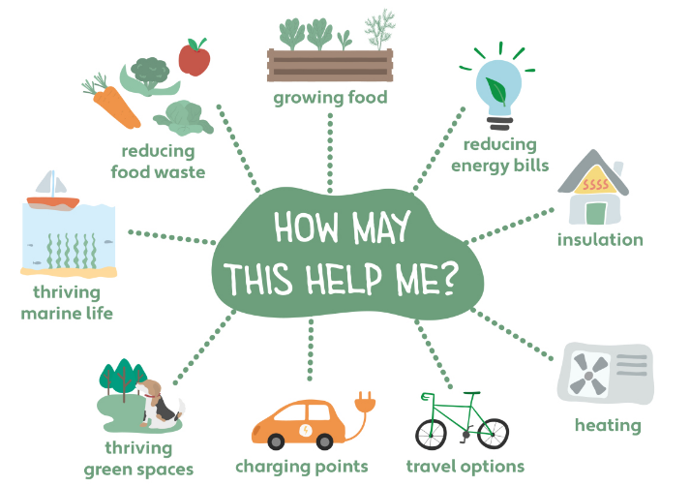
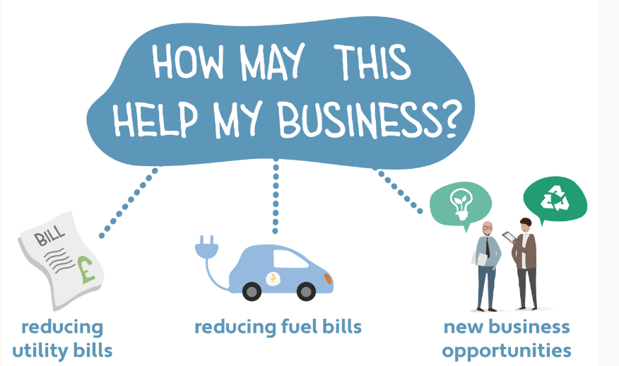

Conclusion and next steps
Torbay's framework to 2050 offers a realistic, flexible approach to climate action. While the ultimate goal is clear, the path to reach it allows for adjustments and responds to ongoing
developments in policy, technology, and community feedback. The framework serves as a guiding document for the continuous journey towards a sustainable and resilient Torbay, ready to face the challenges of climate change while seizing the opportunities it presents for a greener economy and society.
The next steps involve robust engagement, innovative solutions, and a collaborative spirit to ensure that the journey to 2050 is successful and transformative for all of Torbay's residents and sectors.

The Greener Way for our Bay Action Plan 2023 - 2027
To achieve the 2050 net-zero carbon goal every three years the TCP will develop, action plans focused on immediate actions identified in the Net Zero Torbay report, priorities expressed by residents and businesses during the 2022 surveys, Climate Conversations and public consultation, and actions within Torbay's direct influence. This inaugural action plan targets carbon reduction and climate change preparedness in key areas:

- Built Environment
- Power
- Sustainable Travel
- Waste minimisation and food
- Nature based actions
- Net zero businesses, jobs, and skills
- Behaviour Change and Community Engagement
- Adapting to a changing climate
- Cross cutting action

Priorities
The following sections of this action plan outline priority actions to be carried out across Torbay by a range of partners, overseen by the Torbay Climate Partnership. Please visit the Frequently Asked Questions for more explanation on the actions below.

Built Environment
In Torbay, the built environment, encompassing our homes and buildings, is a significant contributor to local carbon emissions. This sector is rresponsible for 39 percent of the total. Predominantly, these emissions stem from heating. Reducing emissions from heating relies on both reducing demand (our need) through efficiency measures, encouraging behavioural change, and supplying required heat using low-carbon technologies such as heat pumps. Energy efficient homes will also create healthy and affordable homes that have been improved for the future. In 2020, 12 percent of homes in Torbay were in fuel poverty and three quarters of Torbay’s housing stock achieve an energy performance certificate rating of C, whereas for England it’s just over half (54 percent). Improving the energy efficiency of homes will help reduce fuel poverty and provide homes that are more resilient to energy price rises.
The Climate Conversations and consultation recommended projects to help homes in fuel poverty
and that Torbay will also need to grow a local skilled workforce to roll out these actions over time.

Long term ambitions and immediate actions

The plan targets the following long-term ambitions:
Helping residents and businesses improve their homes and buildings so they use less energy, generate low carbon heat and are warm, healthy places with lower running costs
Making new buildings that are nice to live and work in but designed to limit the impact on the environment
Immediate actions and timelines
Over the next three years the following actions will be delivered
1.By 2025, Exeter Community Energy (ECOE) to run energy saving clinics, give community talks, recruit, and train, 10 'Community Energy Champions' and visit over 250 homes in need of saving energy advice and grants
2. By 2025, Torbay Council and ECOE to develop projects to help more of us to save energy through installing energy efficiency and low carbon measures in our homes
3. By 2025, Torbay Council and ECOE to help more homes out of fuel poverty through advice and grants for energy efficiency and low carbon measures
4. By 2027, Torbay Council and ECOE to promote Energy Saving Devon (a full support service that can help upgrade homes)
5. By 2027, Torbay Council to strengthen rules required to make new developments net zero carbon with EV charging points
6. By 2027 Torbay Council to work in partnership with companies that use a lot of energy in Torbay and share best practice to help them work towards net zero
7. By 2025, Torbay Council and partners to deliver Make it Net Zero Torbay to help 250 small businesses to save money, through saving carbon, energy waste and water
You can read a full list of actions on the Greener Way for Our Bay website under the heading Supporting information for Greener Way For Our Bay.
Please also visit the Frequently Asked Questions under the same section for more explanation on the actions.

Power Sector
The energy consumed in Torbay's homes and buildings accounts for 19 percent of the area's carbon emissions as of 2021. The reduction achieved so far, a commendable 71 percent since 2008, has largely been due to the decommissioning of coal and gas power stations and the introduction of large-scale renewable energy projects at the national level, including offshore wind. While these impressive reductions have not been driven by local projects, Torbay has a critical role in further decreasing emissions through local initiatives and individual actions. The actions below are designed to support Torbay's ambition to align with the national decarbonisation plans for electricity and to foster the local uptake of renewable energy generation in homes and businesses.

Long term ambitions and immediate actions

The plan targets the following long-term ambition:
Support the national decarbonisation plans for electricity and promote and increase the uptake locally of renewable energy generation in our homes and businesses

Immediate actions and timelines
Over the next three years the following actions will be delivered:
8. By 2027 Torbay Council to work with National Grid and partners on developing an local energy plan to ensure Torbay's energy system is ready for a low carbon future
You can read a full list of actions on the Greener Way for Our Bay website under the heading Supporting information for Greener Way For Our Bay.

Transport
The transport sector is responsible for 28 percent of Torbay’s carbon emissions. To address this, the action plan focuses on shifting towards a greater choice of sustainable, low-carbon travel options. This transition is not only essential for reaching our net-zero targets but also for improving air quality and public health, and for providing accessible, affordable, and efficient travel options for all residents.
The actions below, spearheaded by Torbay Council in partnership with other local organisations, are designed to provide a comprehensive and integrated set of travel options for Torbay.

Long term ambitions and immediate actions
The plan targets the following long-term ambition:
Provide a range of low / zero carbon, affordable and accessible transport options to support people to get about Torbay

Immediate actions and timelines

Over the next three years the following actions will be delivered:
9. By 2027, Torbay Council to encourage cycling and walking and improve the safety of our roads
10. By 2026, Torbay Council with the Bus Partnership to explore an affordable One Ticket option for all bus travel in the Bay
11. By 2025, Torbay Council to invest in sustainable travel options including more cycling, wheeling, and walking routes
12. By 2026, set up community electric car and bike hire clubs to offer accessible low-emission travel
13. By 2027, Torbay Council and the Bus Partnership to Increase zero emission buses across Torbay
14. By 2027, Torbay Council to place public electric vehicle charging points across Torbay and to increase support for the transition to EV
15. In 2024, Torbay Council will develop a new long-term plan for how we travel about Torbay (a Local Transport Plan for Torbay)
You can read a full list of actions on the Greener Way for Our Bay website under the heading Supporting information for Greener Way For Our Bay.

Waste Minimisation and Food
The way things are made and how we use them, and then throw them away creates greenhouse gases (GHG). These emissions contribute to climate change. These emissions arise during the manufacturing and transportation to the customer and then through its disposal.
In 2019-2020 some 41,300 tonnes of waste were generated from homes in Torbay. We recycled and composted about 41 percent of our waste. In 2021 four percent of Torbay’s carbon emissions came from waste, however this does not include the emissions that arise from the disposal or recycling of waste. This is because these processes occur outside Torbay.
We can minimise waste and the associated emissions by reducing food waste, growing, or buying locally, using things for longer, by purchasing less, reusing, and repairing what we already have, and by recycling. We need to focus on reducing food waste and working towards a 60% reduction recycling rate.
As other sectors begin to reduce their emissions, the waste sector's relative impact could increase, making it imperative to address waste generation and management now.

Long term ambitions and immediate actions
The plan targets the following long-term ambition:
Avoid creating waste

Immediate actions and timelines
Over the next three years the following actions will be delivered:
16. SWISCo to continue to reduce waste and increase recycling, working towards the national recycling target of 60% by 2030
17. In 2024, various partners to reduce waste, explore establishing a community repair café
18. In 2024 Torbay Communities to explore more local community based growing projects
You can read a full list of actions on the Greener Way for Our Bay website under the heading Supporting information for Greener Way For Our Bay.

Nature Based Actions
Nature based actions such as tree planting, restoring sea grass and other habitats and re-wilding areas of land, can help store carbon emissions and play a role in achieving net zero carbon. Nature based actions can also help reduce the effects of a changing climate. For example, plants and trees can alleviate flood risk and help cool spaces in the summer. Nature based actions can also restore
nature, improve biodiversity and deliver a range of health benefits to local communities.
Wherever possible, nature based solutions such as tree planting and other schemes to increase carbon storage locally will be encouraged to remove GHG’s from the atmosphere. However, as Torbay has very limited opportunities for local GHG removal we will need to rely on regional and national programmes to tackle any local emissions that cannot be reduced to zero in any other way by 2050.

Long term ambitions and immediate actions

The plan targets the following long-term ambitions:
To make our naturally inspiring coast and countryside help us tackle climate change and its impacts

Immediate actions and timelines
Over the next three years the following actions will be delivered:
19. In 2025 Torbay Council and partners to develop a new plan to restore and protect nature
20. By 2025, the Marine Forum, Wild Planet Trust, and other partners to help protect our local sea grasses
You can read a full list of actions on the Greener Way for Our Bay website under the heading Supporting information for Greener Way For Our Bay.

Net zero businesses, skills, and jobs
In Torbay, while industrial activities contribute only four percent to the Bay's emissions, 39 percent come from heating homes and buildings, which includes commercial premises. The action plan, therefore, focuses on aiding businesses in their transition to net-zero carbon operations which can also help them save money on energy, water, and waste bills. Additionally, the transition presents an opportunity to foster new skills and create jobs within the community, contributing to a sustainable local economy.
These initiatives are integral to achieving the Framework's long-term ambition of supporting businesses to transition to net-zero operations and create new economic opportunities in the process. By providing resources, sharing best practices, and offering guidance, Torbay aims to foster a business environment where sustainability is synonymous with success.

Long term ambitions and immediate actions

The plan targets the following long-term ambition:
Support businesses to go net zero carbon and create new training and job opportunities from the transition to net zero

Immediate actions and timelines
Over the next three years the following will be delivered:
21. By 2025 Torbay Council and partners, to deliver Make it Net Zero Torbay business support programme and help just under 250 businesses to reduce their carbon emissions by saving energy, water, and waste + others
22. By 2025, various partners to develop a green tourism programme and Award to showcase exemplars of good practice and support the overall reputation of Torbay as a sustainable tourism destination
You can read a full list of actions on the Greener Way for Our Bay website under the heading Supporting information for Greener Way For Our Bay.

Behaviour Change and Community Engagement
The way we operate our businesses and the way we live will need to change in the coming years, but as outlined above there are many benefits for us all if we do this. Some of the actions we need to take are technology-based solutions, but most require us all to change our behaviours, be it small changes like switching off lights when we leave a room or larger ones like installing loft insulation. Sharing positive stories on what we can all do and the benefits they offer, is also vital in helping us all to play our part. Engaging Torbay’s residents and businesses is vital to meet the 2035 and 2050 targets of this plan.
By fostering an understanding of the benefits and practicalities of sustainable living, the action plan aims to encourage residents and businesses to adopt changes that contribute to Torbay's climate goals.
These efforts of this plan outline the importance of engaging with the public and creating a collective understanding of the actions needed to tackle climate change. Through shared knowledge, community projects, and a focus on the next generation, Torbay aims to build a culture of sustainability that supports the long-term ambitions of the Framework.

Long term ambitions and immediate actions

The plan targets the following long-term ambition:
Promote action to tackle climate change locally

Immediate actions and timelines
Over the next three years the following actions will be delivered:
23.In 2025, various partners to explore setting up a Torbay Community Action Group or similar to create more local community projects
24. By 2025, the TCP, led by the English Riviera UNESCO Global Geopark to tell positive stories of action happening across Torbay
25.By 2025, the TCP, will explore how to deliver more local campaigns in schools to encourage sustainable lifestyles
You can read a full list of actions on the Greener Way for Our Bay website under the heading Supporting information for Greener Way For Our Bay.

Adapting to a changing climate
Aiming to limit carbon emissions is not enough. Equally crucial is the adaptation to the inevitable changes in our climate.
Recognising that even the most aggressive emission reduction efforts will not prevent some degree of climate impacts locally and globally, this plan includes actions to understand and prepare for the effects of a changing climate on local communities and businesses. We will need to adapt to a changing climate and be better prepared so we can recover quickly from such future events.
This proactive approach to adaptation is integral to the Framework's target of preparing for a changing climate. By preparing for the risks associated with a changing climate and taking pre-emptive actions, Torbay aims not just to mitigate the negative effects but also to seize any opportunities that may arise from the new climate reality.

Long term ambitions and immediate actions
The plan targets the following long-term ambition:
Prepare for a changing climate

Immediate actions and timelines

Over the next three years the following actions will be delivered:
26.Torbay Council and partners will use the results of the Met Office’s Torbay City Pack and Devon, Cornwall, and Isles of Scilly’s Adaptation Strategy to assess and ensure Torbay understands current and future vulnerability to a changing climate and takes actions to adapt and prepare.
You can read a full list of actions on the Greener Way for Our Bay website under the heading Supporting information for Greener Way For Our Bay.

Other or Cross cutting actions
To complement the targeted actions above, this plan includes cross-cutting actions. These actions are designed to enhance the effectiveness of sector-specific actions. They are essential for the success of Torbay's climate action plan, providing the support structure that enables all other measures to be implemented effectively.

Immediate actions and timelines
Over the next three years:
27. By 2027 TCP to review best practice innovative ways to encourage behaviour change
28.By 2027, TCP to explore finance models to help accelerate climate actions
29. By 2027, TCP to develop a list of asks to lobby central government on, asking for more support to deliver this work
In addition to the above actions, there are many others that partners will deliver.
You can read a full list of actions on the Greener Way for Our Bay website under the heading Supporting information for Greener Way For Our Bay.
Please also visit the Frequently Asked Questions under the same section for more explanation on the actions.

Summary of timelines and tasks
Year | Responsible Organisation | Item | Action | Key Performance Indicator (KPI) | Note
2024 | Various | Waste Minimisation and Food | In 2024, various partners to reduce waste, explore establishing a community repair café. | Number of repair cafés established. | In line with waste reduction goals.
 | Torbay Communities | Waste Minimisation and Food | In 2024 Torbay Communities to explore more local community based growing projects. | Number of food growing projects initiated. | Supports local food production and reduces food miles.
 | Various | Power Sector | Develop a local energy plan with National Grid and partners. | Completion and adoption of a local energy plan. | Aims to ensure Torbay's energy system is ready for a low carbon future.
 | Torbay Council | Transport | In 2024, Torbay Council will develop a new long-term plan for how we travel about Torbay (a Local Transport Plan for Torbay) | Local transport plan developed and approved. | Aimed at encouraging active travel and sustainable forms of public transport.
2025 | Exeter Community Energy (ECOE) | Built Environment | By 2025, Exeter Community Energy (ECOE) to run energy saving clinics, give community talks, recruit, and train, 10 'Community Energy Champions' and visit over 250 homes in need of saving energy advice and grants. | Number of clinics conducted, champions trained, and households assisted. | Targets 250 households in need of energy-saving support.
 | TC and ECOE | Built Environment | By 2025, Torbay Council and ECOE to help more homes out of fuel poverty through advice and grants for energy efficiency and low carbon measures | Reductions in the number of homes that live in fuel poverty. | Supporting more people to live in more affordable and energy efficient homes.
 | ECOE and Torbay Council (TC) | Built Environment | Torbay Council and ECOE to develop projects to help more of us to save energy through installing energy efficiency and low carbon measures in our homes. | Number of energy efficiency projects completed. | Aimed at enhancing energy efficiency in homes.
 | TC | Transport | By 2025, Torbay Council to invest in sustainable travel options including more cycling, wheeling, and walking routes. | Several new cycling, wheeling and walking routes have been created to enable more accessibility around Torbay. | Encourage active travel around the Torbay area.
 | Torbay Development Agency (TDA) | Net Zero Businesses, Skills, and Jobs | By 2025 Torbay Council and partners, to deliver Make it Net Zero Torbay business support programme and help just under 250 businesses to reduce their carbon emissions by saving energy, water, and waste + others. | Number of businesses supported to reduce emissions. | Targets around 250 businesses for energy, water, and waste savings.
 | Various | Net Zero Businesses, Skills, and Jobs | By 2025, various partners to develop a green tourism programme and Award and to showcase exemplars of good practice and supporting the overall reputation of Torbay as a sustainable tourism destination. | Programme and award are created and made accessible to those businesses showing best practice in sustainability. | Encourages local business to place a focus on sustainability and help to work towards climate goals within Torbay.
 | Marine Forum, Torbay Harbour Authority, Wild Planet Trust | Nature-Based Actions | By 2025, the Marine Forum, Wild Planet Trust and other partners to help protect our local sea grasses. | Area of seagrass habitats protected or restored. | Part of nature-based actions for carbon sequestration and marine biodiversity.
 | TCP | Behaviour Change and Community Engagement | By 2025, the TCP, led by the English Riviera UNESCO Global Geopark to tell positive stories of action happening across Torbay. | Number of stories shared and schools engaged. | Focuses on community engagement and environmental education.
 | Torbay Council | Nature-Based Actions | In 2025 Torbay Council and partners to develop a new plan to restore and protect nature. | Completion of a habitat restoration and protection plan. | Part of nature-based actions to tackle climate change and improve biodiversity.
 | Torbay Council | Adapting to a Changing Climate | Torbay Council and partners will use the results of the Met Office’s Torbay City Pack and Devon, Cornwall, and Isles of Scilly’s Adaptation Strategy to assess and ensure Torbay understands current and future vulnerability to a changing climate and takes actions to adapt and prepare. | Assessment completed and adaptation measures identified. | Aims to prepare Torbay for the impacts of a changing climate.
 | TCP | Behaviour Change and Community Engagement | By 2025, the TCP, will explore how to deliver more local campaigns in schools to encourage sustainable lifestyles | Delivery of several campaigns to encourage sustainable lifestyles. | Support the active understanding of the roles we can play in tackling climate change.
 | Various | Behaviour Change and Community Engagement | In 2025, various partners to explore setting up a Torbay Community Action Group or similar to create more local community projects | The creation of a community group with local projects being undertaken. | The development of new projects will support the collective to meet the climate goals within Torbay.
2026 | Torbay Council and Bus Partnership | Transport | By 2026, Torbay Council with the Bus Partnership to explore an affordable One Ticket option for all bus travel in the Bay. | Implementation of the 'One Ticket' system. | Intended to simplify public transport use and encourage its adoption.
 | Torbay Council | Transport | By 2026, set up community electric car and bike hire clubs to offer accessible low-emission travel. | Number of hire clubs established. | Promotes accessible, low-emission travel options for residents.
2027 | Torbay Council | Transport | By 2027, Torbay Council and the Bus Partnership to increase zero emission buses across Torbay. | Number of zero-emission buses introduced. | Reduces public transport emissions.
 | Torbay Council and DCC | Transport | By 2027, Torbay Council to place public electric vehicle charging points across Torbay and to increase support for the transition to EV. | Number of charging points installed. | Supports the transition to electric vehicles.
 | TC | Transport | By 2027, Torbay Council to encourage cycling and walking and improve the safety of our roads. | Providing accessible, affordable, and efficient travel options for all residents. | Enabling safer routes for active travel across the area.
 | TC | Built Environment | By 2027 Torbay Council to work in partnership with companies that use a lot of energy in Torbay and share best practice to help them work towards net zero. | Working with local businesses and organisations to identify their energy consumption and solutions to reduce their usage. | Helping to reduce the amount of energy and carbon emissions that they produce.
 | TC | Built Environment | By 2027, Torbay Council to strengthen rules required to make new developments net zero carbon with EV charging points. | Number of developments with EV charging points installed. | Improving homes in preparation for the future.
 | ECOE and TC | Built Environment | By 2027, Torbay Council and ECOE to promote Energy Saving Devon (a full support service that can help upgrade homes). | Number of residents using the service. | Encourages residents to make their homes more energy-efficient.
 | TC | Power | By 2027 Torbay Council to work with National Grid and partners on developing an local energy plan to ensure Torbay's energy system is ready for a low carbon future. | A local energy plan is developed and approved, enabling further renewable and low carbon energy sources. | Aligning Torbay with national plans for decarbonised energy and encouraging local renewable energy sources.
 | SWISCo | Waste Minimisation and Food | SWISCo to continue to reduce waste and increase recycling, working towards the national recycling target of 60% by 2030. | Recycling rate percentage increase. | Aligns with national waste reduction goals.
 | TCP | Cross-Cutting Actions | By 2027 TCP to review best practice innovative ways to encourage behaviour change. | Number of innovative strategies reviewed and implemented. | Supports the overarching strategy for community engagement and climate action facilitation.
 | TCP | Cross-Cutting Actions | By 2027, TCP to explore finance models to help accelerate climate actions. | Number of financial models reviewed and implemented. | Supports the overarching strategy for community engagement and climate action facilitation.
 | TCP | Cross-Cutting Actions | By 2027, TCP to develop a list of asks to lobby central government on, asking for more support to deliver this work. | Asks are identified and put to central government for policy or funding backing to enable actions to be delivered locally. | Supports the delivery of actions within the Torbay Area.

Vision for 2027 to 2035 and pathway to 2050
This part of the Framework outlines actions and a series of Torbay's trajectories from 2027 to 2035, which will create the conditions for a successful route to the 2050 net-zero goal. It presents initial steps, and acknowledges the need for adaptability as environmental, economic, and social landscapes evolve. While laying out a blueprint for future climate actions, it's crucial to note that these plans are subject to refinement to accommodate emerging global, national, and local developments.

Anticipated actions and barriers 2027 - 2035

Built environment
Future actions from 2027 must significantly improve the energy efficiency of existing homes and accelerate the uptake of low carbon forms of heating such as heat pumps. Future actions must also ensure all new homes and buildings built are eco-friendly and net-zero designed. From 2027 to 2035, Torbay Council, along with partners like Exeter Community Energy, must navigate challenges like securing adequate funding and partnerships to boost the uptake of energy-efficient and low-carbon heating solutions. They will also face the task of fostering public awareness and understanding of the benefits of home energy improvements. Additional barriers include the public's confidence in installation services, the necessity for quality advice, and the pressing need to address these issues amidst a cost of living crisis.

Power sector
Long-term goals in the power sector centre on supporting the UK's decarbonisation strategy and promoting local renewable energy initiatives. Actions will involve delivering the completed local energy plan to prepare our local energy systems for the transition to net zero. Barriers include the public's confidence in installation services, the necessity for quality advice, and the pressing need to address these issues amidst a cost of living crisis. There is also the challenge of ensuring that the National Grid can accommodate new energy generated locally, requiring collaboration, and planning to address infrastructural constraints.

Transport
Torbay’s transport sector’s long-term ambition is to provide a choice of sustainable transport options. Post-2027, Torbay Council and partners must continue to make roads safer to encourage cycling, enhance public transport with low-emission buses, and support the transition to electric vehicles. 10 percent of our journeys (by distance) need to shift to sustainable, active travel modes. Funding for infrastructure, the affordability of sustainable transport options, and the readiness for the 2035 ban on new petrol and diesel cars present significant hurdles. Coordination is required to ensure the effective rollout of public EV charging points, while the cost of electric vehicles remains a barrier, compounded by the current cost of living crisis.

Waste minimisation and food
The overarching aim is to continue to minimise waste, particularly food waste. Community groups and the Council will need to work together to reduce waste and increase recycling rates to 60% by 2030 (and review and adopt new targets post 2030). Barriers to these actions include the need for more campaigns promoting waste reduction and the challenge of aligning waste management services that will have just been standardised under recycling regulations in England from 2026. Additionally, Torbay Council lacks control over commercial waste reduction and recycling, highlighting a need for innovative business engagement strategies to reduce this type of waste.

Nature-based actions
Ambitions for nature-based actions include making the most of Torbay’s natural assets to tackle climate change. From 2027, the focus will continue to be on nature restoration and small-scale carbon offset schemes. Funding and coordinating a multitude of stakeholders with diverse interests will be a significant challenge, especially in securing consensus on project implementation.

Net zero businesses, skills, and jobs
Supporting businesses to transition to net-zero carbon and creating new green job opportunities will continue to be the focus from 2027. Barriers here include economic recovery post-Covid, navigating the energy crisis, and addressing the national skills shortage in construction and green jobs. For example, the UK’s current shortage of heat pump engineers illustrates the scale of the workforce development challenge ahead.

Behavior change and community engagement
To promote local climate action, comprehensive campaigns will continue to be required to raise awareness. Securing funding for extensive engagement efforts will be a continual challenge, especially in the context of the cost of living and energy crisis.

Adapting to climate change
Torbay will need to continue to prepare for a changing climate. This is likely to involve new infrastructure and a range of adaptive measures. The key barrier is the need for greater public and business understanding of Torbay’s climate vulnerabilities and the actions required to reduce them. Funding for adaptation measures is also a constraint.

Progress by 2035
Some trajectories (possible routes) to achieve net zero by 2050 are outlined in a new report by the University of Exeter. These have been broken down into annual incremental numbers to work towards in Torbay by 2035. These are below:
- 9689 Photovoltaic (PV) Panels installed on homes and buildings
- 7542 homes remain without loft insulation
- 3195 homes remain without cavity wall insulation
- 5448 fewer homes without solid wall insulation
- 16,376 heat pumps installed
- 6623 customers on heat networks
- 1621 buildings energy efficiency improved to an EPC rating of B (a rating of a buildings energy performance)
- 1456 non-domestic buildings switched to low carbon heating
- 6.1KtCO2 (Kilotonnes of carbon dioxide) reduction in Industrial emissions
- 4.1KtCO2 (Kilotonnes of carbon dioxide) reduction in Transport emissions
- 728 million kilometres travelled by all motor vehicles
- 23700 electric cars owned in Torbay (2030)
- 823 electric charging points installed
- Increase cycling and walking to over 27 million kilometres by 2035

Working towards these will be heavily dependent on support from the UK Government in changing the national policy landscape, accelerating action on climate change, and supporting, where necessary, identified local initiatives.

Summary table of actions from 2027 - 2035
The table below summarises actions to be carried out from 2027 – 2035.
Year | Responsible Organisation | Item | Action
2027-2035 | TC (Torbay Council) & Exeter Community Energy (ECOE) | Built Environment | Secure partners and funding to significantly encourage the uptake of energy efficiency and low carbon heating in homes and businesses
 | TC | Built Environment | Promote meeting Minimum Energy Efficiency Standard with local landlords and understand any support needed to support meeting future targets
 | TC & Torbay Climate Partnership (TCP) | Built Environment | Ask Government for more support to help people and businesses in Torbay create energy efficient homes and buildings
 | TC | Built Environment | Ask Government to strengthen the Future Homes and Building Standards so it includes in-use performance
 | TC | Built Environment | Keep under review the Local Plan’s carbon reduction and renewable energy standards
 | TC & ECE | Power | Secure funding and partners to encourage the increase in renewable energy generation in homes and businesses
 | Various | Power | Deliver the recommendations from the completed local energy plan (see action 8 above)
 | TC | Transport | Continue to make roads safer to encourage more cycling
 | TC & a range of partners | Transport | Deliver the new plans for how we travel about Torbay (As outlined in the Local Transport Plan for Torbay (2024) and ensure it is in line with Net Zero by 2050)
 | Bus Partnership | Transport | Bus Partnership to secure funding and deliver network improvements and increase the number of low emission buses
 | Local Providers | Transport | Secure funding and partner(s) to expand electric car and bike hire clubs
 | TC | Transport | Secure funding to help more people take up walking and cycling, including Bikeability
 | TC | Transport | Secure funding and implement more walking and cycling schemes
 | TC & Others | Transport | Develop practical actions to help Torbay prepare for the national ban on new petrol and diesel cars in 2035, including taxi industry
 | TC | Transport | Secure funding and partner(s) to expand publicly available electric charging points across Torbay
 | Torbay Community Development Trust & others | Waste Minimisation and Food | Help more local communities and groups take action to reduce waste
 | Various | Waste Minimisation and Food | Deliver Torbay’s Food Strategy - waste minimisation related actions
 | SWISCo | Waste Minimisation and Food | Refresh Torbay’s Waste Management Strategy and ensure it is in line with the net zero 2050 target and others
 | SWISCo | Waste Minimisation and Food | Continue to provide practical advice and public campaigns to help reduce waste such as the Love Food, Hate Waste campaign
 | Torbay Harbour Authority (THA) | Waste Minimisation and Food | Work with the Fishing Industry in the Bay to reduce waste
 | Torbay Council, SWISCo & Other partners (TBC) | Nature-based Action | Deliver the new plan to restore and protect nature (Torbay Green and Blue Infrastructure Strategy and the Local Nature Recovery Strategy)
 | THA & Marine Forum | Nature-based action | Continue to protect and enhance Torbay’s Sea grass population and deliver the Marine Protection Vision
 | TBC | Nature-based action | Explore sites for local schemes to help offset carbon emissions locally
 | TC & TDA | Net zero businesses, skills, and jobs | Secure funding and delivery partners to expand the Make it Net Zero Torbay business support programme
 | TC, TCP & TBC | Net zero businesses, skills, and jobs | Encourage more partners to adopt the Torbay Net Zero Event Charter
 | SDC, TC & TDA | Net zero businesses, skills, and jobs | Explore with partners, building a skilled workforce to support delivery locally
 | TCP | Behaviour Change and Community Engagement | Secure funding and to deliver comprehensive campaigns, raising awareness across communities, businesses, and schools
 | Various – including TC & TCP | Adapting to a changing climate | Ensure Torbay understand how our future climate will change and is taking action to adapt

Summary of action - Torbay’s pathway to 2050
The local actions above are summarised below as a pathway to 2050. The actions are designed for TCP and its partners to deliver or influence. Some local actions needed after 2035 cannot be fully known yet (and are not included in this plan). Many depend on national action. A recent review suggests, the UK is not on track to meet interim and long-term climate targets. Therefore, this Framework will remain flexible, ready to adapt and escalate local action as needed to align with the national push towards net-zero by 2050.
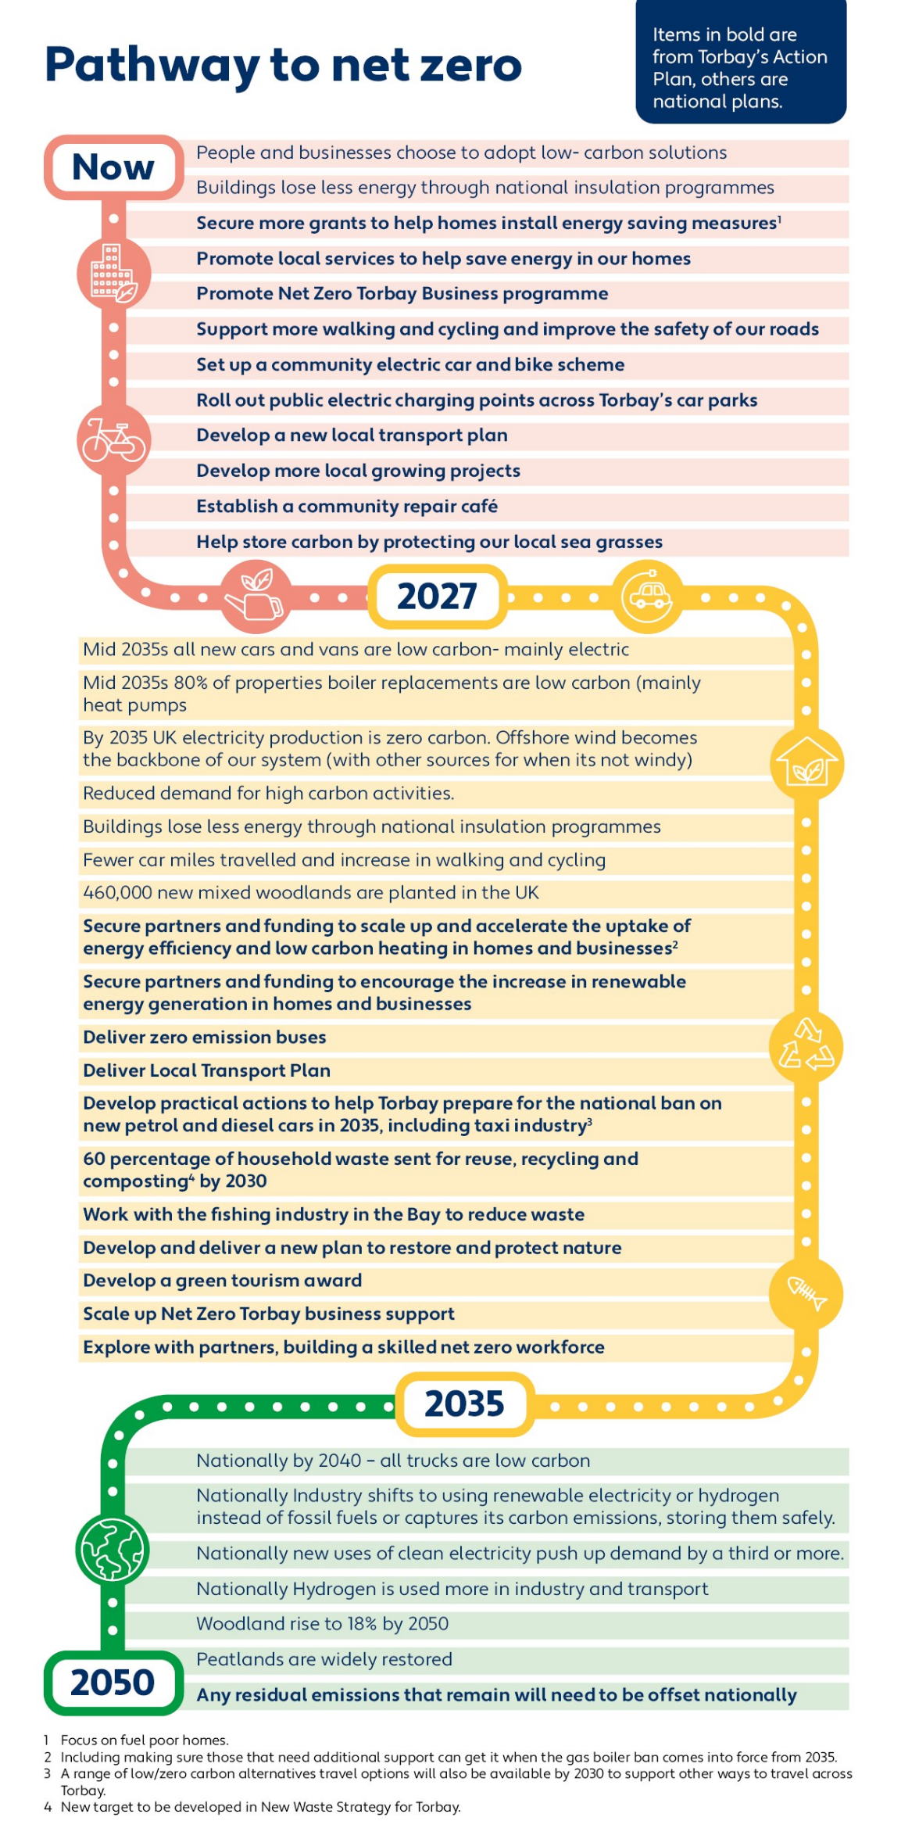

Financing a Balanced Transition

A Complex Challenge

Overview
Achieving net-zero will require a major nationwide investment programme, led by national government, but funded and delivered by private companies and individuals.
The public consultation on the TCEAP did receive some concerned comments about the overall cost for Torbay to deliver actions by 2030. Considering this the TCP has refined the target to net zero carbon emissions by 2050 at the latest. This is aligned with national strategies, ensuring cost-effectiveness, and avoiding unnecessary expenditure from premature actions.
The National Mission initiative underscores that the benefits of reaching net zero by 2050, are anticipated to surpass the costs.
The independent Climate Change Commission (CCC) has analysed that the UK's decarbonisation efforts up to 2050 will likely cost less than one percent of the Gross Domestic Product (GDP), with potential for further reductions. Studies, including one by Cambridge Econometrics, suggest that considering indirect economic impacts could lead to a two percent GDP growth due to the transition, factoring in new employment opportunities, enhanced economic activity, and savings from reduced fossil fuel dependence.

Transition costs
The ‘Net Zero Torbay Report estimates that achieving a net-zero carbon by 2050 at the latest in Torbay could equate to 1.5 percent of its GDP, with financial responsibility for these actions being distributed across various entities, from public and private sectors, national governments, and individuals. The CCC anticipates that nationally, the annual cost will peak at £50 billion by the late 2020s, with investments concentrated on transport, renewables, and building sectors. These expenses are expected to be balanced by operational savings, especially from the increased efficiency of electric vehicles by the late 2030s.

Costs

Cost of action
The cost of actions listed in this document has been examined with local and regional partners. Some actions are already funded by the Council, local partners, external funders, and the Government. Many require only time from staff and volunteers, others require funding and increased staff capacity. This funding is likely to come from a range of external sources such as businesses, funders, and central government. Estimating the total cost for these actions by 2050 is challenging, and responsibility for funding is shared among partners. Initial estimates for some priority actions to be delivered over the next three years are around £56 million.

Cost of Inaction
The cost of inaction is also significant. Without reducing carbon emissions, the physical impacts could cost England’s economy up to 1.5 percent of GDP per year by 2045, escalating to between two and four percent by the century's end. The recent flooding in England illustrates these costs, with damages estimated at £333 million, and would have been significantly larger in the absence of flood defences.

Household Costs
The TCP is conscious that we are in a ‘cost of living’ crisis. It is therefore important to provide support for those who might struggle to afford the changes envisioned by the transition to net-zero. For example, the CCC estimates the average household investment for energy efficiency retrofits is under £10,000, with the majority costing less than £1,000, and leading to reduced energy bills. Even though initiatives led by Exeter Community Energy have already led to significant savings on fuel bills, there are still sizeable upfront costs for some that may struggle to fund retrofitting homes.
To try and alleviate some concerns raised about impacts on delivering actions in Torbay, a high-
level economic, social, equalities and environmental impact assessment on the priority actions
above has been carried out. No actions were deemed to have a negative effect. All subsequent
priority action plans will also undergo a similar assessment.

What Can I Do?
There are lots of things we can do about climate change from calculating our carbon footprint to buying green energy, hang-drying clothes and insulating our roofs, to name but a few ideas.
A great place to start is to look at the Devon Climate Emergency (Top Tips for Everyone – Devon Climate Emergency) and Torbay Council’s Take Action page here.

What Organisations Can Do?
Organisations across Torbay are taking action to tackle climate change. Actions such as calculating your carbon footprint and using less energy, water and waste and transitioning your fleet to zero emission alternatives are just some ideas. Many actions can also help your organisation save money. A great place to start is Devon Climate Emergency What can my organisation do? Webpage (Resources for Organisations – Devon Climate Emergency).
Locally Make It Net Zero Torbay can help businesses design bespoke actions and offer grant funding to make it happen. Find out about how to attend one of the forthcoming events here.

Measuring Success
The Framework outlines the long-term ambition accompanied by shorter- term action plans.
This plan does not quantify the carbon savings associated to each proposed action to be carried out. Where it is possible, as projects develop, carbon savings will be estimated and reported.
Instead, Torbay Climate Partnership will annually monitor and report progress on all actions in the 2024 – 2027 action plan, and subsequent action plans. Torbay’s total emissions (tCO₂e) and a basket of other local performance data on energy efficiency, renewable energy generation, waste, transport, and nature based solutions, where available, will also be reported on, to show annual progress towards the 2035 and 2050 targets.

Glossary
Active Travel - Making journeys by physically active means, like walking or cycling.
Afforestation - Afforestation is the act of planting trees in areas where there were previously no forests. Click here for more information.
Biodiversity – Biodiversity is the term used to describe the enormous variety of life on Earth or in a particular habitat, including plants, animals, bacteria and fungi. Maintaining this variety is considered to be important and desirable for the functioning of natural systems.

Carbon Dioxide equivalent (CO2e) - CO2e is the abbreviation for 'carbon dioxide equivalent.' CO2e is used to measure and compare emissions from greenhouse gases based on how severely they contribute to global warming. For ease this document will refer to these emissions as carbon emissions
Carbon Emissions – For the purpose of this document we have abbreviated Carbon dioxide to carbon emissions. These are emissions that planes, cars, factories, etc. produce that is harmful to the environment. Click here for more information.
Carbon Footprint - A measure of the amount of carbon dioxide released into the atmosphere by an individual, an organisation or a geography’s activities over a particular period.
Carbon Neutral - This means taking as much carbon dioxide equivalent (CO2e) gases out of the atmosphere as we put in. We will reduce emissions to as near to zero as possible. Where residual emissions exist, these will be balanced by removals from the atmosphere. Click here for more information.
Carbon Offset - An action intended to compensate for the emission of carbon dioxide into the atmosphere, such as tree planting. Click here for more information.
Carbon Capture and Storage – is the process of recovering carbon dioxide from the fossil-fuel emissions produced by industrial facilities and power plants and moving it to locations where it can be kept from entering the atmosphere in order to mitigate global warming.
Carbon Storage/Sequestration – The long-term storage of carbon dioxide from the atmosphere naturally in plants, soils, and the ocean, or capturing it with technology and permanently storing it underground.
Climate Adaption - Adaptation refers to the adjustments needed from individuals, communities, and countries in response to changes to our planet’s climate. Click here for more information.
Climate Change Committee - The Climate Change Committee (CCC) is an independent, statutory body established under the Climate Change Act 2008. Their purpose is to advise the UK and devolved governments on emissions targets and to report to Parliament on progress made in reducing greenhouse gas emissions and preparing for and adapting to the impacts of climate change. Click here for more information.
Climate Mitigation – Mitigation describes efforts to reduce or remove emissions of greenhouse gases such as carbon dioxide (CO2) and methane (CH4) which are causing our planet to warm. Click here for more information.
Circular Economy - A circular economy is based on the principles of designing out waste and pollution, keeping products and materials in use (reusing and recycling) and regenerating natural systems. Click here for more information.
Decarbonisation - The reduction or removal of carbon dioxide and other greenhouse gases to achieve zero emissions.
Ecosystems – An ecosystem consists of all the organisms within a physical environment and the environment within which they interact. Within an ecosystem, these living and non-living components are linked together through nutrient cycles and energy flows.
Electric Vehicle (EV) - EVs are vehicles that are either partially or fully powered on electric power.
Fossil Fuels - A natural fuel such as coal or gas, formed in the geological past from the remains of living organisms.
Fugitive Gases - Emissions due to leaks and other unintended or irregular releases of greenhouse gases.
Global Warming - A gradual increase in the overall temperature of the earth's atmosphere generally attributed to the greenhouse effect caused by increased levels of carbon dioxide, CFCs, and other pollutants. Click here for more information.
Greenhouse Effect - A process that occurs when gases in Earth’s atmosphere trap the Sun’s heat, warming the Earth’s surface. Click here for more information.
Greenhouse Gas - An atmospheric gas that traps heat by letting sunlight pass through the atmosphere but prevents heat from leaving the atmosphere. Click here for more information.
Green Tourism - Green tourism is a form of ecotourism that involves visiting natural areas while minimizing environmental impacts. It is a low-impact tourism that aims to protect the environment and culture of an area. Green tourism tries to both minimize and reverse the negative effects of travel. Click here for more information.
Gross Domestic Product - the total value of goods produced, and services provided in a country for one year.
Habitat Restoration – Habitat Restoration is the rehabilitation of an area to recreate a functioning ecosystem.
Methane - A strong greenhouse gas that is emitted from the production of coal, natural gas and oil, livestock, and agricultural practices and from waste landfills.
Nature Based Solutions - These solutions involve protecting, restoring, and sustainably managing ecosystems in ways that increase their resiliency and ability to address those societal challenges, while also safeguarding biodiversity and improving human wellbeing.
Net Zero Carbon – For Torbay this means reducing its greenhouse gas emissions by 100% from 2008 levels by 2050. It means that the total emissions would be equal to or less than the emissions removed from the environment. This can be achieved by a combination of emission reduction and emission removal. Not all emissions can be reduced to zero, so those that remain need to be matched by actively removing greenhouse gases from the atmosphere. This is known as "offsetting". For simplicity, we use the term 'Net Zero Carbon emissions' as shorthand for all greenhouse gases. All figures in this report relate to the carbon dioxide equivalent (CO2e) of all greenhouse gases.
Oceanic Absorption – The absorption of carbon dioxide by the sea is a complicated process that is dependent on the difference in the concentration of carbon dioxide between the sea surface and the air, and the efficiency of the exchange. Click here for more information.
Oceanic Currents – Oceanic currents are continuous, predictable and directional movements of seawater that are produced by a number of forces, such as gravity, wind, water density, and tides. Ocean currents can move horizontally and vertically and can affect the climate and marine life.
Photosynthesis - Photosynthesis is the process by which plants use sunlight, water, and carbon dioxide to create oxygen and energy in the form of sugar.
Renewable Energy - Energy that comes from resources which are naturally replenished on a human timescale such as sunlight, wind, rain, tides, waves, and geothermal heat. Click here for more information.
Rewilding - the process of restoring an area of land to its natural uncultivated state.
Sustainable Transport - Sustainable transport refers to transportation that is or approaches being sustainable. Sustainable transport creates little or no pollution, such as walking or bicycle commuting, and relies on renewable energy or regenerated energy rather than fossil fuels.
Wheeling - Wheeling is a term used alongside walking to describe a wider range of people who may not identify themselves with the term 'walking'. This may or may not include people who travel using wheelchairs, mobility scooters, other walking aids, prams, buggies, etc. In common with each other, walking and wheeling involve travelling at a pedestrian pace. Wheeling is a form of active (i.e. fully or partially people powered) travel. Active travel also includes walking, cycling, scooting, skateboarding, roller skating - i.e. modes of non-vehicular travel that involve physical activity.
Zero Carbon - When no carbon emissions are being produced from a product or service. Click here for more information.
This document can be made available in other languages and formats. For more information, please contact future.planning@torbay.gov.uk

IPCC, 2023, Synthesis Report of the Sixth Assessment Report, Section 2.1
The Intergovernmental Panel on Climate Change (IPCC) is a scientific body of the United Nations. The UK Government fully supports the work of the IPCC. It regards the IPCC’s assessments as the most authoritative view on the science of climate change. IPCC reports undergo an unparalleled, rigorous, and transparent international preparation and peer-review process by scientific experts and governments before they are published
IPCC, 2021, Climate Change 2021: The Physical Science Basis, Summary for Policymakers, Paragraph A.1
Climate change drives UK’s first year over 10°C - Met Office
The Intergovernmental Panel on Climate Change (IPCC) is a scientific body of the United Nations. The UK Government fully supports the work of the IPCC. It regards the IPCC’s assessments as the most authoritative view on the science of climate change. IPCC reports undergo an unparalleled, rigorous, and transparent international preparation and peer-review process by scientific experts and governments before they are published
IPCC, 2023, Synthesis Report of the Sixth Assessment Report, Section 2.1
2021 continues warm global temperature series - Met Office
IPCC, 2021, Climate Change 2021: The Physical Science Basis, Summary for Policymakers, Paragraph B2.1, B2.3
WMO, 2023, State of the Climate 2022. Chapter: ‘Ocean’ Page 6
WMO, 2023, State of the Climate 2022. Chapter: ‘Cryosphere’ Page 13
IPCC, 2021, Climate Change 2021: The Physical Science Basis, Technical Summary, Box TS.4
IPCC, 2021, Climate Change 2021: The Physical Science Basis, Summary for Policymakers, Section A.3 & IPCC, 2021, Climate Change 2021: The Physical Science Basis, Summary for Policymakers, Section B.2
IPCC, 2021, Climate Change 2021: The Physical Science Basis, Summary for Policymakers, Section A.3 & IPCC, 2021, Climate Change 2021: The Physical Science Basis, Summary for Policymakers, Section B.2
Devon Carbon Plan – Devon Climate Emergency
Herein known as Net Zero
Herin known as carbon emissions
A metric that expresses the impact of each different greenhouse gases in terms of the amount of carbon dioxide that would create the same amount of warming.
Torbay reduces its greenhouse gas emissions by 100% from 2008 levels by 2050. If met Technically it means that the total emissions would be equal to or less than the emissions removed from the environment. This can be achieved by a combination of emission reduction and emission removal. Not all emissions can be reduced to zero, so those that remain need to be matched by actively removing greenhouse gases from the atmosphere. This is known as "offsetting". For simplicity, we use the term 'carbon emissions' as shorthand for all greenhouse gases. All figures in this report relate to the carbon dioxide equivalent (CO2e) of all greenhouse gases
The 'net zero target' refers to a government commitment to ensure the UK reduces its greenhouse gas emissions by 100% from 1990 levels by 2050. If met, this would mean the amount of greenhouse gas emissions produced by the UK would be equal to or less than the emissions removed by the UK from the environment
100% from 2008 levels by 2050 (note that the national target is based on a 1990 level, but we do not have data for Torbay until 2008)
Territorial production based emissions (excluding emissions associated with the creation and transportation of all things consumed in an area (known as consumption based emissions)
Vehicles that produce low levels of carbon dioxide
Vehicles that produce low levels of carbon dioxide (and other harmful pollutants)
Nature being used to help store carbon or used to reduce the impacts of climate change i.e. creating shade during the summertime to cool urban areas.
Mission Zero: Independent review of Net Zero Review Conclusion 3
This includes one new rail station and fully electrifying all electric buses (these actions may take longer than this first three year action plan and account for 82 percent of this estimated figure).
The Third National Adaptation Programme (NAP3) and the Fourth Strategy for Climate Adaptation Reporting (publishing.service.gov.uk)

