Spatial Planning Enforcement Policy
Torbay Council
Version Control
Ver. | Date | Changed By | Change | Sections

Contents
1. Introduction 2
1.1. The objectives of the enforcement process are: 2
1.2. Torbay Council’s principles of enforcement 2
1.3. Expediency 2
1.4. Proportionality 3
2. How to report a breach of planning control 3
3. Investigation 4
3.1. Site visits 5
4. Further action 6
4.1. Types of enforcement 6
4.2. Notification 7
Appendix 1 - Expediency matrix 8
Government Guidance and Legislation 9

Planning Enforcement Policy

Introduction
Local Planning Authorities have a discretionary power to take enforcement action where unauthorised development has taken place. Unauthorised development includes building works, changes in the use of buildings or land, the appearance of buildings or land, advertisements, works to Listed Buildings, or works to trees that are protected.
We investigate all complaints we receive about unauthorised development and make decisions on whether to take enforcement action based upon the following criteria:
- The merits of each case;
- The aims and objectives of the Local Plan and other legislation; and
- Whether it is expedient or in the public interest to take enforcement action in respect of the above factors.
This policy will set out Torbay Council’s approach to investigating unauthorised development and our decision making process when deciding whether to take enforcement action.

The objectives of the enforcement process are:
- Ensure that the aims and objectives of the Local Plan are adhered to and implemented.
- Investigate, resolve and monitor unauthorised development, especially with regard to conservation areas, protected trees and listed buildings.
- Monitor compliance with planning permissions, conditions and planning agreements.
- Investigate and respond to complaints in an efficient and timely manner.

Torbay Council’s principles of enforcement
- Torbay Council will apply its Planning Enforcement Policy in an equitable and fair manner. This means that there will be a consistent approach to investigation and consideration of enforcement action, but does not mean uniformity.
- We will conduct all investigations with discretion.
- We will actively work to advise and assist with compliance, seeking solutions with all parties.
- We will take into account the circumstances of the case, the degree of harm (or potential harm) and the impact on the wider public interest when considering appropriate action.
- We will make clear the reasons why the Council has decided to take or not take enforcement action on a specific case.

Expediency
The use of enforcement powers is discretionary and the Council will take into account a number of factors and will make a judgement about whether to take enforcement action based upon the following criteria:
- Whether the breach of control would unacceptably affect public amenity, including Tree Preservation Orders.
- Whether it would give rise to a serious risk to public safety
- Whether the existing use of the land/buildings merit protection in the public interest
- Whether the development is in a Core Tourism Investment Area, as designated in Torbay’s Local Plan 2012 - 2030
In considering whether to take enforcement action the Council will not give weight to the fact that development may have already commenced. It is not a criminal offence to carry out development without planning permission, unless this involves a Listed Building or a tree protected under a Tree Preservation Order.

Proportionality
When considering whether to take enforcement action, the Council will take action commensurate with the harm/potential harm caused by the development. The cost of taking enforcement action will be balanced against the value gained from enforcement action.
We will consider a ‘de minimis’ level of harm caused when considering whether to take enforcement action. This ‘de minimis’ level will be different dependent on the merits of each case. In broad terms, we will not take any enforcement action where a breach is below 250mm of previously consented or permitted development.

How to report a breach of planning control
We will provide the option to report a planning breach via our website. We will also provide the facility to print off a paper version of your complaint from our website.
We request that reports of planning breaches are submitted via the completion of a form to ensure that we capture all of the information required to undertake an investigation.
Information we require to allow us to investigate includes:
- The type of work being undertaken, e.g. unauthorised building or demolition
- The site address
- The person responsible for the works (if known)
- The name and contact details of the person making the complaint (we reserve the right to only investigate serious breaches of planning control that are reported by anonymous sources).
- A description of why there is a potential breach of planning control.
- Any evidence which may help the investigation, for example photographs of the site.
- The harm that the breach causes.

Investigation
We receive in the region of 300 complaints each year. Some of these complaints will require no further investigation because we identify that planning permission already exists for the work, or that planning permission was not required.
Complaints that are made are logged on our system and allocated to an Investigation Officer. The officer’s first task will be to identify whether there is existing planning permission for the development and they will do this by researching our records.
We will then identify whether the potential breach is subject to a time limit for taking Enforcement Action. The time limits are as follows:
- 4 years in respect of operational development (building or ground works) or the change of use of a building to a single dwelling. Where there is evidence than development has been deliberately concealed and investigation may still be carried out and action taken.
- Within 10 years for any other breach of planning control (essentially other changes of use).
- No time limit on breaches relating to listed buildings
We will acknowledge complaints within 5 working days.
If the officer establishes that there is a potential breach of planning control, the officer will categorise the complaint into one of the priority levels below. Whilst we will investigate every complaint that we receive, the volume of workload means that cases will be prioritised, so that higher risk cases are dealt with first. We will investigate based upon the following order of priority:
Priority A
We will aim to respond to these complaints within 5 working days
- Development that could cause a serious and immediate danger to public health and/or safety.
- Unauthorised works to a listed building or scheduled ancient monument (if within the Council’s jurisdiction).
- Unauthorised works to a tree which is subject of a Tree Preservation Order or is situated within a Conservation Area.
- Unauthorised traveller/gypsy occupation of sites
- Any case where the time limit for taking enforcement action expires in the near future.
- Any unauthorised development, advert or breach of condition which is causing irreparable public harm or danger; including pollution or environmental harm.

Priority B
We will respond to these complaints with 15 working days
- Unauthorised development which would adversely affect the character/appearance of a conservation area or the setting of a listed building
- Cases that clearly require attention but are not otherwise a high priority.
- Unauthorised change of use to the detriment of neighbouring amenities.

Priority C
We will respond to these complaints within 28 working days
- Unauthorised development which would be likely to receive planning permission if a planning application were to be submitted.
- Unauthorised satellite dishes/telecommunications equipment on residential premises.
- Unauthorised advertising, such as fly-posters or banners where the harm to neighbouring amenities is not significant.
- Unauthorised signage/advertisements (unless the sign/advertisement seriously affects public safety).

The Planning Enforcement team will not investigate the following:
- Non-planning related neighbour disputes
- Land boundary, ownership disputes.
- Hedge related neighbour disputes.
- Use, signage or development on highways, pavements or grass verges; unless in private ownership. In these instances, complainants are advised to contact the Highways team via www.torbay.gov.uk/highway-maintenance.
- Dangerous structures. In some cases affecting public safety these can be investigated by a Building Control Surveyor. To make a report of this nature, complainants are advised to contact the Council’s Building Control team.

Site visits
The first stage of our investigation will be conducted by researching evidence provided by the complainant, as well as all of the records we hold for the site. If we suspect that a breach of planning control has taken place, we may decide to conduct a site visit to investigate further.
If we do use a site visit to conduct our investigation we will:
- Act with discretion at all times, especially in cases where we need to view the site from the complainant’s address.
- Take a written record of the site visit, including details of any persons present. Photographs taken on site will be recorded on the Council’s planning database.
We will use the case priority matrix above to help us decide if and when to make site visits:
Priority A | Site visit within 5 working days of acknowledgement
Priority B | If we decide a site visit is necessary, we will aim to conduct this within 15 working days of acknowledgement
Priority C | We may decide that a site visit is not necessary in these cases, especially if we are able to negotiate a satisfactory remedy with all parties.  Where we determine that a site visit is necessary, we will aim to visit these sites within 28 working days.

Further action

Types of enforcement
Throughout the investigation process we will stay in touch with both the complainant and the person suspected of breaching planning control. At all stages of the investigation, we will decide upon the proportionate level of future action. The list below details some of the steps we may choose to take, although this list is not exhaustive:
Type of enforcement action | Purpose
No further action | We may decide that enforcement action is not proportionate to the level of harm caused by a breach. This may be for cases where the breach is of a technical nature or where it is judged that unconditional planning permission would have granted should an application be submitted.  We will encourage the submission of a retrospective planning application in these circumstances.
Planning Contravention Notice (PCN) | Requires persons to divulge information in respect of land and activities. This is often the first formal step in resolving a breach of planning control.  Failure to provide information requested through a PCN can result in a fine of up to £1,000, whilst providing false information can result in a fine of up to £5,000.
Request for Information | Similar to a PCN, but cases where the Council has sufficient details about the activities being carried out but requires further information concerning ownership. It is also used in cases involving unauthorised works to a listed building where there is no associated breach of planning control. The penalties attached to an RFI are similar to those for the PCN.
Enforcement Notice | The most common notice used to deal with a breach of planning control. It is served when the Council is satisfied that there has been a breach of planning control and that it is expedient to take action.  An Enforcement Notice will specify the breach, the steps that must be taken to remedy the breach and a specified time period for compliance.  The recipient of an Enforcement Notice has a right of appeal to the Planning Inspectorate and should do so before the notice comes into effect.  Failure to comply with an Enforcement Notice can result in a fine, the value of which will be set by the Court.
Breach of Condition Notice | To secure compliance with conditions specified within a planning permission. A minimum of 28 days will be given for compliance. There is no right of appeal against a Breach of Condition Notice. Failure to comply with a Breach of Condition Notice can result in a fine of up to £1,000.
Stop Notice | Must be accompanied by an Enforcement Notice and served at the same time. A stop notice will ensure that any activity that may irrevocably harm the amenity, public safety or natural environment ceases. A stop notice can be used to ensure that work does notice continue when an appeal is lodged against an Enforcement Notice.  Failure to comply with a Stop Notice can result in a fine, the value of which will be set by the Court.
Temporary Stop Notice | As above, but only valid for 28 days and cannot be re-issued following that period. This will be used when a potential breach requires immediate action and will allow the Council time to investigate the potential breach.  Failure to comply with a Temporary Stop Notice can result in a fine, the value of which will be set by the Court.
Injunction | There may be exceptional cases where it will be to restrain an actual or potential breach of planning control. An injunction can be sought whether or not enforcement action has been taken. Due to the high costs involved an injunction is only used as a last resort and where the Council determines that other action is unlikely to succeed.
Section 215 Notice – Town and Country Planning Act 1990 | This Notice is served owners of buildings/land to remedy the existing condition so it no longer adversely affect the local visual amenity. A Section 215 Notice will detail the steps require to remedy the existing condition and the timescale for compliance.  Failure to comply with a S215 Notice can result in a fine of up to £1,000.
Prosecution | If there is a failure to comply with a Notice, the Council may seek prosecution, which will be sought at a Magistrate’s or Crown Court. A successful prosecution could result in a fine.
Confiscation orders under the Proceeds of Crime Act 2002 (POCA) | Once a valid effective Enforcement Notice is breached, a Council can where appropriate pursue a confiscation order under POCA. The initial preparations for the confiscation order are made in tandem with the prosecution, and an Accredited Financial Investigator will carry out all the investigations into the defendant’s financial situation. Where a conviction is secured, the confiscation order process will normally commence with an application by the Local Planning Authority.

Notification
An affected party can lodge an appeal about an Enforcement Notice with the Planning Inspectorate within one month of being served the Notice. The Planning Inspectorate will deal with the appeal and issue the decision notice. All Enforcement action is suspended while an appeal is being determined.
If we decide to not take any Enforcement action on a case, all parties will be informed along with our clear reasons. The Council holds a Corporate Complaints System if any persons affected by the Investigation and Enforcement process are dissatisfied with the service they have received from the Council.

Appendix 1 - Expediency flowchart
When considering whether to use planning enforcement powers, Council’s must consider the expediency of such action. The flow chart below will help us to determine whether it is expedient to take enforcement action.
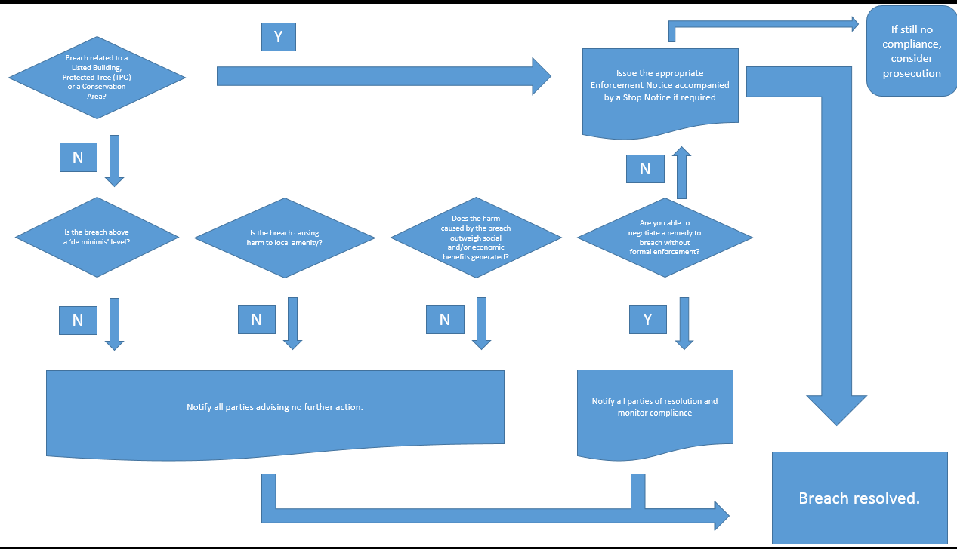

Appendix 2 - Government Guidance and Legislation
Torbay Council undertakes Planning Enforcement in accordance with Local and Central Government legislation, policies and guidance including (but not necessarily restricted to):
- Town and Country Planning Act 1990 (as amended by the Planning and Compensation Act 1991 and The Planning and Compulsory Purchase Act 2004) as amended
- National Planning Policy Framework
- Torbay Local Plan 2012 to 2030
- Town and Country Planning (Control of Advertisements) (England) Regulations 2011
- Planning (Listed Buildings and Conservation Areas) Act 1990
- Anti-Social Behaviour, Crime and Policing Act 2014
- Town and Country Planning (Environmental Impact Assessment) Regulations 2011
- Human Rights Act 1998.
- Article 1 of the First Protocol – protection of property
- Article 6 - the right to a fair trial
- Article 8 – right to respect for family life; and home
- Article 14 – protection from discrimination
- Police and Criminal Evidence Act 1984; as amended
- Localism Act 2011
- Proceeds of Crime Act 2002 (POCA)

