Roof plans
These are required where a roof would be either altered or a new one created by the proposal and should show:
- The shape of the roof
- Specify the roofing material to be used
In addition to the requirements above the floor plan should also show the following information
- Date
- Site address
- What scale the plan is drawn to
- The plan type and, where appropriate, whether the plan shows the site as 'Existing' or 'Proposed'

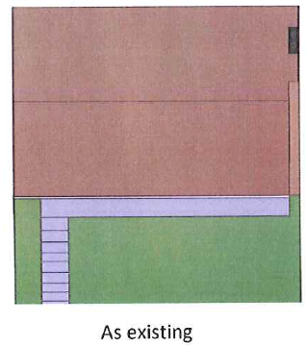
Example roof plans for new pitched-roof dormers in the roof:

