Floor Plans
Floor plans are required to show new development and for existing buildings altered by the proposed development. These should:
- show walls with a dimensions ( a thickness/width) not just a single line
- highlight any existing walls or buildings that are to be demolished, where applicable.
- windows and doors should be shown on the plan

On all plans please show the following information:
- Date
- Site address
- What scale the plan is drawn to
- The plan type and, where appropriate, whether the plan shows the site as 'Existing' or 'Proposed'
It is very important that the floor plans are consistent with the elevation plans supplied. Please read the section Common Inconsistencies

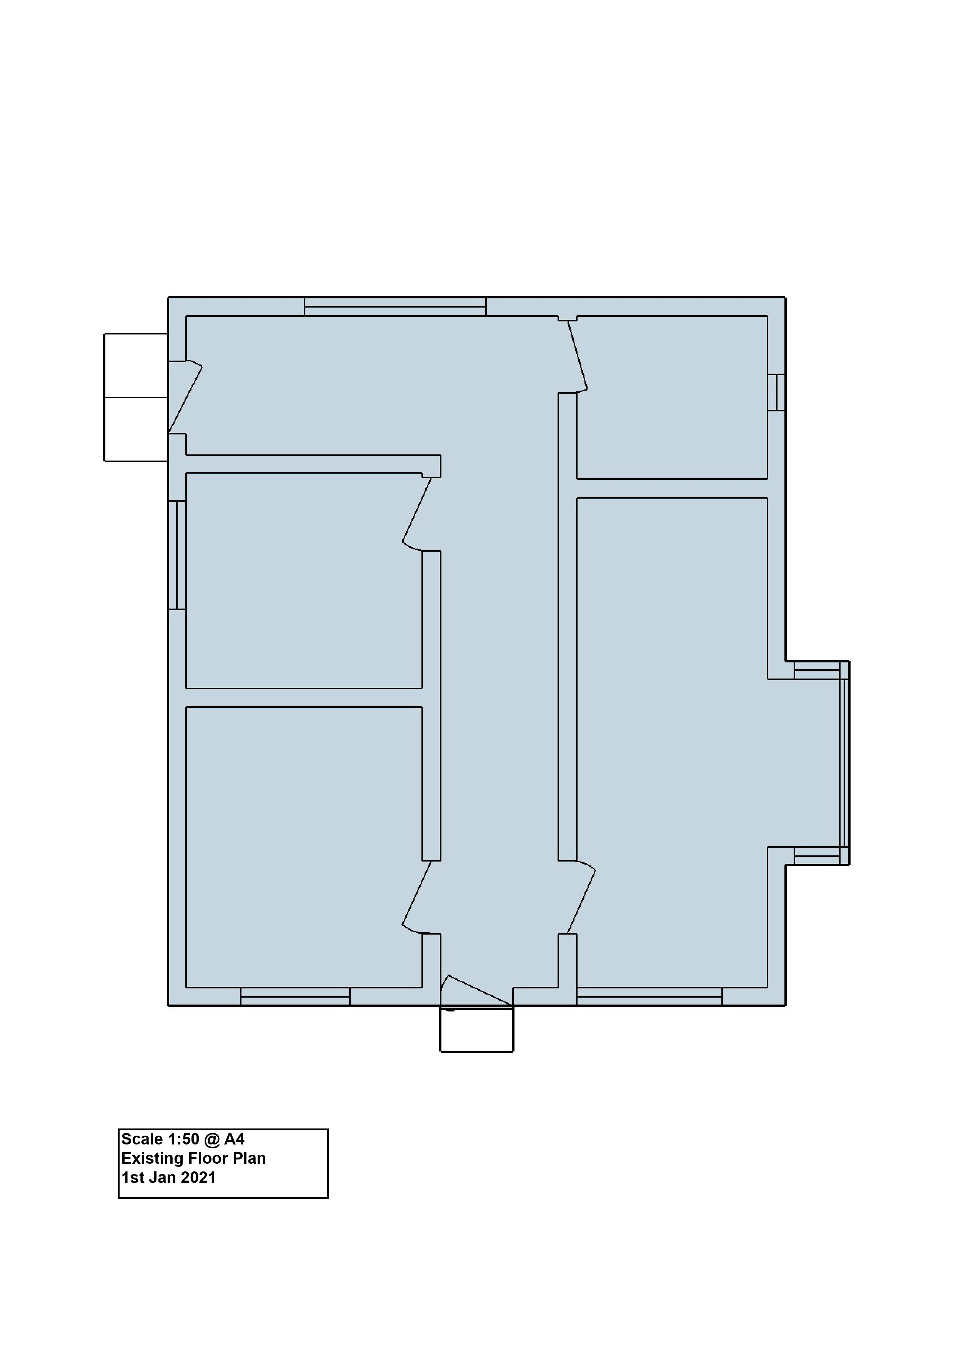
Common inconsistencies
When producing floor plans it is important to make sure that the floor plans are consistent with the elevations.
Two common inconsistencies occur
- There is a difference in window sizes between the two plans
- The window is missing altogether.
The elevation has three windows. The elevation shows that he left window is 120cm wide. However, when comparing the elevation with the floor plan, the left window is 170cm wide. The middle window is missing from the floor plan altogether. The window on the right is consistent between the two plans

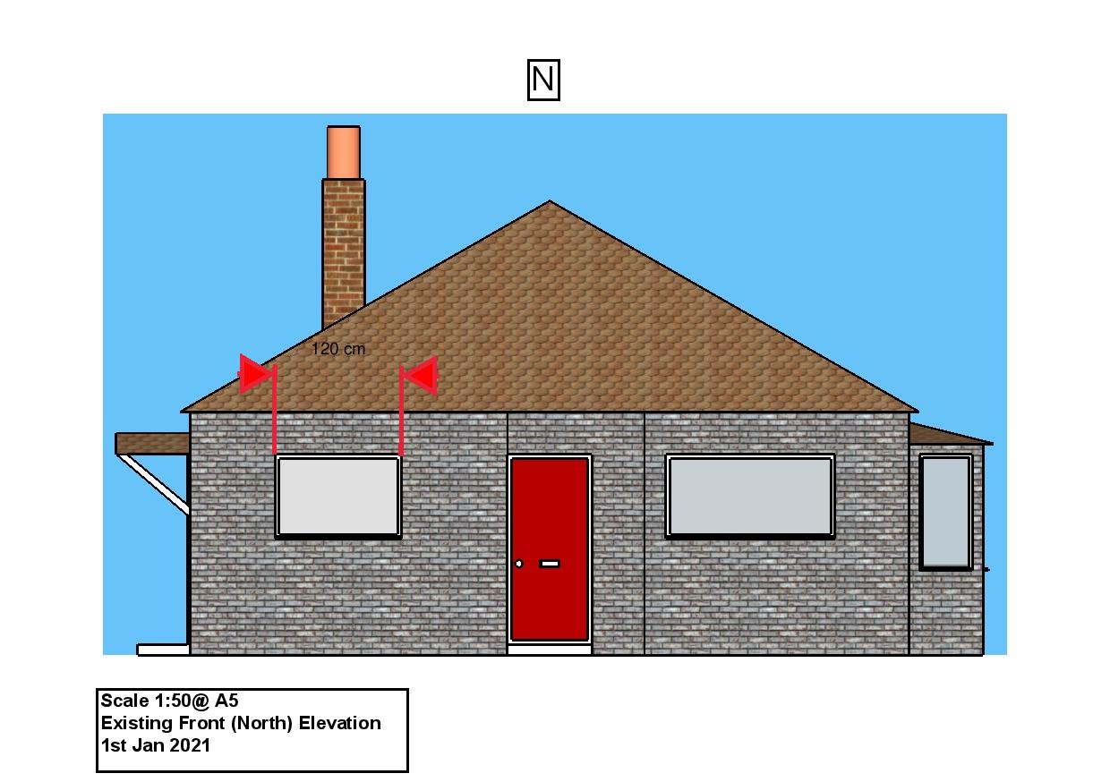

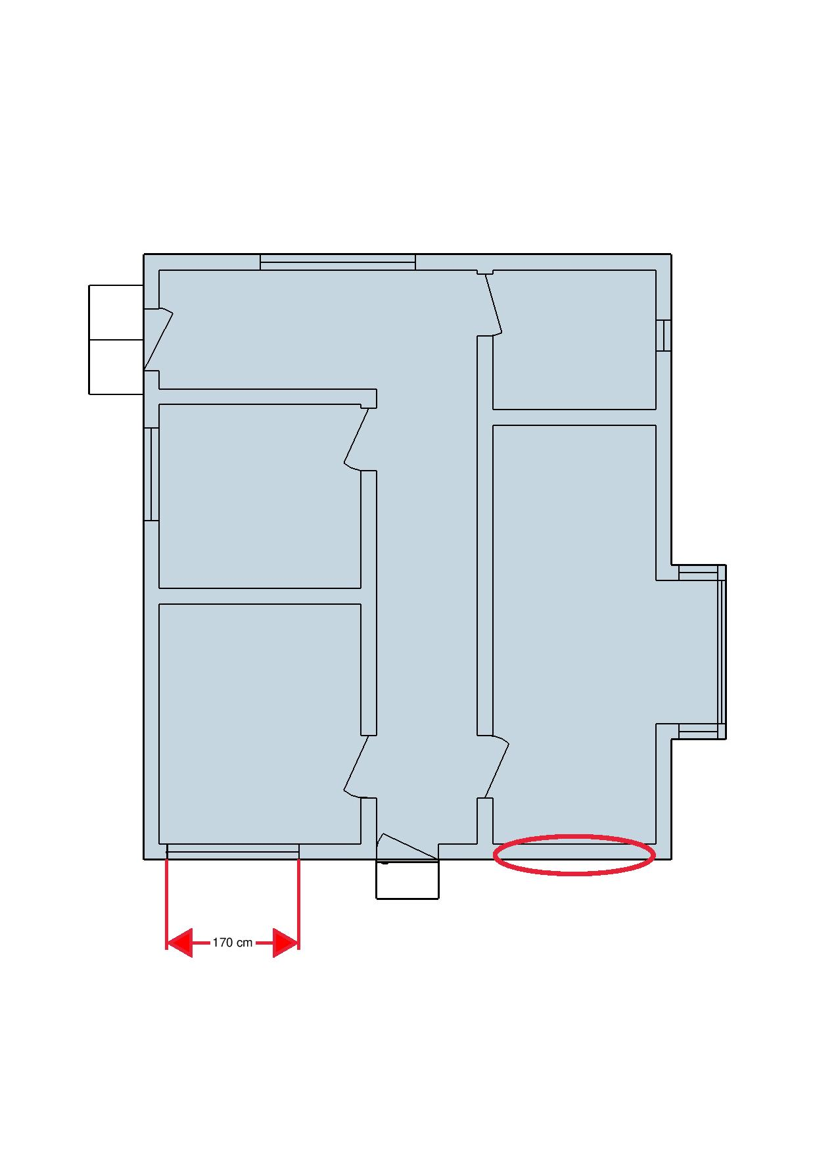

A few moments checking your plans before submitting them to the council can save days or even weeks of delay in processing your plans.

