**Elevation plans**

Elevation plans should:

* Show an existing and proposed drawing for each elevation where a change is to occur.
* Be consistent. Please see examples of Common inconsistencies (below)
* Indicate, where possible, the proposed building materials and the style, materials and finish of windows and doors
* Where a proposed elevation adjoins another building or is in close proximity to it, the drawings should show the relationship between the two buildings and detail the positions of the openings on each property.

The clearest way to illustrate your proposed scheme is to include plans that show the existing i.e. the site as before any changes and the proposed i.e. the site as after the proposed changes.

On all plans please show the following information:

* Date
* Site address
* What scale the plan is drawn to/relevant measurements in metric.
* The plan type and, where appropriate, whether the plan shows the site as 'Existing' or 'Proposed'
* Details such as door and window frames should be included.

Example elevation plans

Porch – front view of existing

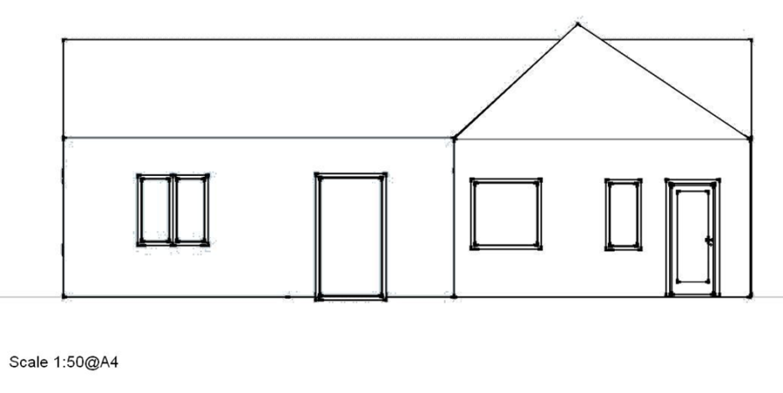

Porch – front view of proposed

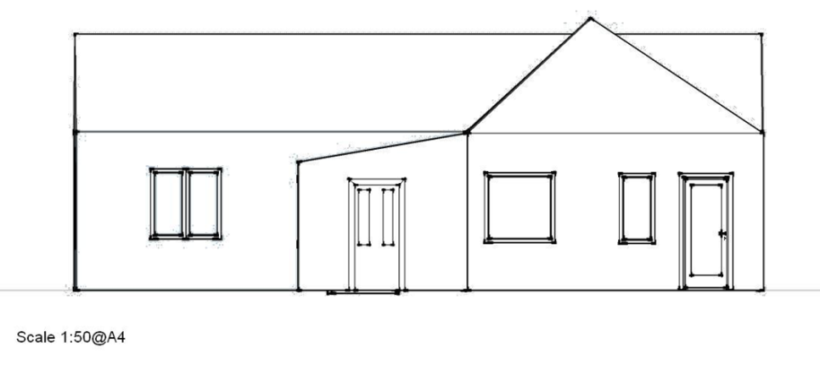

**Common Inconsistencies**

An error that commonly occurs is the failure to represent features that are shown on one elevation and should be visible on another elevation. Examples would include chimneys, bay windows, porches and balconies. (see example below)

The Front elevation shows a canopy over a door (left side), a bay window (right side) and a chimney.

Now please look at the following rear elevation for the same building .

Note that the canopy, bay window and chimney are missing. To be consistent with the front elevation these features must be shown correctly.

Not only should the elevations be consistent with each other, but the elevations should also be consistent with the floor plans. Common errors occur when a window is shown on elevation, but the window is missing from the floor plan or a window shown on a floor plan is missing from the elevation. (see floor plans help text)

**A few moments checking your plans before submitting them to the council can save days or even weeks of delay in processing your plans.**

