**Block Plans /Layout Plan**

Block/Layout plans of the site need to show:

* Site boundaries
* The type and height of boundary treatment (e.g. walls, fences)
* Where a change is proposed
* The position of any building or structure on the other side of such boundaries and where these could influence or be affected by the proposed development
* Existing and proposed parking arrangements
* Scales of 1:50, 1:100 or 1:200 are usually acceptable.

All plans must be drawn to scale

On all plans please show the following information:

* Date
* Site address
* What scale the plan is drawn to/relevant measurements in metric.
* The plan type and, where appropriate, whether the plan shows the site as 'Existing' or 'Proposed'

Example block plan

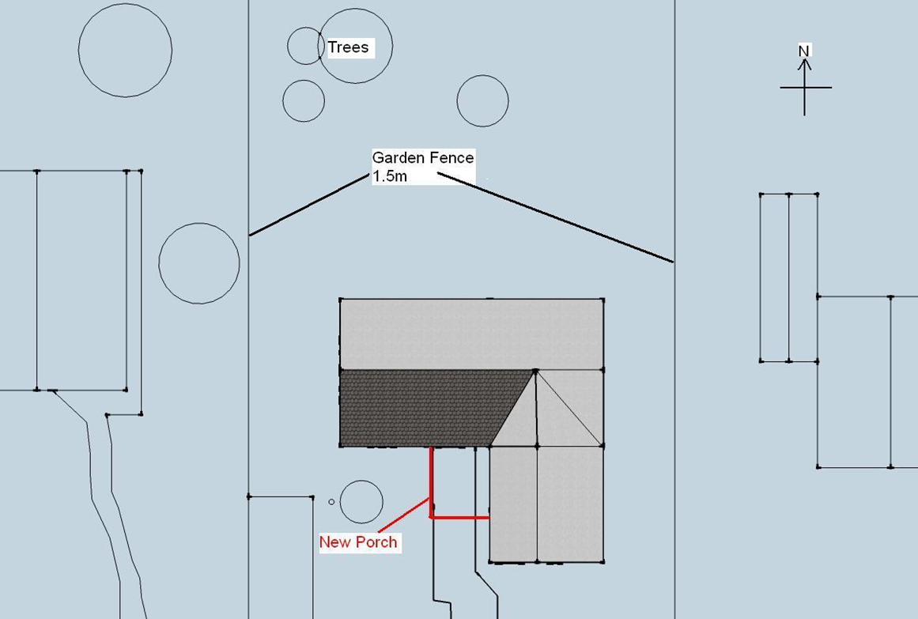

Scale 1:100 1-1-2014 3 New Road, Old Town. Proposed new porch