BOROUGH OF TORBAY
(TORBAY ROAD, PAIGNTON)
EXPERIMENTAL REGULATON OF TRAFFIC ORDER 2022

Statement of Reasons

Torbay Council, in accordance with powers conferred by the Road Traffic Regulation Act 1984 has made an experimental traffic regulation order as it appears expedient on the following grounds -

- for avoiding danger to persons or other traffic using the road or any other road or for preventing the likelihood of any such danger arising
- for facilitating the passage on the road or any other road of any class of traffic (including pedestrians)
- for preserving or improving the amenities of the area.

This experimental scheme is aimed at assessing the effectiveness of reducing vehicular traffic flow along Torbay Road, Paignton. Initially, a number of pedestrian zones were introduced which restricted access to motor vehicles between 6pm and 10am only. However, in light of the feedback received during the first three months of the scheme, the restrictions were then modified by opening up half of Torbay Road to traffic, with additional parking and loading places put in place. It also reverted the flow of traffic along Adelphi Road back to its original state.

Following continued feedback from members of the public and local businesses, a second modification of the scheme was implemented. This further modification retained the access on the eastern section of Torbay Road, with the western section between Hyde Road and the Garfield Road/Queens Road junction being opened up to eastbound traffic only. This will mean that the entire length of Torbay Road can once be accessed by motor vehicles, through use of one-way traffic and a single carriageway. This retained the expansion of the footway that has been put in place through the first two experimental schemes, whilst also providing additional loading bays, parking bays, and dedicated disabled badge holder parking places. In addition to this, traffic flow on Queens Park Road was reverted back to two-way for its entire length.

Following feedback during the first week of operation of the second modification, it was decided that a further third set of modifications was required. The three changes made were as follows:

- One-way traffic added back in on a section of Queens Park Road, running from the bowls club entrance to Torbay Road. This would avoid vehicles meeting head on in a narrow section of the road.
- Overnight parking in the loading bay on Torbay Road opposite the entrance to Torbay Steam Railway was causing access issues for larger delivery vehicles, so the restriction is being changed to loading only at any time to reduce long term parking and free up overnight access for larger vehicles to the steam railway.
- Section of loading bay on the western section of Torbay Road to be changed to 1 hour limited waiting, making it a larger parking area for vehicles.

Documents giving more details particulars of all the order, including any modifications, are shown on plans on deposit.

Notice of Modification
Borough of Torbay (Torbay Road, Paignton) Experimental Regulation of Traffic Order 2022
Borough of Torbay (Various Streets, Paignton) (Various Restrictions) Experimental Order 2022

Notice is hereby given that Torbay Council has, in exercise of the powers conferred in by section 10(2) of the Road Traffic Regulation Act 1984, as amended, modified the experimental traffic orders (“the Orders”) named above.

Modifications made:
1. Loading bay at the westernmost end of Torbay Road amended so that the restriction applies at all times, not just between 8am and 6pm.
2. Loading bay on the section of Torbay Road between its easternmost junction with Queens Park Road and the junction with Queens Road to be changed to a 1 hour maximum stay limited waiting bay between the hours of 8am and 6pm, no return within 2 hours.
3. Part of Queens Park Road to have a one-way traffic flow in place from the entrance of the bowling club to its westernmost junction with Torbay Road.

The Orders include a power to be modified in light of experience as allowed under section 10(2) of the Road Traffic Regulation Act 1984.
These modifications to the Orders are being implemented following feedback during the experimental period to determine the effects of a full or partial pedestrianisation of Torbay Road, Paignton.
The modifications to the experimental scheme will become effective as of 23rd August 2023 and will operate for a period of no longer than eighteen months, during which time the effects of these Orders will be monitored and recommendations made in due course as to whether these measures should be made permanent, discontinued or amended in some way.

All objections to these Orders must be in writing and lodged within six months after the date on which the Orders come into force. Such objections should be sent via email to highways@torbay.gov.uk or delivered to Torbay Council at its address at:

Highways Management,
Torbay Council,
Town Hall,
Castle Circus,
Torquay, TQ1 3DR.

Documents giving more detailed particulars of the Orders and modifications being made are available for inspection between 09:00 and 17:00 each working day on the self-service computers at Torbay Council Connections Office, Paignton Library and Information Centre, Great Western Road, Paignton, TQ3 3HZ. The documentation may also be viewed online at the following web address: www.torbay.gov.uk/proposedtros

If any person wishes to question the validity of the Orders or of any of their provisions on the grounds that such is not within the power conferred by the Act. Or that any requirement of the Act or of any instrument made under the Act has not been complied with, that person may within six weeks from the appearance of this advertisement apply to the High Court for this purpose.

Dated: Wednesday 16th August 2023

DATED 10 August 2023

BOROUGH OF TORBAY
(TORBAY ROAD, PAIGNTON)
EXPERIMENTAL REGULATION OF TRAFFIC
ORDER 2022

ANNE-MARIE BOND
Chief Executive
Torbay Council,
Town Hall,
Torquay,
TQ1 3DR.

BOROUGH OF TORBAY (TORBAY ROAD, PAIGNTON)

EXPERIMENTAL REGULATION OF TRAFFIC ORDER 2022

The COUNCIL OF THE BOROUGH OF TORBAY in exercise of its powers under sections 9 and 10 of the Road Traffic Regulation Act 1984 (hereinafter referred to as “The Act” and all other powers enabling and after consultation with the Chief Officer of Police in accordance with Part III of Schedule 9 of the said Act of 1984 herby makes the following order:-

1. (1) This Order shall come into force on the twenty third day of August 2023 and may be cited as the “Borough of Torbay (Torbay Road, Paignton) Experimental Regulation of Traffic Order 2022”.

(2) While this order is in force, any or all provisions in it may be suspended or modified by an officer of the council authorised for this purpose, or an officer acting under the authority of such officer, if it appears essential:

(a) in the interest of the expeditious, convenient and safe movement of traffic,
(b) in the interest of providing suitable and adequate on-street parking facilities, or
(c) for preserving or improving the amenities of the area through which any road affected by the order runs.

(3) This Order shall continue in force for a period not exceeding eighteen months commencing on 23rd August 2023.

The above power will only be exercised after consulting the Chief Officer of Police and also giving any notice required by the Secretary of State.

2. (1) in this Order the following expressions have the meanings hereby respectively assigned to them:-

"civil enforcement officer" means a person in uniform authorised by or on behalf of the Council to enforce the provisions of this Order;

"disabled person's badge" has the same meaning as in Regulation 3(1) of the Local Authorities’ Traffic Orders (Exemption for Disabled Persons) (England) Regulations 2000 and “relevant position” has the same meaning as in Regulation 4 of those Regulations;

"driver" in relation to a vehicle waiting in a length of road specified in a Schedule to this Order means the person driving the vehicle at the time it was left in that length of road;

“motor cycle” has the same meaning as in Section 136 of the Road Traffic Act of 1984;

"parking disc" means a disc which has been issued by a local authority and has not ceased to be valid, is 125mm square and coloured blue and is capable of showing the quarter hour period during which a period of waiting has begun;

“parking place” means any area of a length of road referred to in Article 4 or Article 5 provided for the leaving of a vehicle or vehicles and “parking space” means any individual area within a parking place provided for the leaving of one vehicle only, and which is either -

(a) bounded on one side or more than one side by the edge of the carriageway of that length of road and on the other side or sides by a traffic sign indicating the limits of the area of carriageway within which a vehicle may be parked; or

(b) bounded on all sides by a traffic sign indicating the limits of the area of carriageway or the area of footway or the area of both carriageway and footway, as the case may be, within which a vehicle may be parked,

and the boundaries referred to in paragraphs (a) and (b) above shall be taken to be the limits of a parking place or the limits of a parking space, as the case may be, for the purposes of Article 9 of this Order;

“pedal cycle” means a pedal cycle or pedal bicycle not being in either case capable of being mechanically propelled;

“penalty charge” means the charge set under the provisions of the Traffic Management Act 2004, with the approval of the Secretary of State for Transport, which is to be paid to the Council following the issue of a penalty charge notice;

“penalty charge notice” means a notice issued or served by a civil enforcement officer pursuant to the provisions of the Traffic Management Act 2004;

"postal packet" has the same meaning as in the Postal Services Act 2000;

“prescribed hours” –

- in relation to a parking place, means the period of time specified in relation to a length of road specified in Article 4 or Article 5 in which the parking place is situated;
- in relation to an authorised parking place, loading bay or loading place, means the period of time specified in relation to that authorised parking place, loading bay or loading place in Article 5;

“road” means the carriageway and any footway, pavement, verge or grass verge comprising a road;

“traffic sign” means a sign of any size, colour and type that is placed in or adjacent to that part or those parts of the road, indicating that a restriction is in place;

“vehicle” includes any part of a vehicle.

- Except where otherwise stated any reference in this Order to a numbered Article or Schedule is a reference to the Article or Schedule bearing that number in this Order.

3. Each parking place may be used, subject to the provisions of this Order, for the leaving during the permitted hours of such vehicles as are passenger vehicles, goods vehicles, motor cycles or disabled persons vehicles.

4. Save as provided in Article 7 no person shall except upon the direction or with the permission of a police constable in uniform, a traffic warden or a parking attendant cause or permit any vehicle to -

(a) wait at any time in any length of road specified in Schedule 1;

(b) be loaded or unloaded at any time in any length of road specified in Schedule 2;

(c) wait between the hours of 8am and 6pm on any day of the week in any length of road specified in Schedule 7 -

(i) for a longer period than one hour;

(ii) if a period of less than two hours has elapsed since the termination of the last period of waiting (if any) by that vehicle in that length of road;

5. Save as provided in Article 8 no person shall except upon the direction or with the permission of a police constable in uniform, or a civil enforcement officer cause or permit any vehicle -

(a) other than a vehicle displaying in the relevant position a disabled person’s badge and a parking disc (on which the driver or other person in charge of the vehicle has marked the time at which the period of waiting began), to wait for a longer period than 4 hours, in any length of road specified in Schedule 3;

- to wait other than for so long as may be necessary for the purpose of enabling goods to be loaded on or unloaded from that vehicle at any time on any day of the week in any authorised loading bay specified in Schedule 4;

(c) to wait other than for so long as may be necessary for the purpose of enabling goods to be loaded on or unloaded from that vehicle between the hours of 8am and 6pm on any day of the week in any authorised loading bay specified in Schedule 5;

(c) other than a motor cycle only, to wait at any time in any length of road specified in Schedule 6;

6. Nothing in Article 4(a) shall render it unlawful to cause or permit any vehicle to wait in any of the lengths of roads referred to in those Articles for a period of not more than 20 minutes in the same place to enable goods to be loaded on or unloaded from the vehicle provided that such loading or unloading is not prohibited or restricted by virtue of Article 4(b).

7. (1) Nothing in Article 4 shall render it unlawful to cause or permit any vehicle to wait in any of the lengths of road referred to in that Article for so long as may be necessary to enable -

(a) a person to board or alight from the vehicle;

(b) the vehicle if it cannot conveniently be used for such purpose in any other road to be used in connection with any of the following operations namely:-

(i) building, industrial or demolition operations;

(ii) the removal of any obstruction to traffic;

(iii) the maintenance, improvement or reconstruction of the said lengths of road; or

(iv) the laying, erection, alteration or repair in or in land adjacent to the said lengths of road of any sewer or of any main, pipe or apparatus for the supply of gas, water or electricity or of any electronic communications network within the meaning of the Communications Act 2003;

(c) the vehicle if it cannot conveniently be used for such purposes in any other road to be used in the service of a local authority or a water authority in pursuance of statutory powers or duties;

(d) the vehicle to be used for fire, ambulance or police purposes;

(e) any vehicle belonging to the Post Office and other companies engaged for the purpose of collecting or delivering postal packets, cash or valuable securities to banks, building society, post offices or post boxes and business premises.

(f) any vehicle being used by dignitaries in pursuance of ceremonial duties on behalf of the local authority.

(2) Nothing in Article 4(a) shall render it unlawful to cause or permit a vehicle which displays in the relevant position a disabled persons badge and a parking disc (on which the driver or other person in charge of the vehicle has marked the time at which the period of waiting began) to wait in any length of road referred to in the said Articles for a period not exceeding three hours (not being a period separated by an interval of less than one hour from a previous period of waiting by the same vehicle in the same length of road on the same day) and provided that the loading or unloading of a vehicle in that length of road is not prohibited or restricted by virtue of Article 4(b).

8. Nothing in Article 5 shall render it unlawful for a person to cause or permit a vehicle to wait in an authorised parking place, loading bay or loading place specified in Schedule 5 -

(a) if the vehicle is being used for the removal of any obstruction to traffic; or

(b) if the vehicle is being used in the service of a local authority or a water authority in exercise of statutory powers or duties and whilst being so used in such service it is necessary for the vehicle to wait in that length of road, bus stop area, authorised loading bay or taxi rank or stand; or

(c) if the vehicle is being used for police, fire or ambulance purposes; or

(d) in any case where the person in control of the vehicle -

(i) is required by law to stop;
(ii) is obliged to stop so as to prevent any accident; or
- is prevented from proceeding by circumstances beyond their control.

- any vehicle being used by dignitaries in pursuance of ceremonial duties on behalf of the local authority.

Manner of Vehicle Standing Within a Parking Place

9. The driver of a vehicle waiting in a parking place or in an authorised loading bay during the prescribed hours shall cause it so to stand:

(a) so that every part of the vehicle is wholly within the limits of the parking place or the authorised loading bay, as the case may be, or where the parking place is comprised of parking spaces, wholly within the limits of a parking space;

- so that no part of the vehicle obstructs any vehicular means of ingress to or egress from any premises adjacent to the side of the road on which the vehicle is waiting;

Contravention In a Parking Place

10. If a vehicle is left in a parking place during the charging hours without complying with the provisions of Articles 4 to 9 inclusive of this Order, then a contravention shall be deemed to have occurred and a penalty charge shall be payable. A penalty charge notice showing the information required by the Traffic Management Act 2004 may then be issued by a civil enforcement officer in accordance with the requirements of that Act.

11. When a penalty charge notice has been issued in respect of a vehicle in accordance with the provisions of Article 10 of this Order, no person not being the driver of the vehicle, a civil enforcement officer or a person duly authorised by the Council shall remove the notice from the vehicle.

Manner of Payment of the Penalty Charge

12. (1) The Penalty charge notice shall be paid to the Council in accordance with the instructions indicated on the penalty charge notice, either –

- by cheque or postal order, which shall be delivered or sent by post to the address indicated in the penalty charge notice ; or
- by any other acceptable means which is agreed by the Council or authorised agent and the person or persons paying the penalty charge.

(2) The penalty charge must be paid to the Council before the end of twenty-eight days beginning with the date of the penalty charge notice.

(3) If the penalty charge is paid to the Council before the end of a period of fourteen days beginning with the date of the penalty charge notice, the amount of the penalty charge shall be reduced in accordance with the provisions of the Traffic Management Act 2004.

(4) For the purposes of this Article the penalty charge shall be taken to be paid when it is received at the office at the address indicated on the penalty charge notice and if the end of the period of twenty-eight days specified in paragraph(2) of this Article or the end of the period of fourteen days specified in paragraph(3) of this Article falls upon a day the said office is closed, the period within which the payment of the penalty charge shall be made shall be extended until the time at which the said office closes on the next full day on which that office is open.

Alteration of Position of Vehicles in Parking Places

13. Where any vehicle is standing in a parking place in contravention of the provisions of the preceding Article or of the provisions of Article 9 of this Order a civil enforcement officer may alter or cause to be altered the position of the vehicle in Order that its position shall comply with those provisions.

Removal of Vehicle from Parking Places

14. Where a civil enforcement officer is of the opinion that any of the provisions contained in this Order have been contravened or not complied with in respect of a vehicle left in a parking place, he/she may remove or cause to be removed the vehicle from the parking place and, where it is removed, shall provide for the safe custody of the vehicle.

Movement of Vehicles in Parking Places In Emergencies

15. Any person duly authorised by the Council, or a police constable in uniform may move or cause to be moved, in case of emergency, to any place he thinks fit, any vehicle left in a parking place.

Power to Suspend Use of Parking Places

16. (1) Any person duly authorised by the Council may suspend the use of a parking place or any part thereof whenever he/she considers such suspension reasonably necessary:-

- for the purpose of facilitating the movement of traffic or promoting its safety;
- for the purpose of any building operation, demolition or excavation in or adjacent to the parking place or the maintenance, improvement or the laying, erection, alteration, removal or repair in or adjacent to the parking place of any sewer or of any main, pipe or apparatus for the supply of gas, water or electricity or of any telegraphic line, traffic sign or parking meter;
- for the convenience of occupiers of premises adjacent to the parking place on any occasion of the removal of furniture from one office or dwelling house to another or the removal of furniture from such premises to a depository or to such premises from a depository;
- on any occasion on which it is likely by reason of some special event that any street may be thronged or obstructed; or
- for the convenience of occupiers of premises adjacent to the parking place at times of weddings and funerals, or on other special occasions.

- A Police Constable in uniform may suspend for not longer than twenty-four hours the use of a parking place or any part thereof whenever he considers such suspension reasonably necessary for the purpose of facilitating the movement of traffic or promoting its safety.

(3) At the discretion of the Chief Officer of police a parking place or any part thereof shall be suspended whenever he/she considers such suspension reasonably necessary to enable the Police to discharge their duties.

(4) Any person suspending the use of a parking place or any part thereof in accordance with paragraphs(1) or (2) above shall thereupon:-
- in the case of a parking place within which the use of all parking bays relating to one parking meter has been suspended, place or cause to be placed over the parking meter relating to those parking bays a cover indicating that the use of the bays is suspended, also traffic signs adjacent to the bays, both actions indicating that waiting by vehicles is prohibited, and ;
- in the case of a parking place the use of any part or parts of which, whether including a parking bay or not, has been suspended, place or cause to be placed in or adjacent to that part or those parts a traffic sign or traffic signs indicating that waiting is prohibited.

- On any suspension of the use of a parking place or part of a parking place in accordance with the provisions of paragraph (1) above, if the use of all the bays relating to one parking meter has been suspended, any person duly authorised by the Council may temporarily remove that parking meter and any post, bracket or other support on which such parking meter is fitted.

(6) No person shall cause or permit a vehicle to be left in any part of a parking place during such period there is in or adjacent to that part of the parking place a traffic sign placed in pursuance of paragraph (4)(a) and (b) above
Provided that nothing in this paragraph shall render it unlawful to cause or permit any vehicle being used for fire brigade, ambulance or Police purposes or any vehicle being used for any purpose specified in Article 16(1)(b), (d) or (e) of this Order to be left in that part of the parking place during such period to in this paragraph, or to any other vehicle so left if that vehicle is left without the permission (i)of the person suspending the use of the parking place or part thereof in pursuance of (1) above, or (ii) of a Police constable in uniform.

Restriction of Use of Vehicles at Parking Places

17. No person shall use any vehicle, while it is in a parking place during the permitted hours, in connection with the sale of any article to any person in or near the parking place or in connection with the selling or offering for sale their skill in handicraft or their services in any other capacity.

Derogation

18. The restrictions imposed by this Order shall be in addition to and not in derogation of any restrictions or requirements imposed by any other made or having effect as if made under the Act or by or under any other enactment.

19. The powers conferred by this Order on a civil enforcement officer may be exercised by a police constable in uniform.

20. While this order is in force, the Orders listed in Schedule 9 are suspended.

Dated the 10th. day of August 2023.

The COMMON SEAL of )
The COUNCIL of )
The BOROUGH of TORBAY )
Was hereunto affixed in the presence of)

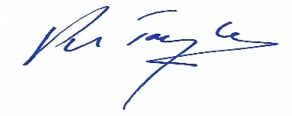
Proper Officer and Authorised Signatory.

S/No.: 9116

Index

Schedule 1 No Waiting At Any Time

Schedule 2 No Loading At Any Time

Schedule 3 Disabled Parking Bay Maximum Stay 4 Hours

Schedule 4 Loading Only At Any Time

Schedule 5 Loading Only 8am to 6pm

Schedule 6 Motorcycle Only Parking

Schedule 7 Limited Waiting 1 Hour No Return Within 2 Hours, 8am to 6pm

Schedule 8 Suspended Orders

Schedule 9 Modifications

Schedule 1: No Waiting At Any Time

Queens Park Road

(i) The west side, from its western junction with Torbay Road southwards and eastward for a distance of 52 metres.

(ii) the east side from a point 30 metres south of its westernmost junction with Torbay Road in a southerly, then easterly, then northerly direction to a point 18.5 metres south of its easternmost junction with Torbay Road.

(iii) the north side from its junction with Queens Road in a westerly then northerly direction for a distance of 59.5 metres.

(iv) the east side from a point 18.5 metres south of its easternmost junction Torbay Road in a southerly direction for a distance of 3.5 metres.

(v) the south side from its junction with Queens Road, west for a distance of 66 metres.

(vi) both sides from its easternmost junction with Torbay Road in a southerly direction for a distance of 15.5 metres.

Queens Road

(i) the east side from its junction with Torbay Road for a distance of 14 metres.

(ii) the west side from a point 5 metres north of the centre line of Adelphi Road northwards for a distance of 12 metres (frontage of the Pavilion vehicular entrance).

Torbay Road

(i) the south side from its junction with Esplanade Road in a westerly direction for a distance of 71 metres.

(ii) the north side from its junction with Esplanade Road in a westerly direction for a distance of 35 metres.

(iii) the north side from a point 52 metres west of its junction with Esplanade Road in a westerly direction to a point 8 metres west of its junction with Parkside Road.

(iv) the south side from a point 93 metres west of its junction with Esplanade Road in a westerly direction for a distance of 13 metres.

(v) the south side from a point 17 metres east of its junction with Queens Road in a westerly direction to a point 19 metres west of the same junction.

(vi) the south side from a point 46 metres west of its junction with Queens Road in a westerly direction for a distance of 24.5 metres.

(vii) the south side from a point 16 metres east of its westernmost junction with Queens Park Road in a westerly direction to its junction with Victoria Street.

(vii) the north side from a point 22 metres west of its junction with Parkside Road in a westerly direction to its junction with Victoria Street.

Victoria Street & Station Square

Both sides between its junctions with Hyde Road and Torbay Road.

Schedule 2 – No Loading At Any Time

Queens Park Road

(i) the west side, from its western junction with Torbay Road southwards and eastward for a distance of 52 metres.

(ii) the east side, from its western junction with Torbay Road southwards for a distance of 4 metres.

(iii) the east side from a point 26 metres south of its westernmost junction with Torbay Road in a southerly, then easterly, then northerly direction to a point 18.5 metres south of its easternmost junction with Torbay Road.

(iv) the north side from its junction with Queens Road in a westerly then northerly direction for a distance of 59.5 metres.

(v) the east side from a point 18.5 metres south of its easternmost junction Torbay Road in a southerly direction for a distance of 3.5 metres.

(vi) the south side from its junction with Queens Road, west for a distance of 66 metres.

(vii) both sides from its easternmost junction with Torbay Road in a southerly direction for a distance of 15.5 metres.

Torbay Road

(i) the south side from a point 16 metres west of its junction with Esplanade Road in a westerly direction for a distance of 55 metres.

(ii) the north side from a point 16 metres west of its junction with Esplanade Road in a westerly direction for a distance of 19 metres.

(iii) the north side from a point 57 metres west of its junction with Esplanade Road in a westerly direction to a point 8 metres west of its junction with Parkside Road.

(iv) the south side from a point 93 metres west of its junction with Esplanade Road in a westerly direction for a distance of 13 metres.

(v) the south side from a point 17 metres east of its junction with Queens Road in a westerly direction to a point 19 metres west of the same junction.

(vi) the south side from a point 46 metres west of its junction with Queens Road in a westerly direction for a distance of 24.5 metres.

(vii) the south side from a point 16 metres east of its westernmost junction with Queens Park Road in a westerly direction to its junction with Victoria Street.

(viii) the north side from a point 22 metres west of its junction with Parkside Road in a westerly direction to its junction with Victoria Street.

Victoria Street & Station Square

Both sides between its junctions with Hyde Road and Torbay Road.

Schedule 3 – Disabled Parking Bay Maximum Stay 4 Hours

Garfield Road

The west side from a point 11 metres north of its junction with Torbay Road in a northerly direction for a distance of 12 metres.

Queens Road

The east side from a point 14 metres south of its junction with Torbay Road in a southerly direction for a distance of 6 metres.

Torbay Road

(i) the south side from a point 47 metres east of its junction with Queens Road in a easterly direction for a distance of 12 metres.

(ii) the south side from a point 32 metres east of its westernmost junction with Queens Park Road in an easterly direction for a distance of 12 metres.

Schedule 4 – Loading Only At Any Time

Torbay Road

(i) the south side from a point 71 metres west of its junction with Esplanade Road in a westerly direction for a distance of 19 metres.

(ii) the south side from a point 13.5 metres east of its junction with Queens Road in an easterly direction for a distance of 16.5 metres.

(iii) the north side from a point 8 metres west of its junction with Parkside Road in a westerly direction for a distance of 14 metres.

Schedule 5 – Loading Only 8am to 6pm

Torbay Road

(i) the south side from a point 16 metres east of its westernmost junction with Queens Park Road in an easterly direction for a distance of 15 metres.

Schedule 6 – Motorcycle Only Parking

Queens Park Road

Both sides from a point 15.5 metres south of its easternmost junction with Torbay Road in a southerly direction for a distance of 3 metres.

Schedule 7 – Limited Waiting 1 Hour No Return Within 2 Hours, 8am to 6pm

Garfield Road

The west side from a point 23 metres north of its junction with Torbay Road in a northerly direction for a distance of 12 metres.

Queens Park Road

(i) the east side from a point 22.5 metres south of its easternmost junction with Torbay Road in a southerly direction for a distance of 10 metres.

(ii) the east side from a point 15 metres south of its western junction with Torbay Road in a southerly direction for a distance of 12 metres.

Torbay Road

(i) the north side from a point 35 metres west of its junction with Esplanade Road in a westerly direction for a distance of 17 metres.

(ii) the south side from a point 30 metres east of its junction with Queens Road in an easterly direction for a distance of 15 metres.

(iii) the south side from a point 19 metres west of its junction with Queens Road in a westerly direction for a distance of 27 metres.

Schedule 8 – Suspended Orders

“Borough of Torbay (Various Streets, Paignton) (Control of Waiting, Loading and Unloading) Order 2020”, the following items only:

Schedule 1.0
Queens Park Road – items (i), (ii), (iii), (iv), (vi) & (vii).
Queens Road – items (ii) & (iv).
Torbay Road – all items.
Victoria Street & Station Square – all items.

Schedule 7.0
Torbay Road – all items.
Victoria Street & Station Square – all items.

Schedule 8.0
Queens Road – all items.

Schedule 10.2
Garfield Road – item (i)

Schedule 11.0
Garfield Road – item (i)

Schedule 13.0
Torbay Road – all items.

Schedule 13.2
Torbay Road – all items.

Schedule 13.5
Victoria Street & Station Square – all items.

Schedule 14.1
Torbay Road – all items.

Schedule 16.0
Queens Road – all items.
Torbay Road – all items.

“Borough of Torbay (Street Parking Places {Pay & Display}) Order 2022”, the following items only:

Schedule 4
Torbay Road – all items.

Schedule 5
Torbay Road – all items.

Schedule 9 – Modifications

The following modifications became effective as of 23rd August 2023 –

Revocations

Loading Only 8am to 6pm

Torbay Road

(i) the south side from a point 31 metres west of its junction with Queens Road in a westerly direction for a distance of 15 metres.

(ii) the north side from a point 8 metres west of its junction with Parkside Road in a westerly direction for a distance of 14 metres.

Limited Waiting 1 Hour No Return Within 2 Hours, 8am to 6pm

Torbay Road

The south side from a point 19 metres west of its junction with Queens Road in a westerly direction for a distance of 12 metres.

New Restrictions

Schedule 4: Loading Only At Any Time

Torbay Road
The north side from a point 8 metres west of its junction with Parkside Road in a westerly direction for a distance of 14 metres.

Schedule 7: Limited Waiting 1 Hour No Return Within 2 Hours, 8am to 6pm

Torbay Road
The south side from a point 19 metres west of its junction with Queens Road in a westerly direction for a distance of 27 metres.
.

Western section of Torbay Road:

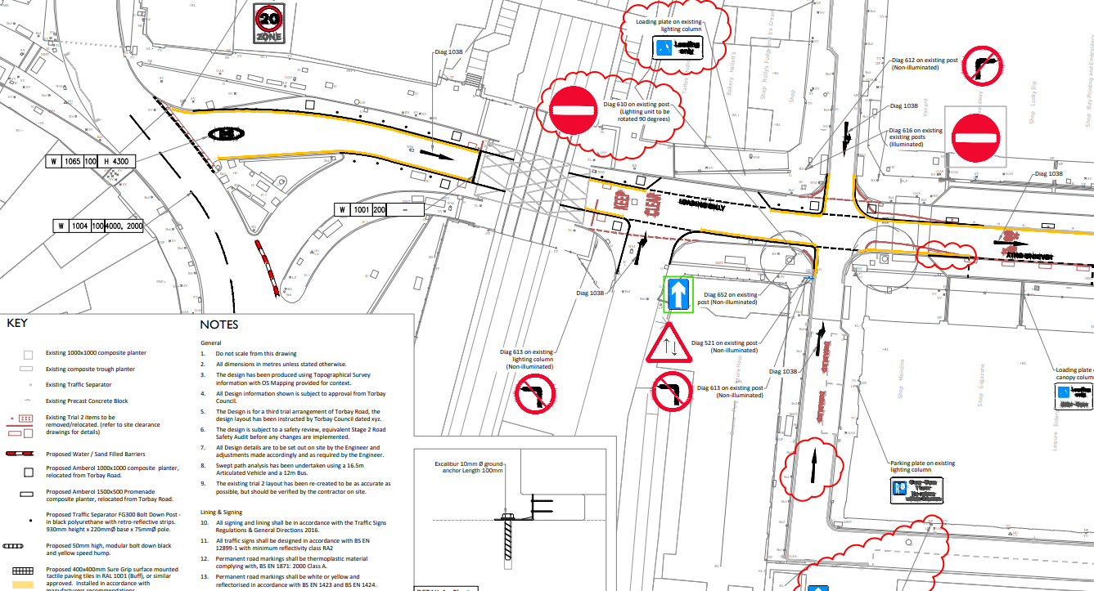

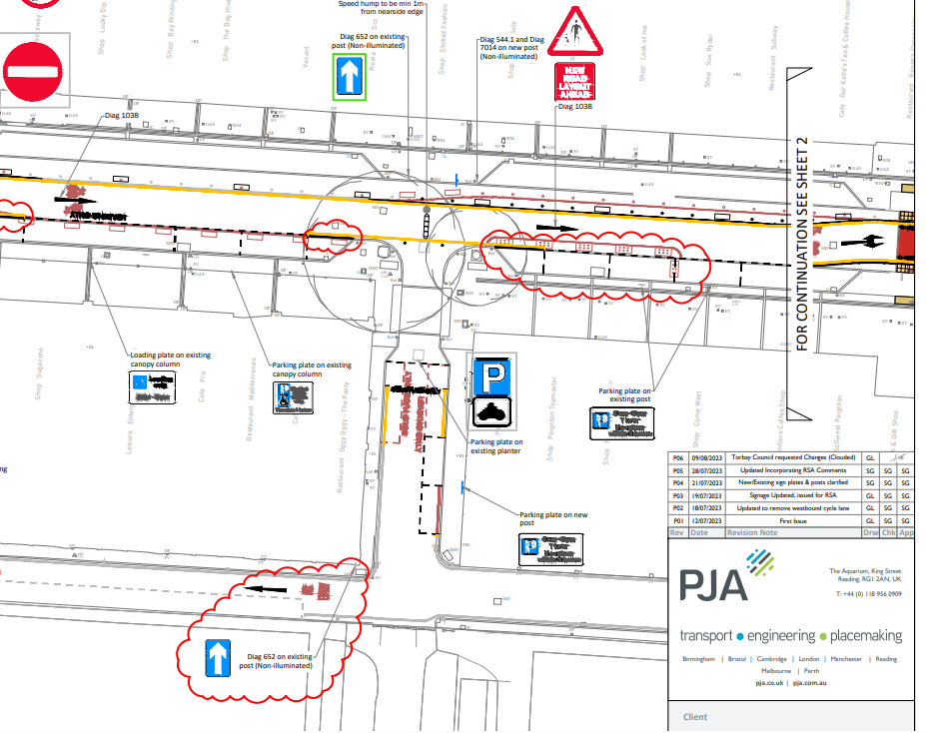

Eastern section of Torbay Road:

