BOROUGH OF TORBAY
(TORBAY ROAD, PAIGNTON)
EXPERIMENTAL REGULATON OF TRAFFIC ORDER 2022

Statement of Reasons

Torbay Council, in accordance with powers conferred by the Road Traffic Regulation Act 1984 has made an experimental traffic regulation order as it appears expedient on the following grounds -

- for avoiding danger to persons or other traffic using the road or any other road or for preventing the likelihood of any such danger arising
- for facilitating the passage on the road or any other road of any class of traffic (including pedestrians)
- for preserving or improving the amenities of the area.

This experimental scheme is aimed at assessing the effectiveness of reducing vehicular traffic flow along Torbay Road, Paignton. Initially, a number of pedestrian zones were introduced which restricted access to motor vehicles between 6pm and 10am only. However, in light of the feedback received during the first three months of the scheme, the restrictions were then modified by opening up half of Torbay Road to traffic, with additional parking and loading places put in place. It also reverted the flow of traffic along Adelphi Road back to its original state.

Following continued feedback from members of the public and local businesses, a second modification of the scheme was implemented. This further modification retained the access on the eastern section of Torbay Road, with the western section between Hyde Road and the Garfield Road/Queens Road junction being opened up to eastbound traffic only. This will mean that the entire length of Torbay Road can once be accessed by motor vehicles, through use of one-way traffic and a single carriageway. This retained the expansion of the footway that has been put in place through the first two experimental schemes, whilst also providing additional loading bays, parking bays, and dedicated disabled badge holder parking places. In addition to this, traffic flow on Queens Park Road was reverted back to two-way for its entire length.

Following feedback during the first week of operation of the second modification, it was decided that a further third set of modifications was required. The three changes made were as follows:

- One-way traffic added back in on a section of Queens Park Road, running from the bowls club entrance to Torbay Road. This would avoid vehicles meeting head on in a narrow section of the road.
- Overnight parking in the loading bay on Torbay Road opposite the entrance to Torbay Steam Railway was causing access issues for larger delivery vehicles, so the restriction is being changed to loading only at any time to reduce long term parking and free up overnight access for larger vehicles to the steam railway.
- Section of loading bay on the western section of Torbay Road to be changed to 1 hour limited waiting, making it a larger parking area for vehicles.

Documents giving more details particulars of all the order, including any modifications, are shown on plans on deposit.

Notice of Modification
Borough of Torbay (Torbay Road, Paignton) Experimental Regulation of Traffic Order 2022
Borough of Torbay (Various Streets, Paignton) (Various Restrictions) Experimental Order 2022

Notice is hereby given that Torbay Council has, in exercise of the powers conferred in by section 10(2) of the Road Traffic Regulation Act 1984, as amended, modified the experimental traffic orders (“the Orders”) named above.

Modifications made:
1. Loading bay at the westernmost end of Torbay Road amended so that the restriction applies at all times, not just between 8am and 6pm.
2. Loading bay on the section of Torbay Road between its easternmost junction with Queens Park Road and the junction with Queens Road to be changed to a 1 hour maximum stay limited waiting bay between the hours of 8am and 6pm, no return within 2 hours.
3. Part of Queens Park Road to have a one-way traffic flow in place from the entrance of the bowling club to its westernmost junction with Torbay Road.

The Orders include a power to be modified in light of experience as allowed under section 10(2) of the Road Traffic Regulation Act 1984.
These modifications to the Orders are being implemented following feedback during the experimental period to determine the effects of a full or partial pedestrianisation of Torbay Road, Paignton.
The modifications to the experimental scheme will become effective as of 23rd August 2023 and will operate for a period of no longer than eighteen months, during which time the effects of these Orders will be monitored and recommendations made in due course as to whether these measures should be made permanent, discontinued or amended in some way.

All objections to these Orders must be in writing and lodged within six months after the date on which the Orders come into force. Such objections should be sent via email to highways@torbay.gov.uk or delivered to Torbay Council at its address at:

Highways Management,
Torbay Council,
Town Hall,
Castle Circus,
Torquay, TQ1 3DR.

Documents giving more detailed particulars of the Orders and modifications being made are available for inspection between 09:00 and 17:00 each working day on the self-service computers at Torbay Council Connections Office, Paignton Library and Information Centre, Great Western Road, Paignton, TQ3 3HZ. The documentation may also be viewed online at the following web address: www.torbay.gov.uk/proposedtros

If any person wishes to question the validity of the Orders or of any of their provisions on the grounds that such is not within the power conferred by the Act. Or that any requirement of the Act or of any instrument made under the Act has not been complied with, that person may within six weeks from the appearance of this advertisement apply to the High Court for this purpose.

Dated: Wednesday 16th August 2023

ROAD TRAFFIC REGULATION ACT 1984

SECTIONS 9 and 10

(Various Road - Paignton)
(Various restrictions) EXPERIMENTAL ORDER 2022

Torbay Council in exercise of its powers under sections 9 and 10 (and any other enabling powers) of the Road Traffic Regulation Act 1984 and of all the other enabling powers and after consultation with the Chief Officer of Police in accordance with Part III of Schedule 9 of the said Act make the following Order:

- This order shall come into operation on the 23rd August 2023.

- While this order is in force, any or all provisions in it may be suspended or modified by an officer of the council authorised for this purpose, or an officer acting under the authority of such officer, if it appears essential:

(a) in the interest of the expeditious, convenient and safe movement of traffic,
(b) in the interest of providing suitable and adequate on-street parking facilities, or
(c) for preserving or improving the amenities of the area through which any road affected by the order runs.

- In this Order:-
A reference to an article or schedule refers to the corresponding article or schedule in this order unless stated and the following expressions have meanings hereby respectively assigned to them:-
- “pedal cycle” means a pedal bicycle or pedal tricycle not being in either case a motor vehicle.

- Without prejudice to the viability of anything done before or to any liability incurred before coming into force of this Order the Orders (or parts) specified in Schedule 1 are hereby suspended.

- The parts specified in the revocations of Schedule 8 are hereby removed from this order.

- Save as provided in Article 4 of this Order no person shall, except upon the direction of a Police Constable in uniform or a parking attendant or duly authorised Council Officer cause or permit any vehicle or motorcycle to-

- Proceed in the lengths of roads specified in Schedules 2 and 3 in a direction other than that specified.
- Enter the road in contravention of those orders in Schedules 4, 5 and 6.
- Be driven or ridden at a speed in excess of that specified in Schedule 7

- Nothing in Article 6 shall apply to prevent any person causing any vehicle to proceed in the length of roads specified if the vehicle is being used :-

- For pedal cycles. (Schedules 3 and 4 only)
- For fire brigade, ambulance or police purposes
- In the service of a Local Authority in pursuance of statutory powers or duties
- In connection with any building operation or demolition in or adjacent to that length of road, the removal of any obstructions to traffic, maintenance, improvement or reconstruction, or in connection with statutory undertaker plant or equipment.
- By any mechanical road cleansing vehicle between the hours of midnight and 8.00am
- For the purposes of traffic control (agreed by the Council or Police) in the event of an emergency or to redirect traffic due to an incident on or affecting the Highway.

- Insofar as any of the provisions of this Order shall conflict with any provisions of any Orders made or having affect as if made under the Act insofar as they relate to the roads specified in the Schedules to this Order, the provisions of this Order shall prevail for the period of the Experimental order.
- This order may be cited as the (Various Road - Paignton)
(Various restrictions) EXPERIMENTAL ORDER 2022

The Council of the Borough of Torbay
Dated 10 August 2023

The Common Seal of the )
Council of the Borough )
Of Torbay was hereunto )
Affixed in the presence )
Of: )
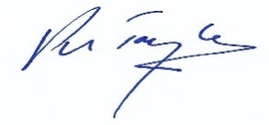

Proper Officer and Authorised Signatory.
Sealing Number: .......9115........
SCHEDULE 1 Suspensions

The County of Devon (Parkside Road, Paignton) (Traffic Regulation) order 1989 (part related to prohibition of Driving)

SCHEDULE 2 – One Way
Road | Length of restriction
Esplanade Road (Rear) | From its junction with Torbay Road to its junction with Torbay Road (Rear)
Queens Park Road | From a point 66m west of its junction with Queens Road to its westernmost junction with Torbay Road
Torbay Road | From its junction with Hyde Road eastwards to its junction with Garfield Road

SCHEDULE 3 – One Way (except cycles)
Road name | Length of restriction
Torbay Road | From its junction with Esplanade Road westwards to its junction with Garfield Road.

SCHEDULE 4– No Entry (Except Cycles)
Road name | Restriction
Torbay Road | At a point 4.5m east of its junction with Garfield Road

SCHEDULE 5 – No Entry
Road name | Restriction
Queens Park Road | At a point 4.5m south of its westernmost junction with Torbay Road
Torbay Road | At a point 6m west of its junction with Garfield Road
Torbay Road | At a point 5m west of its junction with Parkside Road and Queens Park Road

SCHEDULE 6– No Right Turn
Road name | Restriction
Parkside Road | Into Torbay Road (westbound)

SCHEDULE 7– 20 mph Speed Limit
Road name | Length of restriction
Queens Road | From a point 10m north of its junction with Adelphi Road for a distance of 142m
Queens Park Road | For its whole length
Torbay Road | From a point 12m west of its junction with Esplanade Road to its junction with Hyde Road
Garfield Road | From its junction with Torbay Road to a point 7m north of its junction with Parkside Road
Parkside Road | For its whole length
Esplanade Road (Rear) | From its junction with Torbay Road to its junction with Kernou Road
Torbay Road (Rear) | For its whole length

The Council’s reasons for making this Order is to implement an experimental Pedestrianised Zone in Torbay Road and to facilitate movements in adjacent roads related to this work.

SCHEDULE 8 – Modifications

The following modifications became effective as of 23rd August 2023 –

Revocations

No Left Turn
Road name | Restriction
Queens Park Road | Into Torbay Road (westbound)

New restrictions

SCHEDULE 2 – One Way
Road | Length of restriction
Queens Park Road | From a point 66m west of its junction with Queens Road to its westernmost junction with Torbay Road

SCHEDULE 5 – No Entry
Road name | Restriction
Queens Park Road | At a point 4.5m south of its westernmost junction with Torbay Road

Western section of Torbay Road:

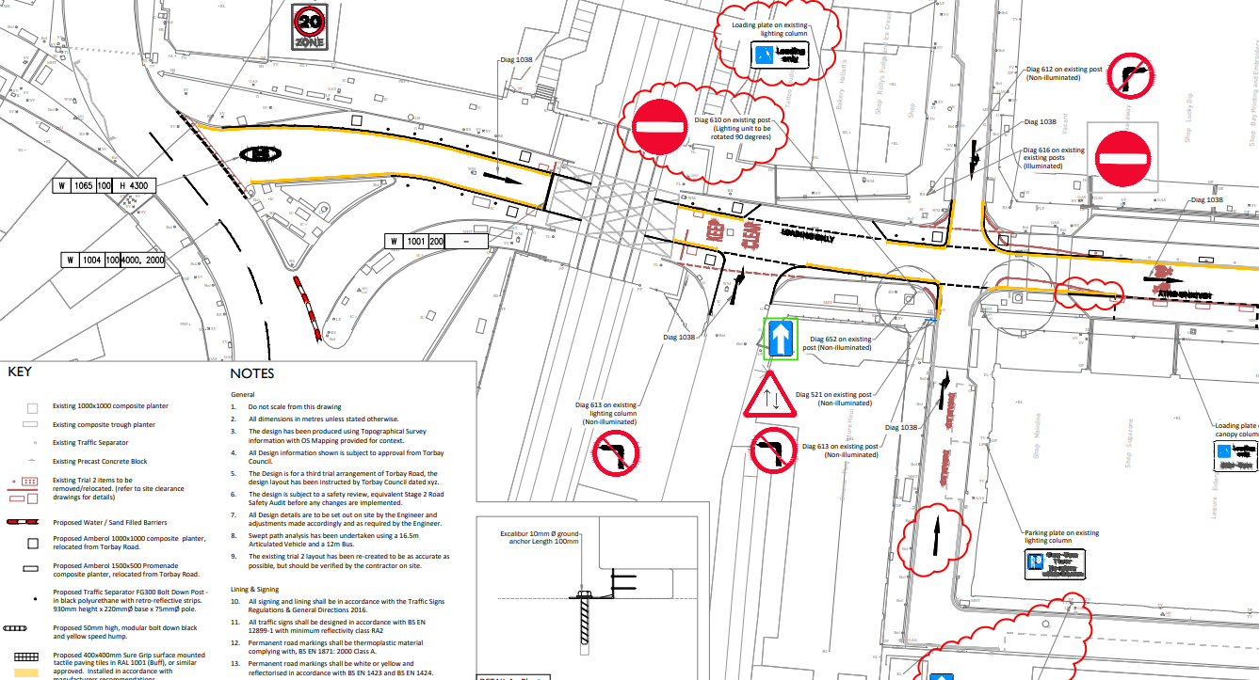

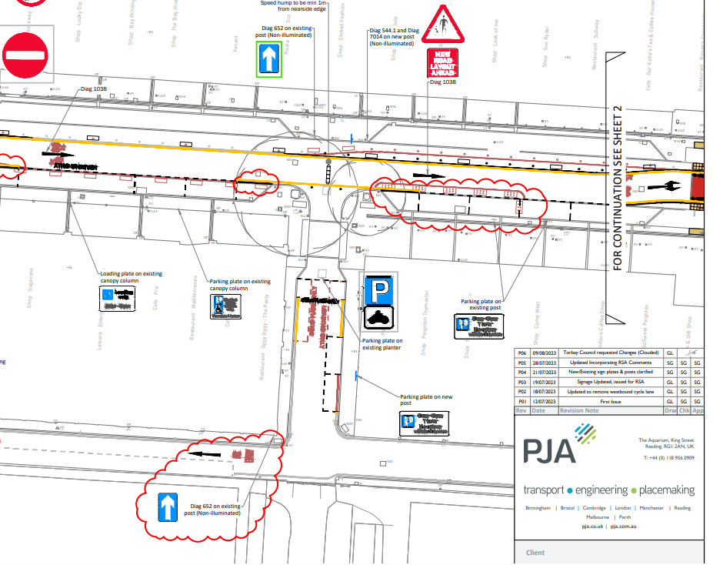

Eastern section of Torbay Road:

