SITE OVERVIEW: Amber – significant constraints
Town | Torquay
Site Name | Land North of Bottompark Lane
HELAA Reference no. | 21T145
Approx. yield | 20
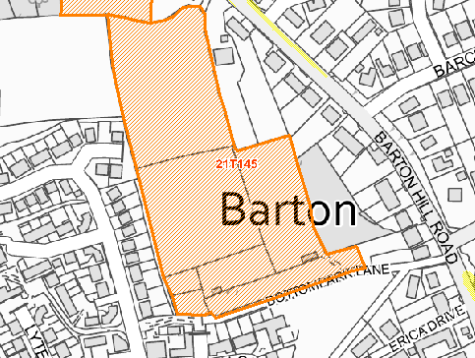
Suitable | Yes - Part ULPA, but within the built-up area.
Available | Yes – put forward to call for sites.
Achievable | Due to the topography of the land, it is likely that the capacity of the site would be lower than typically expected for its size. Space needed for an internal access road and possibly retaining structures due to the site’s topography.
Customer Ref no.
Source of Site (call for sites, Local Plan allocation etc.). | Post Panel Addition
Current use | Horse grazing.
Site description | The site comprises a steeply sloping area of land which forms part of a roughly square semi-improved grassland field to the east of Montserrat Rise on the northern edge of Torquay. Access to the site is via a private driveway off Monserrat Rise. The site is partly within an Urban Landscape Protection Area (ULPA). Part of the site is a local plan Committed & Other Deliverable Development Site - (Scotts Bridge/Barton Remainder)
Total site area (ha) | Approx. 2.3ha
Developable site area (ha) | Approx. 1.38ha

SUITABILITY ASSESSMENT: STAGE A

Strategic potential: | No
Housing? | Yes
Employment? | No
Other Use? | No
Biodiversity- Within SAC/SSSI | No- localised biodiversity issues.
Flood Zone 3b | No
Other NPPF Showstoppers (not policy constraints) | None

SUITABILITY ASSESSMENT: STAGE B

Access | Possibly via Martinique Grove: possible ransom strip issues.  Access via Bottompark Lane is a possibility but extremely narrow, steep, and unlikely to be adoptable. Access to Barton Hill Road would be steep and difficult to achieve.
Flood risk, water quality and drainage | No
Heritage and Archaeology (including distance from assets). | No significant heritage constraints.
Infrastructure | The site is located at the edge of the built-up area with access to infrastructure connections. Access onto Baron Hill Road is difficult.
Landscape | Part of the site is within the Scotts Bridge/Barton Urban Landscape Protection Area.  Site recognized for providing important green ridgeline.  Development of this land likely to have some landscape impacts.
Ecology | The site is located within the Consultation Zones for Cirl Buntings and for Greater Crested Newts.
Safety related constraints | No
Soils (Agricultural Land classification) and contamination | 4- Severe Limitations (and subsequent development of Scott bridge Barton will have further removed the potential for agricultural use.
Local Plan | Urban Landscape Protection Area (Policy C5)  Trees, hedgerows, and natural landscape features (Policy C4)  Biodiversity and Geodiversity (Policy NC1)
Neighbourhood Plan | Green Corridors (Policy TE4)
Development progress (where relevant) | No: access difficulties need to be overcome.
Other
Site potential | 20 if access difficulties can be overcome.

AVAILABILITY ASSESSMENT
Reasonable prospect of delivery (timescale):

The next 5 years
A 6-10 year period
An 11-15 year period | 20
Later than 15 years

