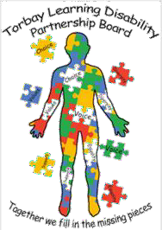

Newsletter January 2022

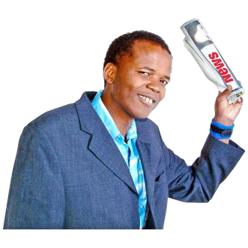
Ambassador’s
Newsletter

January 2022

In this newsletter:
Meet the Ambassadors

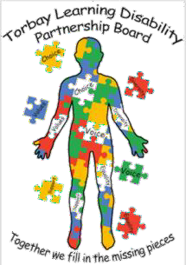
About the Torbay Learning Disability Partnership Board

The work that the Ambassadors have done.

The work being planned.

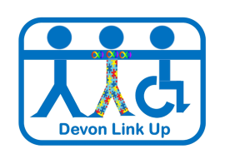

Meet the Ambassadors
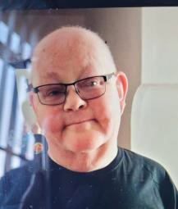
Neil – Neil is the Lead Ambassador and Co-Chair of The Learning Disability Partnership Board.

Tracie - Tracie lives in Brixham and is
a great artist.

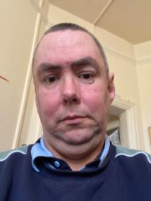
Shaun – Shaun lives in Paignton and is a DJ in his spare time.

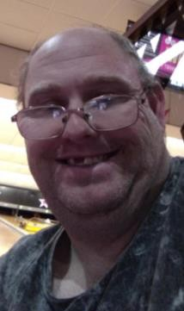
Jamie – Jamie lives in Torquay and spends his time looking after his daughter.

Adele, Martin and Ben are also part of the team and we are looking forward to welcoming them back soon.

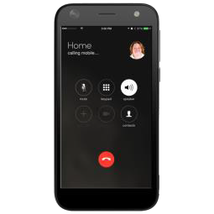
We are looking for new Ambassadors to join us.
If you are interested please contact us on 07808053992
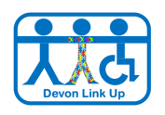

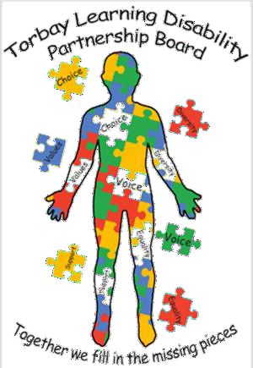
Torbay Learning Disability
Partnership Board
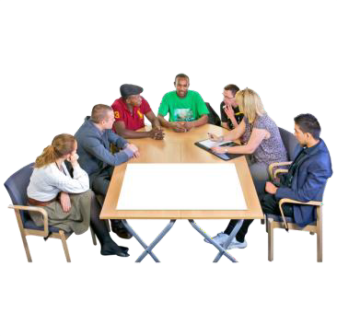
The Partnership Board works to help improve services for people with learning disabilities in Torbay.
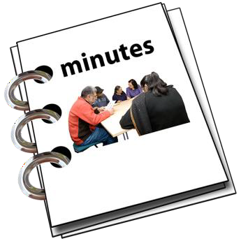
The Partnership Board is about working together and people on the Board come from different organisations including health, social care, education, carers and local groups like Mencap.

The Partnership Board meets 4 times a year and the minutes from the meetings are available for people to read.

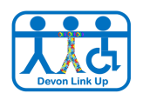
The Ambassadors job is to share things which people with learning disabilities are talking about and may need help with. They also check that work is being done as agreed.

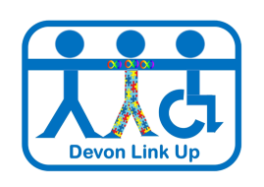

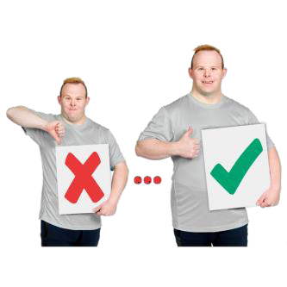
What changes have we made?

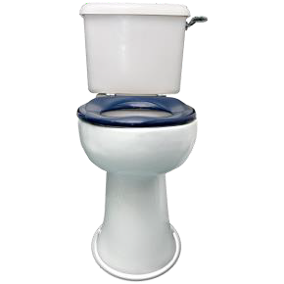
Toilet Cards
We have been talking to Torbay Council about the toilets in Torbay. You need to have a bank card to use the toilet and not everyone has one.

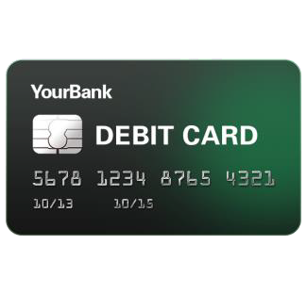Torbay Council have worked with the Ambassadors and Torbay Mencap to make sure that people can have a card and can use the toilets.

If you need a card, please contact Carole at Torbay Mencap.
chair@torbaymencap.co.uk

Health

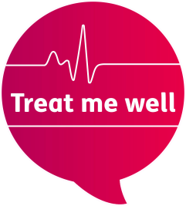
Treat Me Well
The Ambassadors work with the Torbay Hospital Treat Me Well group.

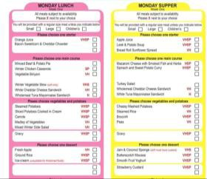The Ambassadors have designed an easy read hospital menu to help make it easier for people to understand their food choice.

In the Autumn, the Ambassadors will go to the Treat Me Well meetings

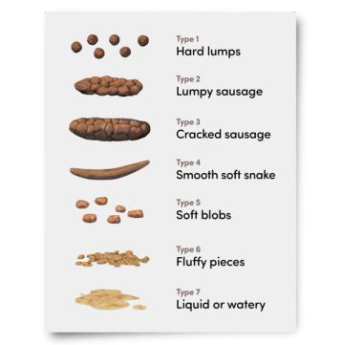
The Ambassadors are doing some work about constipation which will help people talk about it more.

Constipation is one of the problems which causes people with learning disabilities to die too early.

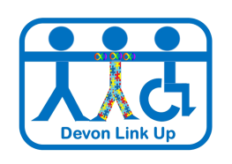

Health

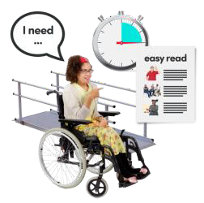
Reasonable Adjustments
Reasonable Adjustments are small changes which can be made to help people with learning disabilities when they go for health appointments.

Small changes can include, quiet appointment times, easy read information, desensitisation visits, and good communication.

You can get a letter to give to your doctor to ask for small changes. Please go to www.devonlink-up.org for more information.

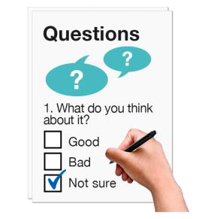
We would also like to hear from people about their experience at the doctors. There is a survey on the Devon Link Up website if you would like to take part.

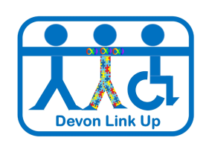

GP registration
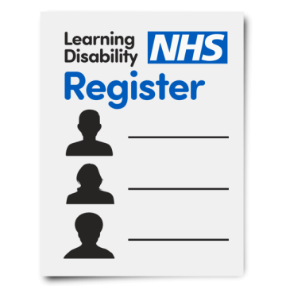
Some people are not on the learning disability register with their Doctor. This means they may not get the help they need and may not get an annual health check.

It is good if people tell their Doctor.
The Ambassadors are doing a survey about GP surgeries. You can help by completing the form.

COVID-19
The pandemic has been very hard for everyone, and people have been talking about their feelings and worries.
The Ambassadors have been talking with health services about what works well and the things that have been difficult.

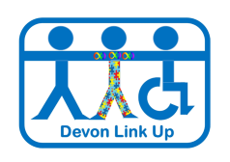

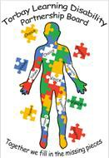
Partnership Board Logo
The Partnership Board has a new logo!
There was a competition to design the logo and the Ambassadors picked this as the winner because it shows the work that is being done, it is person centred and is bright and attractive. Look out for it on all of our work!

Planned work for 2022
The Ambassadors are planning a Housing event in the summer.

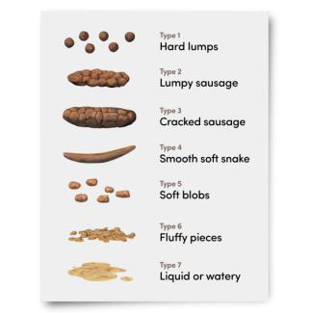
There is work planned to tell people about constipation and what to do about it.

If you would like more information about the Ambassadors work, please contact us.

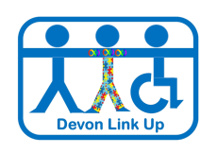
Jom@devonlink-up.org 07808053992

Do you want to Make a Difference in 2022?

Become an Ambassador for
the

Torbay Learning Disability Partnership Board

You can help us by speaking up about things that are important to people with learning disabilities who live in Torbay

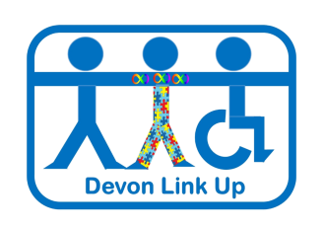Interested?
Contact us for more information at: Jom@devonlink-up.org 07808053992

