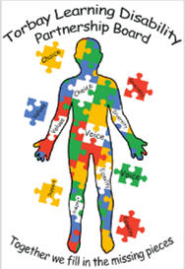
minutes of the Torbay Learning Disability Partnership Board meeting. 28th July 2022.

Neil welcomed everyone to the meeting.

People at the meeting-
Sue, Neil, Tracie, Pam, Si, Kate, Adam, Mike, Lorraine, John, Corrina, Emma, Alex.

Apologies from
Shaun, Jamie, Jo Williams, Lindsey, Leanne, Sarah B

Neil asked if anyone knew about Councillor Jackie Stockman because she has not been to any meetings. It was agreed that other Councillors can attend but they must be silent observers. Adam said he would find out.
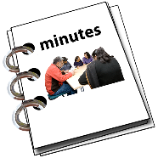
Minutes of the last meeting.
Sue read the minutes.
The following feedback was given –
John is standing in for Sharon and will look at how the Treat Me Well work is going.
- Alex is meeting with the Job Centre in September and the Ambassadors have invited a member of the DWP to the next Board meeting to talk about some of the problems people have.
- The LD champion list has been sent around.
- Kate will bring information about Hate Crimes to the meetings and the Neighbourhood team would like to come to the Housing event.
- The carers card has been checked and places are taking the card.
- The Liaison nurses will be asked to come to the Board meeting.
- Adam congratulated the Board on getting the Toilet Cards sorted. The success of the card shows how powerful the Board is. Emma also congratulated the Ambassadors.
John asked if the care providers know about the card and said it would be good to put something in the newsletter.

Ambassador Report
Neil read the Ambassador report.

Activities in the Bay and cost.
The Ambassadors asked for information about the activities that are available for people and how much they cost.
Sue asked if it would help to have a calendar of activities across the Bay and a cost for each activity.
Pam said that carers are being asked to pay more for services because the cost is going up and carers have to pay the difference.
Adam and John said they would talk to Deborah Gidman because if people have assessed needs, these should be paid for, and it may put people at risk if this did not happen.
The Torbay Advice network can help people with things like bills.

Seafront plans
The Ambassadors looked at the seafront plans and were worried about the lack of access for disabled people.
Steve Darling has given Adam and Si a task to make the beaches more accessible for disabled people.
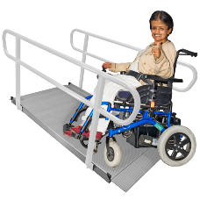
Adam has to get the money agreed and then there needs to be a check on the beaches to see which ones would be ok for people to use if good equipment is available. Hollacombe and the Ambassadors will help.
Once Adam knows about the money, there will be chance for people to work together and think about how the plans can work well.

Alex talked about Supported Internships and he will be give some time at the next meeting to tell people about this.

Liberty Protection Safeguards.
The Ambassadors looked at the new Liberty Protection Safeguarding information. John said Torbay has given their feedback and said the safeguards do not do enough to keep people’s freedom safe and that advocacy needs to be well funded.
The new plans start in 2023 and Torbay are working to be ready for the changes.

Housing Update
Adam gave an update about housing in Torbay.
There are more people who want to have their own home and housing in Torbay is difficult because there is not enough at the moment.
Over 50 new homes are planned for people with learning disabilities in the next 10 years.
Adam told the meeting about some new housing.
Crossways in Paignton will have 90 new homes and they will be ‘extra care’ places so that people have more help when they need it.
Torre Marine in Torquay will have 72 new homes and these will also be ‘extra care’ places, mostly for people who have a dementia.
There may be other new buildings for people with learning disabilities and Adam would like the Ambassadors to help with checking the homes are good.

Hate Crime
Kate gave an update about Hate Crime. The number of reports is quite low and the Police would like to hear from people who have experienced Hate Crime.
There are a lot of things which stop people talking about crime and the Police are opening their offices again so that people can go in and talk to officers.
There are areas where there are often a lot of problems and the neighbourhood team look at this. There is also a lot of online hate crime.

Lorraine asked about the training the Police have.
Kate explained that the Police do have training and the new officers can do community placements where they meet different groups.
The Ambassadors recently had a Police trainee at their meeting, and it was a good experience.
Alex asked what the Board and the people at the meeting could do to help with training.

Torbay Family Carers report
Emma said there are a lot of family carers who want information about housing choices but they do not know who to talk to.
Sue said it will be important for family carers to come to the Housing event to find out what is available. An interactive map, information sheets and leaflets which will help.
Adam said he is meeting with Sam French to explain to social workers about how to help people more. It is important to plan for the long term.
Adam does not have a clear way of finding out how many people may need help in the future. There needs to be a pathway so that people can talk.

Emma asked about a survey which looked at the recommendations from a report which Healthwatch Torbay did about services.
Corrina explained that Hollacombe carry out their own service survey to give people a voice about their service.
The Ambassadors met with Helen Burn to talk about a survey but have not finished it yet.
It is important for people to know what is available and what everything costs so they can make good choices.

Emma asked about any complaints that Torbay have received because Sharon said she was checking this. John said he did not know at the moment but he would find out and report back.

Carers Report
Pam talked about the cost of paying for more care and how difficult it is making things for carers.
Pam also talked about recruiting a new rep as Michelle has sadly had to resign as a rep with the Board.

Any other business
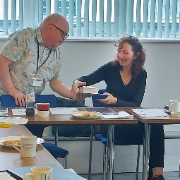
Nobody had any other business.

Neil made a presentation to Sue to thank her for all her hard work and to say how much she will be missed.
Thank you Sue!

Summary of actions

Adam and groups to share information to make a pathway so that Adam knows about future housing needs.

John to find out if there have been any complaints which are relevant to the work of the Partnership Board and to bring information to the next meeting.

Alex to be given time at the next meeting to talk about Supported Internships.

Adam to find out whether the FAB team are doing up to date assessments about the cost of people’s care and how this affects people’s needs being met.

Adam to find out about placing an article about the Toilet Card to be put in the care sector newsletter.

Liaison nurses to be invited to the next meeting.

Adam to find out if Councillor Stockman is going to come to the meetings and if not, which other Councillors may be able to attend.

Date of next meeting 6th October 2022 at 10am

