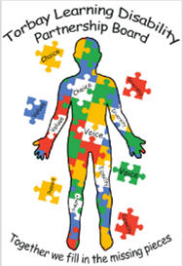

Torbay Learning disability Partnership Board
Minutes from meeting
7 April 2022
People at the meeting
- Sharon (Deputy Director)
- Neil (Ambassador)
    - Helen (Torbay NHS Trust)
    - Corrina (Hollacombe)
    - Alex ( South Devon College)
    - Sue ( Torbay Council)
    - Kate ( Police)
    - Lindsey ( Carers Rep)
    - Tracie (Ambassador)
    - Jamie (Ambassador)
    - Leanne (Torbay Council)
    - Jo ( Devon Link Up)
    - Pam (carers rep)
    - Michelle (carers rep)
    - Helen (Mencap)

Apologies
- Sarah Bickley
- Adam (Torbay Council)
- Jo (Torbay Council)
- Dr Catherine Lisset
    - Shaun (Ambassador)
Everyone was introduced.
Sharon and Neil chaired the meeting together.
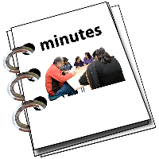
Neil asked if there were any changes to the notes of the last meeting and no changes were made.

Ambassador’s report and housing plan
Neil read out the Ambassador’s report.

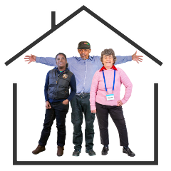
Housing event
The Ambassadors have created an action plan for the housing event. We are hoping that it will be in Learning Disabilities week in June, but we need to find the location first and agree dates. If people can help, please contact the Ambassadors.
Sue confirmed that Steve Honeywell has given a budget of £5,000 to the Ambassadors for events this year. Sue said this money can be used entirely on the housing event but perhaps there might be something else the Ambassadors would like to arrange instead. Mencap may also be able to support the housing event budget.
Carol and Committee to confirm their budget.
A subgroup meeting date was arranged for the 21st April to discuss this further.
Sharon mentioned that Emma did a lot of work around hosting an event last year and put together a template and timetable and has a contact list of invitees.
Action for Corrina to ask Emma to share what information she still might have from last year.
Neil said he would like the local Mayor to open the event.
Action for Sharon to find out who this is currently.

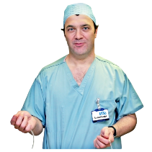
Dr Lissett
The Ambassador’s met with Dr Lissett to try and understand the plan about general anaesthetic and scans. It was complicated because of jargon and lots of information so the Ambassadors are going to work on this.

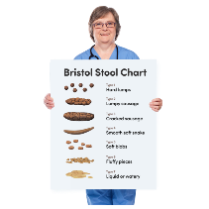
Constipation
The Ambassadors have made a video about
constipation which can be shared. It is very important to encourage everyone to talk about poo so that people become more aware of constipation, which can be a cause of early death.

Action for Jo to send constipation video to Leanne to circulate.

Newsletter
The Ambassadors have written their first newsletter which has been sent out. The feedback has been very good.

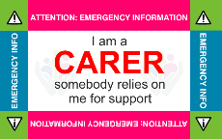
Carers Card
The carers are checking if the card is still being accepted after covid. Some people are worried it is not being accepted everywhere.
Michelle confirmed she is doing work with Lindsey on this. Lindsey said it would be good to know where it was not accepted so she can look into this.

Jamie asked for a list of places who accept the carer’s card.

Action for Lindsey to make it published more clearly where the carers card can be used

Treat Me Well
The Treat Me Well group are thinking about co-producing their meetings and the Ambassadors met with Sharon to talk about how this can happen in the next few months.

Job Centre

The Ambassadors are hearing about a lot of problems with Job Centre staff and the way they treat people with learning disabilities and Autistic people. The Ambassadors have written a letter which people can put on their journals and take to appointments to remind staff that they need to make reasonable adjustments. It would be good to invite someone from the Job Centre to the next meeting.
Alex said that he was concerned to hear this. He wondered about staff training and suggested it might be helpful to invite someone from the Job Centre to our meetings.
Sue said at our working party we wanted a representative from employment at our meetings.
Jo said in the letter it talks about making reasonable adjustments. Lindsey wondered if everyone could have a copy of this letter as it can be advertised in Signpost magazine to let people know where they can get a copy.

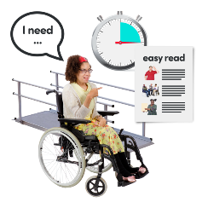
Reasonable Adjustments
The Ambassadors went to a meeting run by Dr Gaywood. They talked about Reasonable Adjustments and the importance of small changes which make things easier for people when they have a health appointment. Dr Gaywood thanked the Ambassadors for attending the meeting.
Alex met with Dr Gaywood himself and has a useful list of Learning Disability Champion GPs in the local area. Alex will forward this to Leanne to pass across to the Ambassadors (this has been done).
Action for Jo – The list of champions to go into the Ambassadors newsletter.

Thank You

The Ambassadors would like to thank Ali and the staff at Hollacombe for letting us use their room, it has been really helpful, and we like the décor!

Hate Crime Report – Kate
South Devon and Torbay. Kate said that actually this is a good thing as hate crime is usually under reported so it shows more people are coming forward.

The police are getting better at recording and recognising hate crimes. These are thankfully small numbers but it could be because of the covid pandemic and other barriers such as the method of reporting by email/online forms.
Kate is happy to offer statistics at future partnership boards.
Jamie said he doesn’t see many PCSOs in the area. Kate said there are now more police in the area and she can pass on details of local neighbourhood police officers if this were something the Ambassadors would like.
Kate said there are lots of new police recruits and work going into training in neurodiversity. However if the Ambassadors notice anything not being done very well Kate encouraged everyone to let the Police know so it can be worked on.
Action for Kate to feedback that online reporting is not accessible for everyone and to bring a hate crime report to each Learning Disability Partnership Board meeting.
Further action for Kate to provide contact details of local neighbourhood police.

Carer’s report
There is now a new carer’s card. The design has been changed. If anyone would like a new one, they can get in touch with Signpost. This can be used at the hospital for free parking, Paignton Zoo, the cinema and lots of other places.

Updated amendment from Lindsey

You will need to apply for a CEA (The Cinema Exhibitors Association Card - Cinema Card) which costs £6.00 & you also need to be in receipt of one of these benefits;
- Disability Living Allowance,
- Attendance Allowance,
- Personal Independence Payment,
- Blind Persons Registration, or Armed Forces Independence Payment.
Registration is annual, costs £6 plus a photo and entitles you to free admission to cinemas.
Paignton Zoo will also require evidence of benefit before adding a plus one carer onto an annual pass or general day admission.

Action for Lindsey to make sure carer’s services are up to date and all carers have been contacted with a new card as a few people did not get the new one.
Torbay Hospital Liaison Nurse
The carers are worried that the Torbay Hospital Liaison Nurse is not covering evenings and weekends.
There is now a Learning Disability Champion on each
ward and all nurses should have training too.

Action for Sharon to bring this up in the Treat Me Well Group.
Quiet areas in Hospitals
Pam highlighted the lack of quiet areas for those with disabilities to sit and wait when in hospital.
Sharon said how this is difficult due to every day being different in A&E and wait times being breached all the time. Although this is challenging it is something we want to look at and maybe the Torbay Hospital Liaison Nurses should be invited to the board.

LD Treat Me Well
Due to staff pressures there has not been a meeting so far this year. The next meeting is 16th May.
It was suggested maybe Jo and the Ambassadors could observe a Treat Me Well meeting as it is important for those with lived experience to be a part of it.
Sharon thanked the Ambassadors for their questionnaires they filled in.
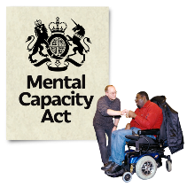
Liberty Protection of Safeguarding Procedures of the Mental Capacity Act
Sharon said that consultation is now open for people to contribute to legislation. The document is over 100 pages and so quite a lot to take in. Would the Ambassadors, Jo and Mencap like to have a working party meeting to contribute to that legislation? Sharon is happy to send information about this if needed.
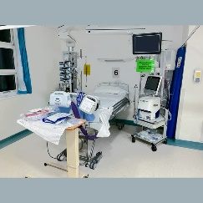
Ward Walkaround
At the moment the Learning Disability ward walk around tour is too unsafe as the numbers of covid patients is too high.

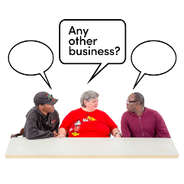
Any other business
Nobody had any other business.
The meeting finished and Neil and Sharon thanked everyone for coming.

