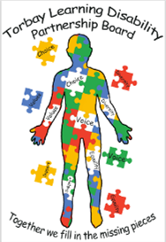
Torbay Learning disability Partnership Board
Minutes from meeting 6th January 2022

People at the meeting Sharon ( Deputy Director) Helen ( Torbay NHS Trust)
Ali ( Hollacombe) Si ( Space) Alex ( South Devon College).
Sue ( Torbay Council) Kate ( Police) Lindsey ( Carers Rep) Neil ( Ambassador) Adam ( Torbay Council) Tracie ( Ambassador) Helen ( Mencap) Dr C Lissett.
Debbie ( Torbay Council). Hannah ( Devon Link Up)

Apologies
Jon ( Adult safeguarding)
Pam (carers rep) Michelle ( carers rep) Jamie ( Ambassador) Shaun (Ambassador) Jo ( Director) Jo ( Devon Link Up)

Sharon welcomed everyone
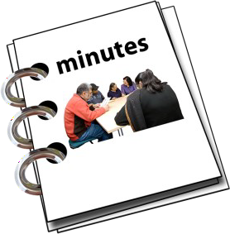
.
Sharon asked if there were any changes to the notes of the last meeting. No changes were made

Things to do after the last meeting Toilets
Neil said that the Ambassadors met with Carol King and Mencap have cards for people. Some people think the cards do not work properly.

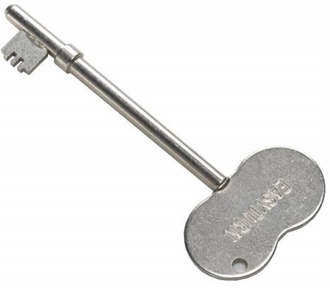
Sharon said that each card has a number. Sharon did not know if there was a refund for people who have radar keys.

Norfolk Adult Safeguarding Report
Jon will review the report and talk to Neil and Sharon will send him a reminder to do this.

Ambassadors report
Neil told everyone about the work the Ambassadors have done.
The Ambassadors have talked to Torbay Mencap about working together.
The Coalition for Disabled People were contacted about the new toilet cards but they have not replied.
Neil gave an update about the Housing event plan.
Steve Honeywill and Adam may be able to help with funding for the Housing event.
The Ambassadors were going to meet with Councillors Darling and Sykes but it had to be changed because of Covid.
June could be a good month to hold the event as part of Learning Disability Week.

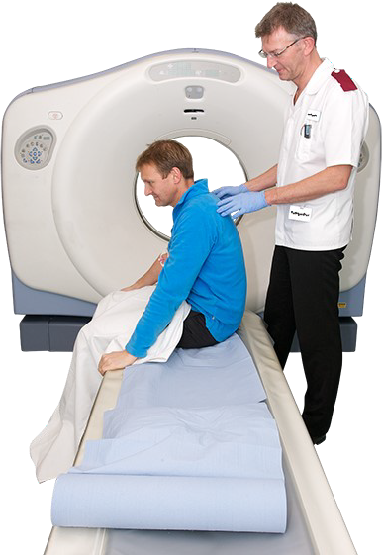
Dr Lissett
Dr Lissett talked about making things easier for people who need a scan. It is hoped that more people can be supported to have a scan without anaesthetic.

Sharon thanked Dr Lissett.
The Ambassadors would like to help with this work.

Treat me well

Sharon said she would tell everyone at the next meeting about work being done with care home providers.

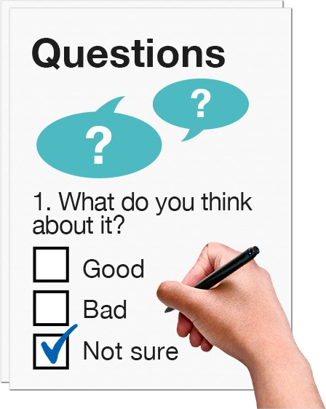
Sharon said that the Oliver McGowan training in learning disability and Autism will be starting at the Trust.

A Questionnaire is being sent out about community health, appointments and hospital care.

Some people are not registered with their Doctor as having a learning disability and it means they don’t get the right help.
Sharon explained that there was work
being done about this.

Some surveys have been sent back to Healthwatch about GP surgeries. The Ambassadors will report on it at the next meeting.

Carers Report
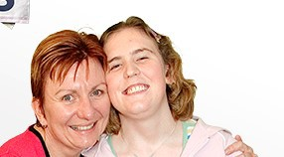
An email account has been set up for the carers reps. Torbay Mencap have made a flyer to explain bout Helen’s new role.
There is work being done with the Fab
team about council tax and Sharon will talk to Rachel Harris about it.

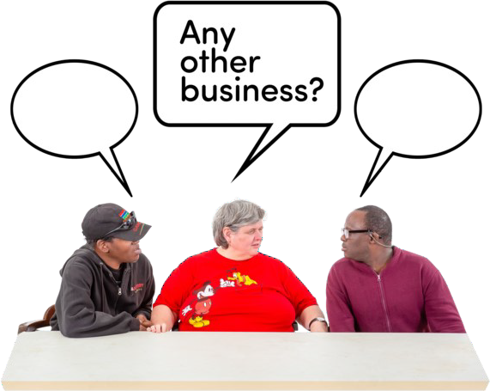
Any other business

There was no other business.

The next meeting is on 7th April at 10am.

Neil thanked everyone for coming to the meeting.

